CURRICULUM VITATE

Rank: Watch officer |  | Nationality: AZERBAIJANI |  |  | 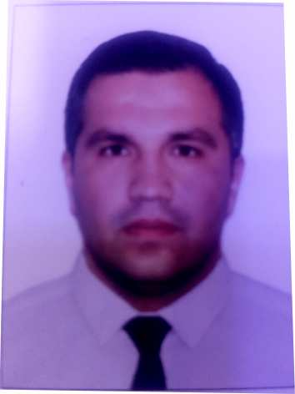
Languages:
TURKISH Excellent
AZER. Excellent
RUSSIAN Excellent
English GOOD

Full name Mammadov Ruslan
 |  | Marital status; Married
Date& place of birth; 25.02.1989 AZERBAIJAN |  | Next of Kin;  Mobile; Father. (+994) 50 388 87 65
Present address: AZERBAIJAN Baku  Nearest airport; Haydar Aliyev / BAKU |  | Mobile phone: (+994) 50 424 87 98  Gmail.com : ruslan.memmedov034  @gmail.com
 |  |  |  |  | Height; 173cm
 |  |  |  |  | Weight; 91 kg
Educational history: RUSSIAN MARITIME ACADEMY
English level; A1-A2
SEMANS IDENTIFICATON CARD | 1762/21 |  | 29.10.2021 | ASTRAXAN/RUSSIA |  | 01.11.2022
SEAMENS BOOK | DQK 021409 |  | 21.09.2022 | State maritime agency |  | 21.09.2027
TRAVEL PASSPORT | C00311279 |  | 22.05.2014 | AZERBAIJAN  ASAN 2 |  | 21.05.2024

LICENSE | Grade of License | Number | Date  issued | Place Issued | Exp. Date
National | WATCH officer | ASF205294760 | 14.12.2021 | RUSSİA .ASTARXAN | 20.10.2026
THE STATE MARİTİMEAGENCY | Exstrace From Seafarers Medical Sertifcate | № 3631 | 25.08.2022 | ASCO medical | 25.08.2024

CERTIFICATES | Number | Date Issued | Place Issued | Exp.Date
Basic trannig for oil and chemical tanker | SA- 0209-18 | 11.06. 2018 | AZERBAIJAN Baku | 08.06.2023
Advianced fire Fighting | №-005300 | 08.12.2021 | ASTARXAN RUSSİA | 08.12.2026
Security trannig for seafarers with  designated securutiy duties | №- 005302 | 07.12.2021 | ASTARXAN RUSSİA | 07.12.2026
Ships carrying dangerous and hazardous substances in sloid form in bulk and in packaged form | №-006172 | 18.12.2021 | ASTARXAN RUSSİA | 18.12.2026
Medical first aid | №-005301 | 13.12.2021 | ASTARXAN RUSSİA | 13.12.2026
Leadership and teamwork | №-006173 | 21.12.2021 | ASTARXAN RUSSİA | 20.12.2026
Proficiency in survival craft and rescue boats other than fast rescue boats | №-005299 | 20.10.2021 | ASTARXAN RUSSİA | 20.10.2026
ISM code training for shipboard personel(requirments of the chapter lX of the International Convention SOLAS-74 as amended and International Safety Management code) | №-006171 | 15.12.2021 | ASTRAXAN RUSSIA | 15.12.2026
Radar observation and plotting | AB-1688241 | 29.10.2021 | ASTRAXAN RUSSIA | 29.10.2026
Operational use of automatic radar plotting aids (ARPA) | AB-1465365 | 12.11.2021 | ASTRAXAN RUSSIA | 12.11.2026
Operational use of electronic chart display and informational systems (ECDIS) | AB-1465471 | 19.11.2021 | ASTRAXAN RUSSIA | 19.11.2026

PREVIOUS SEA SERVICE:

Vessel`s  name | Type of vessel | DWT | flag | Company`s name | RANK | Period  From - To
Silver Star | GEN.CARGO | 3540 | AZERBAIJAN | Samaya Ltd | A/B | 05.09.2017  10.02.2018
Caspian Carrer | Tanker | 5000 | AZERBAIJAN | Samaya Ltd | A/B | 25.06.2018  02.02.2019
Astana | Tanker | 12000 | AZERBAIJAN | Cms | A/B | 06.06.2019  18.10.2019
Almati | Tanker | 12000 | AZERBAIJAN | Cms | A/B | 21/12/2019  25/03/2020
Silver Star | Gen.cargo | 3540 | AZERBAIJAN | Samaya Ltd | Watch officer | 14.06.2021  18.12.2021
MY EFEKAN2 | Gen.cargo | 2660 | VANUATU | My ship group | Watch officer | 25.02.2022  20.08.2022

