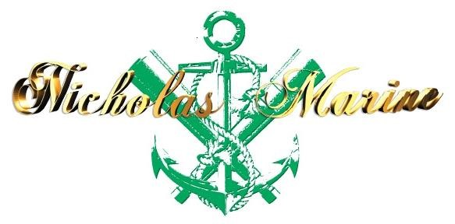
Tel: +994508516362

E-mail:
yusifliismet@gmail.com

APPLICATION FORM
A. SEAMAN’S PERSONAL DETAILS
POSITION TO APPLY FOR |  |  |  |  | A/B |  |  |  |  |  |  | CERTIFIED FOR
NAME / SURNAME |  |  |  |  | Yusifli Ismat
FATHER'S NAME |  |  |  |  | Natiq |  |  |  |  |  |  | MOTHER'S NAME
 | D.O.B./P.O.B. |  |  |  | 10.10.1993 |  |  |  |  |  |  | NATIONALITY |  |  |  |  | AZERBAIJAN
ADDRESS |  |  |  |  | Tovuz ray. Xatinli kendi
MOB: |  | +994508516362 |  |  |  |  | PHONE NO.: |  |  | ------------ |  |  |  |  | E-mail |  |  |  | yusifliismet@gmail.com
MARITAL STATUS |  |  |  |  | Single |  |  |  |  | CHILDREN UNDER 18 YEARS
NEXT OF KIN |  |  |  |  | BROTHER |  |  |  |  | RELATION
NEXT OF KIN ADDRESS AND PHONE |  |  |  |  |  |  |  | +994505840807
GRADUATED FROM |  |  |  |  | ‘’KAINAT – M TM’’ LLC |  |  |  |  |  |  |  |  |  |  |  |  |  | USA VISA: NO
DEGREE OF DIPLOMA ISSUED |  |  |  |  |  | ABLE SEAMAN
WEIGHT |  |  | 68 | HEIGHT |  |  |  |  | 170 |  |  | EYES COLOR |  | brown |  |  |  | HAIR COLOR |  |  | THE BLACK
B. DOCUMENTATION
CERTIFICATES |  |  |  |  |  |  |  |  |  |  | NUMBER |  | 1SSUING DATE |  |  | VAL1DATION DATE |  |  |  | ISSUING PLACE
Certificate of competency |  |  |  |  |  |  |  |  |  |  | ID№RP09853 |  | 07.11.2019 |  |  | 07.11.2024 |  |  |  | AZERBAIJAN
Seaman’s book |  |  |  |  |  |  |  |  |  |  | DQK№014744 |  | 19.07.2019 |  |  | 19.07.2024 |  |  |  | AZERBAIJAN
International passport |  |  |  |  |  |  |  |  |  |  | C01862282 |  | 28.03.2018 |  |  | 27.03.2028 |  |  |  | AZERBAIJAN
Training for Seafarers with designated security duties |  |  |  |  |  |  |  |  |  |  | SH-1327-19 |  | 14.10.2019 |  |  | 14.10.2024 |  |  |  | AZERBAIJAN
Proficiency in survival craft |  |  |  |  |  |  |  |  |  |  | SL-0567-20 |  | 15.08.2020 |  |  | 15.08.2025 |  |  |  | AZERBAIJAN
( STCW-78,A-VI/1-1/1-2/1-3/1-4.) |  |  |  |  |  |  |  |  |  |  | SO-2570-19 |  | 27.10.2019 |  |  | 27.10.2024 |  |  |  | AZERBAIJAN
International safety management code |  |  |  |  |  |  |  |  |  |  | SP-1481-14 |  | 15.10.2019 |  |  | 15.10.2024 |  |  |  | AZERBAIJAN
Ship security-related familiarization security-awarness training |  |  |  |  |  |  |  |  |  |  | SI-2291-19 |  | 14.10.2019 |  |  | 13.10.2024 |  |  |  | AZERBAIJAN
Extract From Seafarers Medical Certificate |  |  |  |  |  |  |  |  |  |  | --------------- |  | 17.03.2021 |  |  | 17.03.2023 |  |  |  | AZERBAIJAN

Another States Seaman's books | Rank | Document No | Issued | Valid
NO | NO | NO | NO | NO
Another States Certificates of competency | Rank | Document No | Issued | Valid
NO | NO | NO | NO | NO

 |  | C. PREVIOUS SEA SERVICE
VESSEL | FLAG | TYPE / DWT | ENG / HP | RANK | S/ON | S/OFF | OWNERS
BALKAN1 | PANAMA | GEN CARGO | 1766/2* | A/B | 14.02.2020 | 10.01.2021 | BALKAN SHİPPİNG
GAHURA | PANAMA | GEN CARGO | 1687/3* | A/B | 07.05.2021 | 24.12.2021 | GAHURA  SHİPPİNG
BOSPHORUS QUEEN | PANAMA | GEN CARGO |  | A/B | 14.04.2022 | 02.12.2022 | BEK DENIZCILIK

English abilities: Satisfactory: ⁯ Average: YES Poor: ⁯

ACCEPTABLE SALARY:

SIGNATURE: DATE: 05.12.2022

