

PERSONAL DETAILS
Family name |  | Nuruzade |  |  | 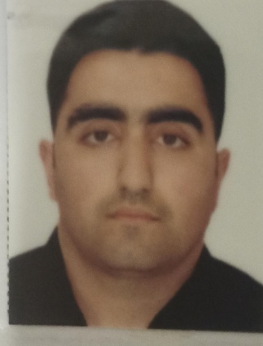
First name |  | Mehdi
Father’s name |  | Sanan
Date and place of birth |  | 05 november 1996 / Azerbaijan, Sabirabad region
Nationality |  | Azerbaijanian
Marital status |  | Single
Permanent address |  | Sabirabad region
Nearest airport |  | Haydar Aliyev Airport/Baku, Azerbaijan
Height (cm) | Weight (kg) | Eyes color | Hair color | Size of safety shoes | Size of coveralls
170 | 70 | Brown | Black | 42 | L
CONTACT DETAILS
Mobile/whatsapp | E-mail address
+994 55 5043409 | mehdi_nuruzade@mail.ru

Full name of School | Place of Issue | Grade/Class | From | To
Kaspian Education Centre | Azerbaijan, Baku | Rating forming part of an engine-room watch | 07.01.2022 | 04.07.2022
NEXT OF KIN IN CASE OF EMERGENCY
Next of kin | Nuruzade Vafa | Relationship | Mother
Address | Azerbaijan,Sabirabad region
Mobile phone | +994555043409
TRAVEL PASSPORT DETAILS
Document | Number | Place of Issue | Issued | Valid
National Travelling Passport | C 03803656 | Ministry of  Internal Affairs of Azerbaijan  Republic | 07.07.2022 | 06.07.2032
SEAMAN’S BOOK DETAILS
Document | Number | Place of Issue | Issued | Valid
National Seaman’s Book | DQK  020187 | Azerbaijan State  Maritime  Administration | 14.05.2022 | 14.05.2027
EDUCATION
KNOWLEDGE OF LANGUAGES
Languages | Speaking | Reading | Writing
Azerbaijan | native | native | native
English | Beginner | Beginner | Beginner
Russian | Beginner | Beginner | Beginner
Turkish | fluent | fluent | fluent
COMPUTER SKILLS
Windows | Microsoft Office | Internet
Good | Good | Good

MEDICAL INFORMATION
Document | Grade | Place of issue | Last exam | Next exam
Seaman’s Medical Certificate | Health Certificate | Azerbaijan State  Maritime  Administration | 01.04.2022 | 01.04.2024
CERTIFICATE OF COMPETENCY
Class/Grade | Issuing country | Certificate No. | Date issued | Expires | Details of Limitations
Rating forming part of an engine-room watch | Azerbaijan | 1493/22 | 19.07.2022 | Unrestriced
STCW AND OTHER CERTIFICATES
Name of course/Certificate | Institute | Place | Date of issue | Cert.No | Date of expiry
Personal safety and social responsibilities | STCW | Azerbaijan | 21.04.2022 | № SO-1734-22 | 21.04.2027
Training for seafarers with designated security duties | STCW | Azerbaijan | 25.05.2022 | N SH-0980-22 | 25.05.2027
Ship Security -related familiarization security -awareness training | STCW | Azerbaijan | 22.04.2022 | N SI-0879-22 | 22.04.2027
International safety management code | STCW | Azerbaijan | 20.05.2022 | N SP-1504-22 | 19.05.2027
Proficiency in survival craft and boats other than fast rescue boats | STCW | Azerbaijan | 23.05.2022 | N SL-1338-22 | 23.05.2027
Basic training and qualifications on oil and chemical tanker cargo operations | STCW | Azerbaijan | 04.11.2022 | SA-0866-22 | 04.11.2027

SEA EXPERIENCE (MOST RECENT EXPERIENCE ON TOP LINE)

Vessel | Company | Type of vessel | Flag | DWT | GRT | Rank | Sign on | Sign off

