APPLICATION FORM
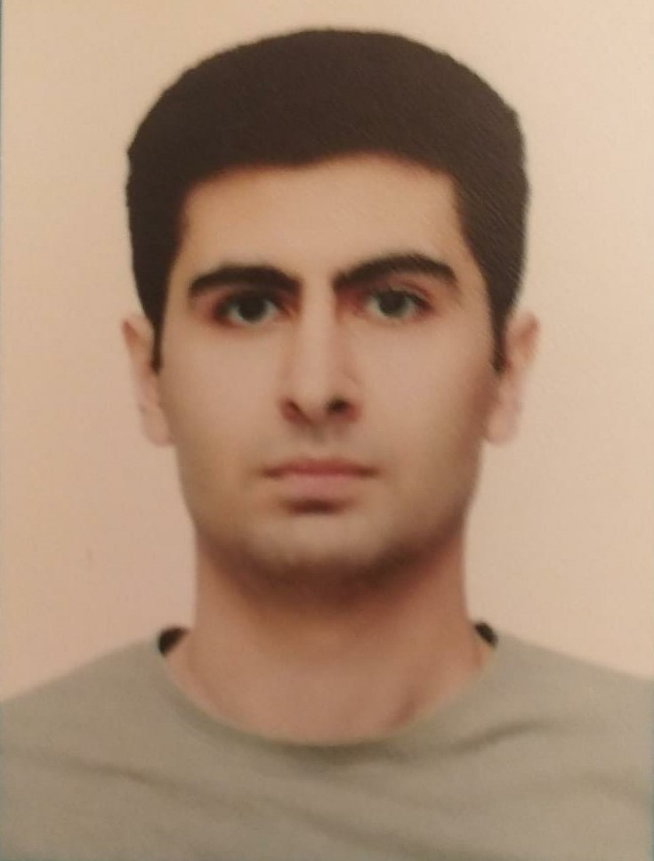

 |  |  |  |  | 6 | G | Z | 3 | 2 | T | W
Personal ID Number

Position Applied for:ELECTRO-TECHNICAL RATING | Date Available from: ANY TIME

1. PersonalData
Family Name: Sahmaliyev | First Name: Çingiz | Middle Name: Rövşən
Date of Birth: 26.08.1999 | Place of Birth:Azerbaijan/Baku | Citizenship: Azerbaijani
Permanent Address: Azerbaijan/Baku |  | Phone (Home): (055) 339 19 99  WhatsApp +99455 339 19 99  E-mail: cingiz.sahmaliev@mail.ru

2. MaritimeEducation
Nameofschool | Town | Country | From | To | Type of degree or diploma
Azerbaijan State Marine Academy | Baku | Azerbaijan | 2016 | 2020 | Bachelor
Specialty |  |  |  |  | Process Automation Engineering

3. ProfessionalTest
English | Pre-intermediate | Score
Russian | Good | Score
Professional Interview Date | Result

4. FamilyDetails
Civil Status (Single, Married, Separated, Divorced, Widowed) : Single

Next of Kin (the first emergency contact) : | Relationship /Father
Address of Residence:  Azerbaijan/Baku | (055) 208 77 73

5. IdentityDocuments
Document | Country | Number | PlaceofIssue | IssueDate | ExpiryDate
Seaman'sBook | Azerbaijan | DQK 018338 | State Maritime Adminstration | 04.09.2021 | 04.09.2026
TravelPassport | Azerbaijan | C03599423 | Ministry of Internal Affairs | 31.08.2021 | 31.08.2031

6. ValidVisa
CountryorUnion | Type | ValidUntil

7. Courses Attended and Certificates Obtained
Document | Number | Dates |  | Place
Document | Number | Issue | Expiry | Place

CertificateofCompetency | RP-10560 | 30.08.2021 | 30.08.2031 | State Maritime Administration
MalteseEndorsementof COC
OilTankerEndorsement
ChemicalTankerEndorsement
GasTankerEndorsement
OilTankerFamiliarizationTraining
ChemicalTankerFamiliarizationTraining
GasTankerFamiliarizationTraining
OilTankersSpecializedTraining
ChemicalTankerSpecializedTraining
GasTankerSpecializedTraining
BasicTrainings | SO-1485-19 | 17.05.2019 | 15.04.2024 | State Maritime Administration
Proficiency in Survival Craft and Rescue Boats | SL-0521-21 | 23.04.2021 | 22.04.2026 | State Maritime Administration
AdvancedFireFighting
MedicalFirstAidTraining
Medical First Aid Training and Medical Care
GMDSS
GMDSS Endorsement
RadarObservation&Plotting
Automatic Radar Plotting Aids S-or (ARPA)
BridgeTeamManagement
Shiphandling&Maneuvering
Ship Security-related familiarization security-awareness training | SI-1458-19 | 17.05.2019 | 18.04.2024 | State Maritime Administration
MalteseEndorsementof SSO
ISM Code | SP-0798-19 | 21.05.2019 | 22.04.2024 | State Maritime Administration
SafetyOfficer
ECDISTrainingCourse
RiskAssessmentCourse
C.O.W./ I.G.S
FirePracticeonTankers
VapourRecoverySystem
UnmannedMachinerySpace
FRAMO FamiliarizationCourse
Cargo Ballast Operations on Oil/Chemical Tankers
HazardousMaterials
Welder
Turner
Risk Management And Incident Investigation
Training of seafarers with designated security duties | SH-0598-21 | 12.08.2021 | 07.02.2026 | State Maritime Administration
Dangerous hazardous and harmfull cargoes
BasicTraining and qualifications on oil and chemical tanker cargo operations
Crowd management training

8. PhysicalData
Height | 186 sm
Weight | 77
ColourofHair | Black
ColourofEyes | Brown
BoilersuitSize | XL
ShoesSize | 44

9. MedicalHistory | Yes | No
Have you ever signed off a ship due to medical reasons? | Yes
Did you undergo any medical operation in the past? |  | No
Have you consulted a doctor during the last 12 months for an illness/accident? |  | No
Do you have any health or disability problems now? |  | No

If yes, please give full details:

 | Passed: | Validtill:
International Medical Examination | 10.01.2023 | 10.01.2025
Vaccination Against YellowFiver
Vaccination Against Diphtheria

10. References (please give name and address of your current or past employer) | Officeremarks

NameofCompany
Name of person to contact
Address
Phone

NameofCompany
Name of person to contact
Address
Phone

11. Bank address forallotments
Beneficiary
AccountNo.
NameofBank
BankAddress

12. Knowledgeandexperience | Yes | No
OCIMF vetting experience:
ISGOT knowledge:

13. I hereby declare that the above, including Medical History, is true
Place

14. ForOfficeuseonly

15. SeagoingExperience

Nameofvessel | Flag | Vessel’sType | DWT | EngType | HP | Manageror Owner | Rank | From d/m/y | Tod/m/y | Total  m/d
Nizami | Azerb daijan | Drei cargo | 3950 | Diesel |  | Azerbaijan Caspian Shipping Closed Joint-Stock Company | practitioner | 18.06.2014 | 28.09.2014 | 3 m, 10 d.
Aura | Azerbaijan | Offshore | 1393 | Diesel |  | Azerbaijan Caspian Shipping Closed Joint Company | practitioner | 01.06.2015 | 28.09.2015 | 3 m, 28 d.
Şirvan | Azerbaijan | Crane | 11159 | Diesel |  | Azerbaijan Caspian Shipping Closed Joint Company | practitioner | 01.06.2016 | 21.09.2016 | 3 m,. 20 d
Merkuri-1 | Azerbaijan | Passenger ship | 19813 | Diesel |  | Azerbaijan Caspian Shipping Closed Joint Company | electrician | 19.01.2017 | 22.02.2017 | 1m, 2d
Bade | Turkey | General  Cargo | 3128 | Diesel |  | Admiral Shipping International Trading inc | electrician | 07.11.2021 | 08.12.2021 | 1 m 1 d
Total |  |  |  |  |  |  |  |  |  | 1.1 year

Total rank sea service: Total type of vessel sea service:
Rank | Years |  | Typeofvessel | Years
Able seaman |  |  | OIL TANKER
 |  |  | LPG0
 |  |  | DRY CARGO
 |  |  | TANKER ICE
 |  |  | OIL /CHEMICAL TANKER
 |  |  | FERRY
Total |  |  | Total:

