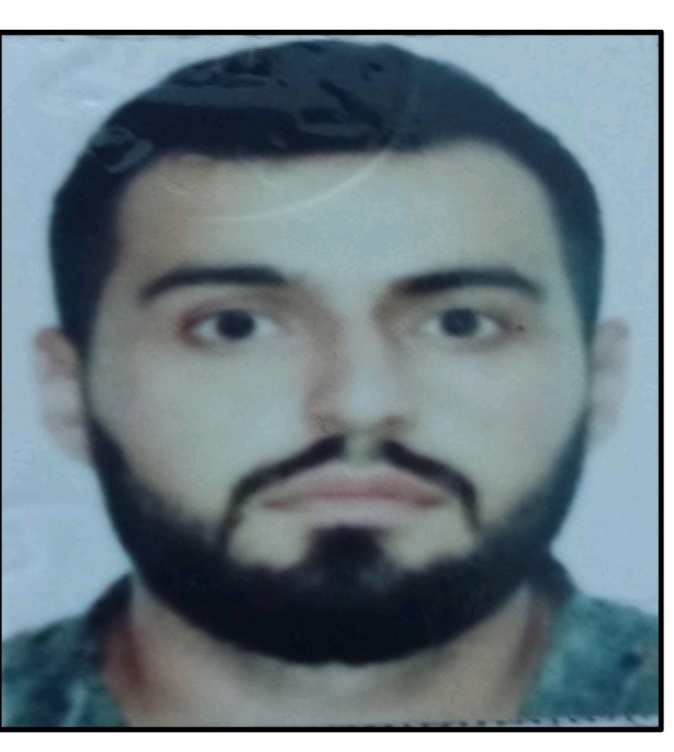

APPLICATION FORM

6 | 7 | F | B | N | V | M
Personal ID Number

Position Applied for: | Date Available from:

1. Personal Data
Family Name: Gayıbkhanov | First Name: Turan | Middle Name:
Date of Birth: 08.03.1996 | Place of Birth (City and Country): Azerbaijan Gusar rayon Yukharı Zeykhur | Citizenship: Azerbaijan
Permanent Address: Azerbaijan Gusar rayon Yukharı Zeykhur |  | Phone (Home): +994773003866(Father)  Phone (Business/ Mobile):+994775838577  E-mail:tgaibkhanov@mail.ru

2. Maritime Education
Name of school | Town | Country | From | To | Type of degree or diploma
Azerbaijan State Maritime Academy | Azerbaijan | Baku | 15.09.2013 | 20.06.2017 | bachelor's diploma

3. Professional Test
English Test Date | Name of Test | Score
Professional Test Date | Name of Test | Score
Professional Interview Date | Result

4. Valid Visa
Country or Union | Type | Valid Until

5. Identity Documents
Document | Country | Number | Place of Issue | Issue Date | Expiry Date
Seaman’s passport | Azerbaijan | DQK 018043 | Respublic of Azerbaijan | 23.07.2021 | 23.07.2026
Travel Passport | Azerbaijan | C02729485 | Respublic of Azerbaijan | 26.12.2019 | 25.12.2029

6. Courses Attended and Certificates Obtained
Document | Number | Dates |  | Place
Document | Number | Issue | Expiry | Place

Certificate of competency SECOND ENGİNEER of ships powered by main propulsion machinery of 3000 kW propulsion power or more | 000861\22 | 08.06.2022 | 08.06.2027 | Republic of Azerbaijan State Maritime Administration
Second Engineer Officer of ships powered by main propulsion machinery of 3000 kw propulsion power or more | 0007101 | 08.06.2022 | 08.06.2027 | Republic of Azerbaijan State Maritime Administration
Ship security-related familiarization security-awareness training (STCW Code,A-VI/6,Pa.1 to Pa. 4; IMO Model course 3.27) | SI-0125-22 | 27.01.2022 | 26.01.2027 | Republic of Azerbaijan State Maritime Administration
Engine resource management | ER-0159-19 | 12.09.2019 | 12.09.2024 | Republic of Azerbaijan State Maritime Administration
Dangerous hazardous and harmfull cargoes | SK-0287-21 | 27.07.2021 | 27.07.2026 | Republic of Azerbaijan State Maritime Administration
Training in advanced fire-fighting | SJ-0561-20 | 27.11.2020 | 27.11.2025 | Republic of Azerbaijan State Maritime Administration
Inert Gas System (Solas-74 Chapter || -2, Section B, Regulation 4, Pa. 5.5, STCW Code A-V/1-1; IMO Model Course 1.02) | SX-0060-21 | 10.08.2021 | 10.08.2026 | Republic of Azerbaijan State Maritime Administration
High voltage electrical equipment | Certificate N4 | 28.09.2021 | 28.09.2026 | ADMİRAL Education-Training Complex
Leader ship and Teamwork | DL-0255-19 | 08.09.2019 | 08.09.2024 | Republic of Azerbaijan State Maritime Administration
Proficiency in survival craft and boats other than fast rescue boats | SL-1250-20 | 14.12.2020 | 14.12.2025 | Republic of Azerbaijan State Maritime Administration
Proficiency in Fast Rescue Boats | Certificate N1 | 27.09.2021 | 27.09.2026 | ADMİRAL Education-Training Complex
Training for seafarers with designated security duties (STCW Code,A-VI/6,Pa.6 to Pa.8;IMO Model Course 3.19) | SH-1191-19 | 28.08.2019 | 27.08.2024 | Republic of Azerbaijan State Maritime Administration
Medical First Aid | SN-0751-19 | 31.10.2019 | 31.10.2024 | Republic of Azerbaijan State Maritime Administration
ISM Code | SP-1196-20 | 02.12.2020 | 02.12.2025 | Republic of Azerbaijan State Maritime Administration
personal survival techniques (STCW-78,A-VI/1-1)  fire prevention and fire fighting (STCW-78,A-VI/1-2)  elementary first aid (STCW-78,A-VI/1-3)  personal safety and social responsibilities (STCW-78,A-VI/1-4) | SO-1178-19 | 03.05.2019 | 03.05.2024 | Republic of Azerbaijan State Maritime Administration
Basic training and qualifications on oil and chemical tanker cargo operations (STWC Code, A-V/1-1 Pa.1; IMO Model Course 1.01) | SA-0142-21 | 04.05.2021 | 04.05.2026 | Republic of Azerbaijan State Maritime Administration
Advanced training for oil tanker cargo operations (STWC Code, A-V/1-1 Pa.2.1 and Pa.2.2; IMO Model Course 1.02)erations | SB-0061-21 | 27.04.2021 | 27.04.2026 | Republic of Azerbaijan State Maritime Administration

7. Physical Data
Height | 183
Weight | 83
Colour of Hair | Black
Colour of Eyes | Black
Boilersuit Size | 52(XL)
Shoes Size | 43

8. References (please give name and address of your current or past employer) | Office remarks

Name of Company
Name of person to contact
Address
Phone

9. Knowledge and experience | Yes | No
OCIMF vetting experience:
ISGOT knowledge:

10. Seagoing Experience

Name of vessel | Flag | Vessel’s Type | DWT | Eng Type | HP | Manager or Owner | Rank | From d/m/y | To  d/m/y | Total  m/d
Atlet-24 | Azerbaijan | AHTS | 2723 | Zultser 6CM  2x1600 kW |  | ASCO(Caspian Marine Oil Fleet | Third engineer | 15.03.2020 | 15.06.2020
Nefteqaz-58 | Azerbaijan | AHTS | 2737 | Zultser 6CM  2x2650 kW |  | ASCO(Caspian Marine Oil Fleet | Third engineer | 16.06.2020 | 06.04.2021
Vadim Seyidov | Azerbaijan | AHTS | 2737 | Zultser 6CM  2x2650 kW |  | ASCO(Caspian Marine Oil Fleet | Third engineer | 05.05.2021 | 31.10.2021
Gultakin Askerova | Azerbaijan | AHTS | 2737 | Zultser 6CM  2x2650 kW |  | ASCO(Caspian Marine Oil Fleet | Third engineer | 01.01.2022 | 15.01.2022
Aydın Mammedov | Azerbaijan | AHTS | 2723 | Zultser 6CM  2x1600 kW |  | ASCO(Caspian Marine Oil Fleet | Third engineer | 15.02.2022 | 28.02.2022
Vadim Seyidov | Azerbaijan | AHTS | 2737 | Zultser 6CM  2x2650 kW |  | ASCO(Caspian Marine Oil Fleet | Third engineer | 01.03.2022 | 31.07.2022
BK Usko | Equatorial Quinea | General Cargo | 2980 | Skoda 6L350 || PS 2x515 Kw |  | Usko Shipping Company LTD | Second engineer | 20.08.2022 | 31.12.2022

Total rank sea service: Total type of vessel sea service:
Rank | Years |  | Type of vessel | Years
Oiler | 1 year 2 months |  | OIL TANKER
Third engineer | 2 years 4 months |  | LPG
Second engineer | 4 months 10 days |  | DRY CARGO
 |  |  | TANKER ICE
 |  |  | OIL /CHEMICAL TANKER
 |  |  | FERRY
Total | 3 years 10 months 10 days |  | Total:

