APPLICATION FORM

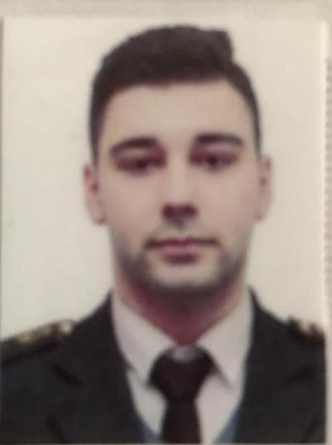
6 | L | Z | F | P | A | K
Personal ID Number

Position Applied For: ETO | Date Available from: Any Time

1. Personal Data
Family Name: Ahmedzadeh | First Name: Nicat | Middle Name: Shahin
Date of Birth: 07.04.1998 | Place of Birth : Azerbaıjan Baku | Citizenship: Azerbaıjan
Permanent Address: Azerbaıjan , Baku |  | Phone Mobil : Az (+994) 70 228 02 06 WP  E-mail : djokerbaku@gmail.com

2. Maritime Education
Name of school | Town | Country | From | To | Type of degree or diploma
Azerbaijan State Marine Academy | Baku | Azerbaıjan | 01.09.2016 | 01.06.2020 | Bachelor

3. Language | Speak | Reading | Write
Azerbaijani | Native | Native | Native
Turkısh | Good | Good | Good
Russian | Native | Native | Native
English | Good | Good | Good

4. Family Details
Civil Status(Single, Married, Separated, Divorced, Widowed) : Single
Next of Kin (the first emergency contact) Ahmadov Shain |  |  |  |  |  | Relationship: Father
Address of Residence : Azerbaıjan , Baku |  |  |  |  |  | Phone : (+994) 50 940 72 59
5. Identity Documents

Document | Country | Number |  | Place of Issue |  |  |  | Issue Date |  | Expiry Date
Seaman's Book | Azerbaıjan | DQK 011016 |  | Azerbaijan |  |  |  | 12.05.2022 |  | 12.05.2027
Travel Passport | Azerbaıjan | C03930671 |  | Azerbaijan |  |  |  | 13.08.2021 |  | 13.08.2031
Civil Passport | Azerbaıjan | AA1335074 |  | Azerbaijan |  |  |  | ------------- |  | 05.12.2029
6. I hereby declare that the above, including Medical History, is true
Place: |  |  | Date |  |  | Signature:
7. Courses Attended and Certificates Obtained

Document |  |  | Number |  | Dates |  |  |  | Place
 |  |  |  |  | Issue |  | Expiry
Certificate of Competency Electro-Technical Officer over 750 KW power and more |  |  | RP09817 |  | 08.10.2019 |  | 08.10.2029 |  | Azerbaıjan
Training for seafarers with designated security duties |  |  | SH-0050-22 |  | 21.01.2022 |  | 21.01.2027 |  | Azerbaıjan
Proficiency in survival craft and rescue boats other than fast rescue boats |  |  | SL-0180-22 |  | 21.01.2022 |  | 21.01.2027 |  | Azerbaıjan
Ship Security-related familiarization security – awareness |  |  | SI-0074-22 |  | 21.01.2022 |  | 21.01.2027 |  | Azerbaıjan
International Safety Management Code |  |  | SP-0104-22 |  | 21.01.2022 |  | 21.01.2027 |  | Azerbaıjan
Personal survival techniques –fire prevention and fire-fighting – elementary first aid – personal safety and social responsibilities |  |  | SO-0026-22 |  | 21.01.2022 |  | 21.01.2027 |  | Azerbaıjan
Training id advanced fire-fighting |  |  | SJ-1652-22 |  | 18.11.2022 |  | 18.11.2027 |  | Azerbaıjan
Leadership and Teamwork |  |  | DL-1724-22 |  | 14.11.2022 |  | 14.11.2027 |  | Azerbaijan
Medical first aid |  |  | SN-1480-22 |  | 22.11.2022 |  | 16.11.2027 |  | Azerbaijan
Certificate of competency for Electro-Technical Officer |  |  | 0007689 |  | 22.12.2022 |  | - |  | Azerbaijan
Endorsement of certificate for Electro-Technical Officer |  |  | 001990/22 |  | 22.12.2022 |  | 22.12.2027 |  | Azerbaijan

8. Physical Data

Height | 178 sm
Weight | 80 kq
Colour of Hair | Black
Colour of Eyes | Brown
Boilersuit Size | 43
Shoes Size | M

9. References ( please give name and address of your current or past employer )
Name of Company 1 | ASCO
Name of person to contact | Roza xanim ( Personal Müdür )
Address | Baku, Aydin Nasirov 3
Phone | +994 12 404 37 00
Name of Company 2 | Topaz Shipping Company CO
Name of person to contact | Yusif M
Address | Baku, ISR Plaza Business Centre 69
Phone | +994 12 497 87 67
10. Bank address for allotments
Beneficiary
Account No.
Name of Bank
Bank Address

Name of vessel | Flag | Vessel’s Type | DWT | Manager or Owner | Rank | From d/m/y | To d/m/y
Gyultakin Asgerova | Azerbaijan | Offshor Supply | 1396 | SOCAR | Electrician | 20.06.2017 | 01.11.2017
Fortress | Azerbaijan | PSV | 3333 | Topaz Marine LTD | Electrician | 25.06.2018 | 03.11.2018
Caspian Reliance | Azerbaijan | Tug | 1903 | Topaz Marine LTD | Electrician | 05.07.2019 | 05.11.2020
Ismet Qayibov | Azerbaijan | Tanker | 2920 | ASCO | Electrician | 01.02.2020 | 21.05.2020
Professor Gul | Azerbaijan | Cargo | 3985 | ASCO | Electrician | 15.07.2021 | 09.09.2021
Volgo Balt 226 | Panama | General Cargo | 3500 | Soylu Shipping | Electrician Officer | 18.02.2022 | 10.05.2022
Tiara | Malta | General Cargo | 6061 | Platin Shipping | Electrical Officer | 27.05.2022 | 20.11.2022

