CURRICULUM VITAE
PERSONAL DETAILS
Family name |  | JAFAROV |  |  | 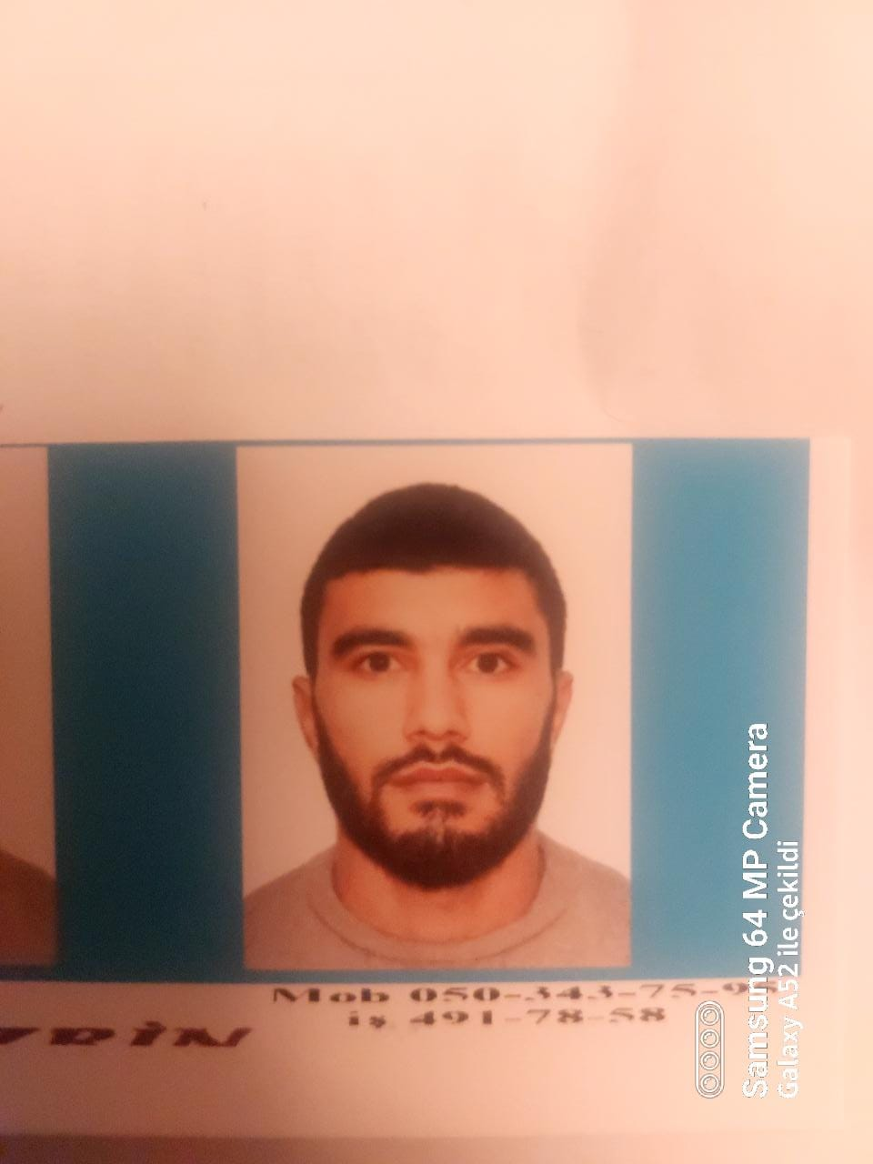
First name |  | MAIS
Father’s name |  | SHAKIR
Date and place of birth |  | 18.04.1999 Azerbaijan
Nationality |  | Azerbaijani
Marital status |  | No
Permanent address |  | Azerbaijan, BAKU
Nearest airport |  | Heydar Aliyev International Airport Baku, Azerbaijan
Height (cm) | Weight (kg) | Eyes color | Hair color | Size of safety shoes | Size of coveralls
164 cm | 60 kg | BROWN | BLACK | 40 | 44
CONTACT DETAILS
Mobile | E-mail address
+994559542470 | Ceferovmais1999@gmail.com
NEXT OF KIN (FOR EMERGENCY)
Next of kin | Shamsi Jafarov | Relationship | Brother
Date of birth | 05.06.1997 | Address | Baku,Azerbaijan
Phone | - | Mobile phone | +994552449435
TRAVEL PASSPORT DETAILS
Document | Number | Place of Issue | Issued | Valid
PASSPORT | CO2154708 | Azerbaijan | 04.11.2018 | 03.11.2028
SEAMAN’S BOOK DETAILS
Document | Number | Place of Issue | Issued | Valid
Seaman book | DGK021977 | Azerbaijan ,Baku | 19.11.2022 | 19.11.2027
SEAARERS IDENTITY | AZE026845 | Azerbaijan ,Baku | 19.11.2022 | 19.11.2027
EDUCATION
Full name of School | Place of Issue | Grade/Class | From | To
Azerbajan Marine Akademiy | Azerbaijan , Baku | ABLE SEAFARER ENGİNE 0073/22 | 19.01.2022
KNOWLEDGE OF LANGUAGES
Languages | Speaking | Reading | Writing
Azerbaijan | Excellent | Excellent | Excellent
Russian | Excellent | Excellent | Excellent
Turkish | Excellent | Excellent | Excellent

COMPUTER SKILLS
Windows | Microsoft Office | Internet
Excellent | Excellent | Excellent
MEDICAL INFORMATION
Document | Grade | Place of issue | Date of issue | Date of expiry
Med.Sertificate | A/B | Azerbaijan | 03.11.2022 | 03.11.2024
CERTIFICATE OF COMPETENCY
Class/Grade | Issuing country | Certificate No. | Date issued | Expires | Details of Limitations
MOTORMAN | Azerbaijan Marine Administration | 2467/22 | 10.11.2022 |  | A-III/4
STCW AND OTHER CERTIFICATES
Name of course/Certificate | Institute | Place | Date of issue | Cert.No | Date of expiry
International Safety Management | Azerbaijan Marine Adminstration | Azerbaijan Baku | 07.06.2022 | SP-1631-22 | 03.06.2027
Proficiency in survival craft and boats other than fast rescue boats | Azerbaijan Marine Adminstration | Azerbaijan Baku | 22.06.2022 | SL-1684-22 | 17.06.2027
Training for seafarers with designated security duties | Azerbaijan Marine Adminstration | Azerbaijan Baku | 23.06.2022 | SH-1141-22 | 22.06.2027
Basic safety trainig | Azerbaijan Marine Adminstration | Azerbaijan Baku | 26.05.2022 | SO-2445-22 | 26.05.2027
Ship Security-related familization security-awareness | Azerbaijan Marine Adminstration | Azerbaijan Baku | 29.06.2022 | SI-1602-22 | 29.06.2027
SEA EXPERIENCE (LAST 5 YEARS – MOST RECENT EXPERIENCE ON TOP LINE)
Vessel | Company | Type of vessel | Flag | DWT | GRT | BHP | Rank | Sign on | Sign off
M/V SHAIR SABIR | CASPIAN SHIPPING | GEN CARGO | AZERBAIJAN | 4876 | 4532 | 1150x2 | MOTORMAN | 05.04.2020 | 15.11.2020
ŞAİR VAGİF | CASPIAN SHIPPING | GEN CARGO | AZERBAIJAN | 5495 | 5200 | 108,33 X 16.74 | MOTORMAN | 10.02.2021 | 11.12.2021

