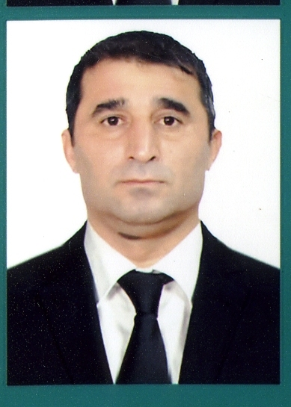 |  |  |  | ASAF  MAMMADOV (COOK)

Objective
I want to obtain a position as a cook in your company.

Education
Lankaran city , Boladi village school (1984-1995)
The Maritime Agency, Cook ( 2010-2011)

Work experience
Palmali Voyager one Sh.Co.LTD, Cook (2012-2012)
Palmali Trading Co ltd, Cook (2012-2013)
Palmali Voyager Shipping Co LTD, Cook (2013-2014)
Palmali Voyager Five Sh.Co.LTD, Cook (2014-2015)
Palagent LLC, Cook (2016-2016)
Palmali Voyager Trad Sh.LTD, Cook (2016-2017)
Paltrading-1 Co LTD, Cook (2017-2018)
Palmali Trading Co LTD. Cook (2018-2019)
Paltrading-4 Co LTD, Cook (2019-2019)
Paltrading-2 Co LTD, Cook (2019-2020)
Primavera Marine LTD, Cook (2020-2021)
Nazlı Shipping Co LTD, Cook (2021-2022)

Language skills
Azerbaijan – Native
Russian – Fluent
Turkish – Fluent

Seaman’s documents
-Certificate- Ship Security-reelated familiarization security-awareness training (11.05.2018-11.05.2023)
-Certificate- SAFETY FAMILIARIZATION, BASIC TRAINING AND INSTRUCTION FOR ALL SEAFARERS (18.01.2021-18.01.2026)
-Certificate- Proficiency in survival craft and boats other than fast rescue boats (14.01.2021-14.01.2026)
-Certificate- Speciality of Cook (29.01.202

Details of last 10 sea service

m/v “Palmali Voyager” / Palmali Voyager one Sh.Co.LTD / Cook
03.2012 – 11.2012
m/v “İlyas Efendiyev” / Palmali Trading Co ltd / Cook
11.2012 – 09.2013
m/v “Nakhchivan” / Palmali Voyager Shipping Co LTD / Cook
09.2013 – 06.2014
m/v “Palmali Confidence” / Palmali Voyager Five Sh.Co.LTD / Cook
06.2014 – 08.2015
m/v “Palmali Voyager” / Palmali Voyager Five Sh.Co.LTD / Cook
08.2015 – 03.2016
m/v “ Zeynalabdin Tagiyev ” / Palmali Voyager Trad Sh.LTD / Cook
05.2016 – 02.2017
m/v “Mirzaga Khalilov” / Paltrading-1 Co LTD / Cokk
02.2017 – 05.2018
m/v “ İlyas Efendiyev ” / Palmali Trading Co ltd / Cook
05.2018 – 02.2019
m/v “Riad Ahmedov” / Paltrading-4 Co LTD / Cook
02.2019 – 10.2019
m/v “İsmayıl Shikhly” / Paltrading-2 Co LTD / Cook
10.2019 – 06.2020
m/v “Mammad Amin Resulzadeh” / Nazlı Shipping Co LTD,/ Cook
02.2022 – 06.2022

 |  | Date of birth 31.12.1977  Lankaran
Lankaran city .,
Boladi village
 |  | +99450 774-65-88  +99455 914-31-77
 |  | asefm661@gmail.com

