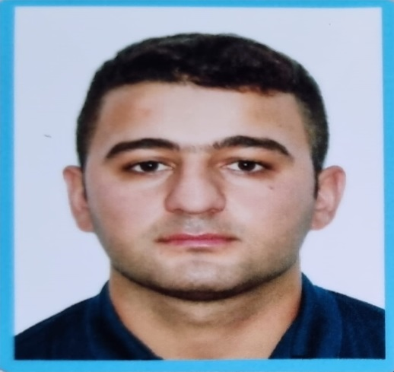

APPLICATION FORM

6 | A | E | Z | 9 | U | A
Personal ID Number

Position Applied for: Fitter/Welder | Date Available from: 02.06.2023

1. Personal Data
Family Name: Nasirov | First Name: Huseyn | Middle Name:
Date of Birth: 26.10.1997 | Place of Birth (City and Country): Lankaran, Azerbaijan | Citizenship: Azerbaijan
Permanent Address: AZ 4233,Viravul village, Lankaran district, Azerbaijan |  | Phone (Home): +994 25 25 66 309  Phone (Business/ Mobile): +994 50 588 85 18  E-mail: huseynnesirov13@gmail.com

2. Maritime Education
Name of school | Town | Country | From | To | Type of degree or diploma
Kainat Training Center | Baku | Azerbaijan | 17.02.2020 | 09.10.2020 | RFPNW - Course On "Marine Engineering And Shipping"

3. Professional Test
English Test Date | Name of Test | Score
Professional Test Date | Name of Test | Score
Professional Interview Date | Result

5. Valid Visa
Country or Union | Type | Valid Until
4. Identity Documents
Document | Country | Number | Place of Issue | Issue Date | Expiry Date
National ID card | Azerbaijan | AA3995766 | Azerbaijan, Baku | 08.07.2022 | 07.07.2032
Seafarers’ identity document | Azerbaijan | AZE021481 | Azerbaijan, Baku | 08.10.2020 | 08.10.2025
Passport | Azerbaijan | C01485237 | Azerbaijan, Lankaran | 24.07.2017 | 23.07.2027

6. Courses Attended and Certificates Obtained
Document | Number | Dates |  | Place
Document | Number | Issue | Expiry | Place

Ship Security - related familiarization security –awareness training | SI-0077-21 | 17.02.2021 | 17.02.2026 | Baku, Azerbaijan (State Maritime Agency)
Training for seafarers with designated security duties | SH-0072-21 | 19.02.2021 | 19.02.2026 | Baku, Azerbaijan (State Maritime Agency)
Proficiency in survival craft and boats other than fast rescue boats | SL-0177-21 | 22.02.2021 | 16.02.2026 | Baku, Azerbaijan (State Maritime Agency)
International Safety Management Code | SP-0171-21 | 23.02.2021 | 23.02.2026 | Baku, Azerbaijan (State Maritime Agency)
Safety familiarization training  Personal survival techniques  Fire prevention and fire fighting  Elementary First Aid  Personal Safety and Social Responsibilities | SO-0342-21 | 03.03.2021 | 03.03.2026 | Baku, Azerbaijan (State Maritime Agency)

7. Physical Data
Height | 180 cm
Weight | 89 kg
Colour of Hair | Dark brown
Colour of Eyes | Brown
Boilersuit Size | XL
Shoes Size | 43
8. References (please give name and address of your current or past employer) | Office remarks
Name of Company | Trimorya Shipping and Trade Ltd
Name of person to contact | B. Akin Akarlar
Address | Orhan Saik Gokyay Cad. No: 68, B Blok, K: 3, D: 6, 35600 Karsiyaka, Izmir / TURKIYE
Phone | +905 305 105 380
9. Knowledge and experience | Yes | No
OCIMF vetting experience: |  | No
ISGOT knowledge: |  | No

10. Seagoing Experience

Name of vessel | Flag | Vessel’s Type | DWT | Eng Type | HP | Manager or Owner | Rank | From d/m/y | To  d/m/y | Total  m/d
ALFA ORIONIS | COMOROS | General Cargo | 3381 t | SKL | 1460 | Trimorya Shipping and Trade Ltd | Able Seaman/Welder | 30.05.2021 | 20.11.2021 | 5/21
ODESSA 1 | COMOROS | General Cargo | 3227 t | SKL | 1460 | Trimorya Shipping and Trade Ltd | Able Seaman/Welder | 30.11.2021 | 17.06.2022 | 6/15
SORMOVSKIY 121 | Belize | General Cargo | 3353 t | SKL | 1460 | Trimorya Shipping and Trade Ltd | Able Seaman/Welder | 20.08.2022 | 26.02.2023 | 6/6
ODESSA 1 | COMOROS | General Cargo | 3227 t | SKL | 1460 | Trimorya Shipping and Trade Ltd | Able Seaman/Welder | 19.05.2023 | _________ | 0/7

Total rank sea service: Total type of vessel sea service:
Rank | Years |  | Type of vessel | Years
AB/Welder | 2 |  | OIL TANKER | ---
 |  |  | LPG | ----
 |  |  | DRY CARGO | 2
 |  |  | TANKER ICE | -----
 |  |  | OIL /CHEMICAL TANKER | ----
 |  |  | FERRY | -----
Total | 2 |  | Total: | 2

