CV APPLICATION FORM 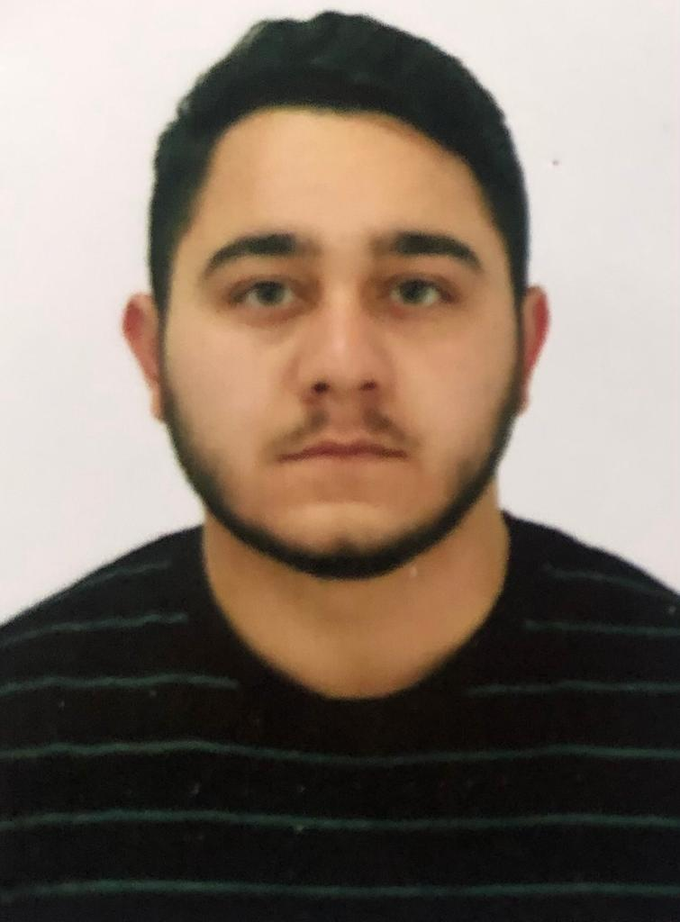

A | Z | E | 0 | 1 | 6 | 4 | 2 | 5
Personal ID Number

Position Applied for: OOW (Vardiya Zabiti) | Date Available from:ANY TIME

1. Personal Data
Family Name:MAHMUDLU | First Name: MURAD
Date of Birth: 23.12.2000 | Place of Birth (City and Country):  Azerbaijan Neftchala city | Citizenship: AZERBAİJAN
Permanent Address Azerbaijan Neftçala H.ALIYEV PR NO5 |  | Phone Mobile:+994 51 979 34 34(24 hrs)  WhatsApp: +994 51 979 34 34  E-mail murad047@bk.ru

MARITIME EDUCATION
NAME OF SCHOOL | TOWN | COUNTRY | FROM | TO | TYPE OF DEGREE OR DIPLOMA
AZERBAIJAN STATE MARINE ACADEMY | BAKU | Azerbaijan | 2017 | 2021 | BACALAVR

FAMILY DETAILS
CIVIL STATUS(SINGLE,MARRIED):SINGLE

NEXT OF KIN THE FIRST EMERGENCY CONTACT/MAHMUDOV MAHMUD | RELATIONSHIP:FATHER
 | PHONE: +994 50 207 98 28

IDENTITY DOCUMENTS
DOCUMENT | COUNTRY | NUMBER | PLACE OF ISSUE | ISSUE DATE | EXPIRY DATE
SEAMAN’S BOOK | AZERBAIJAN | DQK 023073 | AZERBAIJAN,BAKU | 18.03.2023 | 18.03.2028
TRAVEL PASSPORT | AZERBAIJAN | C04034614 | AZERBAIJAN,BAKU | 21.04.2022 | 21.04.2032
CERTIFICATE OF COMPETENCY | AZERBAIJAN | 000440/23 | AZERBAIJAN,BAKU | 26.04.2023 | --------------

VALID VISA
CONTRY OF UNION | TYPE | VALİD UNTİL
N/A | N/A | N/A
N/A | N/A | N/A

CERTIFICATE
DOCUMENT | NUMBER | DATE |  | PLACE
DOCUMENT | NUMBER | ISSUE | EXPIRY | PLACE

CERTIFICATE OF COMPETENCY | 000440/23 | 26.04.2023 | ---------------- | AZERBAİJAN
CERTIFICATE OF COMPETENCY ENDORSEMENT | 000440/23 | 26.04.2023 | ---------------- | AZERBAİJAN
PROFİCİENCY İN SURVİVAL CRAFT AND BOATS OTHER THAN FAST RESCUE BOATS | SL-0614-22 | 18.03.2022 | 18.03.2027 | AZERBAIJAN
RADAR NAVIGATION,RADAR PLOTTING AND USE OF ARPA(OPERATIONAL LEVEL) | SR-0065-21 | 14.04.2021 | 14.04.2026 | AZERBAIJAN
GMDSS | DQ-0181-21 | 20.04.2021 | 20.04.2026 | AZERBAIJAN
GMDSS ENDORSEMENT | DQ-0181-21 | 20.04.2021 | 20.04.2026 | AZERBAIJAN
INTERNATIONAL SAFETY MANAGEMENT CODE | SP-0732-23 | 02.03.2023 | 02.03.2028 | AZERBAIJAN
OPERATIONAL USE OF ELECTRONIC CHART DISPLAY AND INFORMATION (ECDIS) | SZ-0182-21 | 20.04.2021 | 20.04.2026 | AZEEBAIJAN
SHIP SECURITY-RELATED FAMILIRIZATION SECURITY-AWARENESS TRAINING | SI-0725-23 | 02.03.2023 | 28.02.2028 | AZERBAIJAN
STCW-78,A-VI/1-1/1-2/1-3/1-4 | DL-0181-23 | 09.03.2023 | 09.03.2028 | AZERBAIJAN
TRAINING FOR SEAFARERS WITH DESIGNATED SECURITY DUTIES(STCW CODE,A-VI/6) | SH-0564-22 | 12.04.2022 | 12.04.2027 | AZERBAIJAN
TRAINING IN ADVANCED FIRE-FIGHTING | SJ-0313-23 | 06.03.2023 | 06.03.2028 | AZERBAIJAN
LEADERSHIP AND TEAM WORK | SW-0135-23 | 04.04.2023 | 04.04.2028 | AZERBAIJAN
BRIDGE RESOURCE MANAGEMENT | SO-1014-23 | 06.03.2023 | 27.02.2028 | AZERBAIJAN
MEDICAL FIRST AID | SN-0399-23 | 10.03.2023 | 10.03.2028 | AZERBAIJAN

PHYSICAL DATA
HEİGHT | 170 sm
WEIGHT | 75 kg
COLOUR OF HAIR | Black
COLOUR OF EYES | MIXED
SUIT SIZE | MEDIUM
SHOES SİZE | 40

MEDİCAL HISTORY | Yes | No
Have you ever signed off a ship due to medical reasons? |  | No
Did you undergo any medical operation in the past? |  | No
Have you consulted a doctor during the last 12 months for an illness/accident? |  | No
Do you have any health or disability problems now? |  | No

