CURRICULUM VITAE

(Application for Electro-Technical)
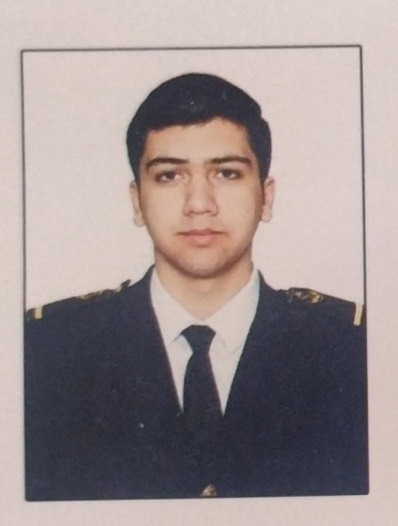

Personal Date
Name : Ibrahimov Valeh Nazim
Place Date of Birth : Azerbaijan, Aghstafa
Date of Birth : 23 July 1999
Nationality : Azerbaijan
Citizenship : Azerbaijan
Sex : M
Blood Group : A(II) RH-
Height : 178cm
Colour of eyes : Brown
Marrial Status : Single

Address : Aghstafa, Eynalli
Mobile Phone : (+90) 552 889 17 05
E-mail : valeh.ibrahimov8@gmail.com
Documents
No | Kind | Number | Date of Issued | Expired Date
1 | Passport | C01670534 | 18.11.2017 | 18.07.2027
2 | Seaman Book | DQK023775 | 19.05.2023 | 19.05.2028
3 | Seafarers' Identity  Document | Type:S  AZE028643 | 19.05.23 | 19.05.28
4 | ID Card | AZE15392089 | 28.08.2015 | 23.07.2024

Education
No | Name of University | Type of degree | Date of Issued | Expired Date
1 | Azerbaijan State Marine Academy | Bachelor | 15 September 2016 | July 2020
2 | 9 Eylul | Master | 6 October 2020

Certificates
No | Certificate | Number of Certificate | Date of Issued on/valid until
1 | Electro-technical Rating | 1353/19 | 25.12.2019-25.12.2029
2 | Safety familiarization, basic training and instruction for all seafarers  (personal survival techniques,  fire preventation and fire fighting ,  elementary first aid,  personal safety and social responsibilities) | SO-1992-23 | 12.05.23-12.05.28
3 | Proficiency in survival craft and boats other than fast rescue boats (STCW Code, A-VI/2 Pa.1,Pa.2,Pa.3 and Pa.4) | SL-1677-23 | 23.05.23-23.05.28
4 | International Safety Management Code | SP-1528-23 | 19.05.23-15.05.28
5 | Ship Security-related familirization security -awareness training  (STCW Code,A-VI/6,Pa.1 to Pa.4,) | SI-1406-23 | 16-05.23-16.05.28
6 | Training for seafarers with designated security duties (STCW Code, A-VI/6,Pa.6 to Pa.8;  IMO Model Course 3.19) | SH-0494-20 | 18.09.2020-10.09.2025
7 | Leadership and Teamwork  (IMO Model Course 1.39) | DL-0375-23 | 11.05.23-11.05.28
8 | Training in advenced fire-fighting.  (STCW Cofde, A-VI/3 Pa.1 , Pa.2 , Pa.3 and Pa.4 IMO Model Course 1.20) | SJ-0607-23 | 08.05.23-08.05.28
9 | Medical Firs Aid  (STCW Code, A-VI/4 Pa.1 , Pa.2 ,Pa.3 ; IMO Model Course 1.14) | SN-0764-23 | 17.05.23-17.05.28
10

Sea Experience

No | Name Of Company | Rank | Name of Vessel | Flag | Type of Vessel | GRT | Periode of  Service |  | TTL MM
 |  |  |  |  |  |  | From | To | TTL MM
1 | ASCO | Electro-Technical Rating (probationer) | M/V Vagif Jafarov | Azerbaijan | Crane | 2971 | 24.06.2017- | 26.10.2017 | 4 M 2 D
2 | ASCO | Electro-Technical Rating (probationer) | M/V Shirvan | Azerbaijan | Crane | 2882 | 17.07.2018- | 26.10.2018 | 3 M 9 D
3 | "Topaz Marine and Energy" "BUE Caspian LTD" | Electro-Technical Rating | M/V Caspian Provider | Azerbaijan | Offshore/Cargo | 2471 | 14.07.2019- | 31.08.2019 | 1 M 18 D
4 | ASCO | Electro-Technical Rating | M/V Garadagh | Azerbaijan | General Cargo | 5141 | 25.01.2020- | 30.05.2020 | 4 M 5 D
4 | Emiroglu Shipping LTD | Electro-Technical Rating | M/V Rize | Panama | General Cargo | 4109 | 12.11.2020- | 25.02.2021 | 3 M 13 D
5 | Orion shipping LTD | ETO  (Electro-Technical oFfiser) | M/V Alfa Orionis | Comoros | General Cargo | 2170 | 04.06.2021 | 23.02.2022 | 8M 19D

Reference Verification
No | Organization | Name of Organization | Country / City | Telephone | P.I.C.
1. | Emiroglu Shipping LTD | Emiroglu Shipping LTD | Turkey/Istanbul | (+90) 538 458 05 32 | Chieff Engineer
2. | Orion shipping LTD | Orion shipping LTD | İzmir/Turkey | +90 530 774 81 34 | Technical manager
3 | Orion shipping LTD | Orion shipping LTD | İzmir/Turkey | +994 50 850 50 14 | Chief Engineer

