CURRICULUM VITAE
PERSONAL DETAILS
Family name |  | HASANOV |  |  | 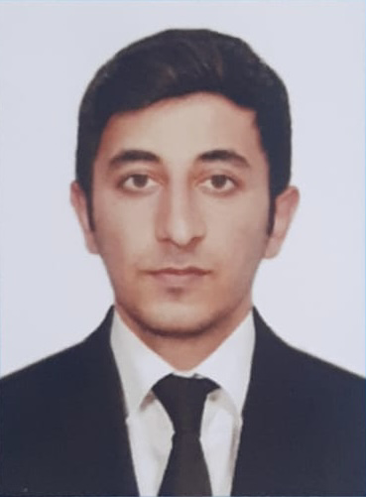
First name |  | ELVIN
Father’s name |  | ILHAM
Date and place of birth |  | 29.08.1998
Nationality |  | Azerbaijan
Marital status |  | Singl
Permanent address |  | Azerbaijan, Neftchala
Nearest airport |  | Heydar Aliyev International Airport Baku, Azerbaijan
Height (cm) | Weight (kg) | Eyes color | Hair color | Size of safety shoes | Size of coveralls
1.68 cm | 67 kg | Brown | Black | 41 | S
CONTACT DETAILS
Mobile | E-mail address
+994514284625  WhatsApp | elvinhesenli.mail.com@gmail.com
NEXT OF KIN (FOR EMERGENCY)
Next of kin | HASANOV | Relationship
Phone | +994514284625 | Address | AZERBAIJAN Neftchala
TRAVEL PASSPORT DETAILS
Document | Number | Place of Issue | Issued | Valid
PASSPORT | C03114105 | Azerbaijan | 12.12.2022 | 11.12.2032
SEAMAN’S BOOK DETAILS
Document | Number | Place of Issue | Issued | Valid
Seaman book | DGK023372 | Azerbaijan ,Baku | 20.04.2023 | 20.04.2028
SEAARERS IDENTITY | AZE028241 | Azerbaijan ,Baku | 20.04.2023 | 20.04.2028
EDUCATION
Full name of School | Place of Issue | Grade/Class | From | To
KAINAT TEDRIS MERKEZI “MMC” | Azerbaijan , Baku | MZ N-000493 | 05.09.2022 | 17.03.2023
KNOWLEDGE OF LANGUAGE
Languages | Speaking | Reading | Writing
Azerbaijan | Excellent | excellent | Excellent
Turkish | Excellent | excellent | Excellent
COMPUTER SKILLS
Windows | Microsoft Office | Internet
Excellent | Excellent | Excellent
MEDICAL INFORMATION
Document | Grade | Place of issue | Date of issue | Date of expiry
Med.Sertificate | Engine-room watch | Azerbaijan Baku | 22.12.2022 | 22.12.2024
CERTIFICATE OF COMPETENCY
Class/Grade | Issuing country | Certifikate  No-0906-23 | Date issued | Expires | Details of Limitations
Engine-room  Watch | Azerbaijan Marine Administration | RP-12719 | 12.04.2023 | No limit | A-3/4
STCW AND OTHER CERTIFICATES
Name of course/Certificate | Institute | Place | Date of issue | RANK | Cert.No | Date of expiry
International Safety Managemen | Azerbaijan Marine Adminstration | Azerbaijan Baku | 31.01.2023 | Engine-room watch | SP-0191-23 | 31.01.2028
Proficiency in survival craft and boats other than fast rescue boats | Azerbaijan Marine Adminstration | Azerbaijan Baku | 27.01.2023 | Engine-room watch | SL-0278-23 | 27.01.2028
Training for seafarers with designated security duties | Azerbaijan Marine Adminstration | Azerbaijan Baku | 02.02.2023 | Engine-room watch | SH-0259-23 | 02.02.2028
Basic safety trainig | Azerbaijan Marine Adminstration | Azerbaijan Baku | 26.01.2023 | Engine-room watch | S0-0359-23 | 19.01.2028
Ship Security-related familization security-awareness | Azerbaijan Marine Adminstration | Azerbaijan Baku | 26.01.2023 | Engine -room watch | SI-0257-23 | 26.01.2028
SEA EXPERIENCE (LAST 5 YEARS – MOST RECENT EXPERIENCE ON TP LINE)
Vessel | Company | Type of vessel | Flag | DWT | GRT | Rank | Sign on | Sign off

