CURRICULUM VITAE
PERSONAL DETAILS
Family name |  | ASLANZADE |  |  | 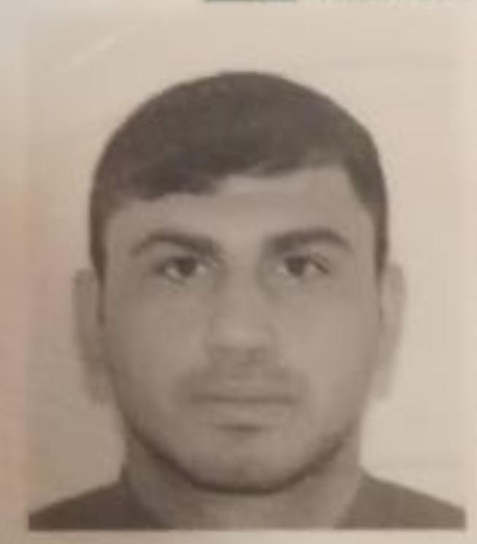
First name |  | FARID
Father’s name |  | AZAR
Date and place of birth |  | 26.04.2022
Nationality |  | Azerbaijan
Marital status |  | No
Permanent address |  | Azerbaijan, Astara
Nearest airport |  | Heydar Aliyev International Airport Baku, Azerbaijan
Height (cm) | Weight (kg) | Eyes color | Hair color | Size of safety shoes | Size of coveralls
1.78 cm | 80 kg | BROWN | BLACK | 43 | XL
CONTACT DETAILS
Mobile | E-mail address
+99451 525 81 77  Watcaap | djanastarli26@gmail.com
NEXT OF KIN (FOR EMERGENCY)
Next of kin | ASLANOV AZAR | Relationship | FATHER
Phone | +99450 725 12 54 | Address | Azerbaijan Astara Siyaku
TRAVEL PASSPORT DETAILS
Document | Number | Place of Issue | Issued | Valid
PASSPORT | C03756925 | Azerbaijan | 11.12.2022 | 10.12.2032
SEAMAN’S BOOK DETAILS
Document | Number | Place of Issue | Issued | Valid
Seaman book | DGK020751 | Azerbaijan ,Baku | 09.07.2022 | 09.07.2027
SEAARERS IDENTITY | AZE025616 | Azerbaijan ,Baku | 09.07.2022 | 09.07.2027
EDUCATION
Full name of School | Place of Issue | Grade/Class | From | To
KAINAT M ZM “MMC” | Azerbaijan , Baku | Motorman MZ-000179 | 18.02.2022 | 23.09.2022
KNOWLEDGE OF LANGUAGE
Languages | Speaking | Reading | Writing
Azerbaijan | Excellent | excellent | Excellent
Russian | Excellent | excellent | Excellent
Turkish | Excellent | excellent | Excellent
COMPUTER SKILLS
Windows | Microsoft Office | Internet
Excellent | Excellent | Excellent
MEDICAL INFORMATION
Document | Grade | Place of issue | Date of issue | Date of expiry
Med.Sertificate | Engine-room watch | Azerbaijan | 29.03.2022 | 29.03.2024
CERTIFICATE OF COMPETENCY
Class/Grade | Issuing country | Certificate  No.2205-22 | Date issued | Expires | Details of Limitations
Engine-room  Watch | Azerbaijan Marine Administration | RP11875 | 11.10.2022 | No limit | A-3/5
STCW AND OTHER CERTIFICATES
Name of course/Certificate | Institute | Place | Date of issue | Cert.No | Date of expiry
International Safety Management | Azerbaijan Marine Adminstration | Azerbaijan Baku | 19.05.2022 | SP-1476-22 | 18.05.2027
Proficiency in survival craft and boats other than fast rescue boats | Azerbaijan Marine Adminstration | Azerbaijan Baku | 16.05.2022 | SL-1240-22 | 16.05.2027
Training for seafarers with designated security duties | Azerbaijan Marine Adminstration | Azerbaijan Baku | 20.05.2022 | SH-0894-22 | 20.04.2027
Basic safety trainig | Azerbaijan Marine Adminstration | Azerbaijan Baku | 19.05.2022 | S0-2203-22 | 11.05.2027
Basic training and qualifications on oil and chemical tanker cargo operations | Azerbaijan Marine Adminstration | Azerbaijan Baku | 18.11.2022 | SA-0907-22 | 18.11.2027
Ship Security-related familization security-awareness | Azerbaijan Marine Adminstration | Azerbaijan Baku | 23.05.2022 | SI-1122-22 | 12.05.2027
SEA EXPERIENCE (LAST 5 YEARS – MOST RECENT EXPERIENCE ON TOP LINE)
Vessel | Company | Type of vessel | Flag | DWT | GRT | BHP | Rank | Sign on | Sign off
ECOSUPPORTER | BUE Caspian LTD | Tanker | Azerbaycan | 715 g/t |  | 6 CH | Engine-room watch | 21 05.2022 | 20.08.2022
Balkan Marmara | Volqabat 212 bolt | General Cargo Ship | Barbados | 8700Dwt |  | 8CH | Engine room watch | 29.05.2022

