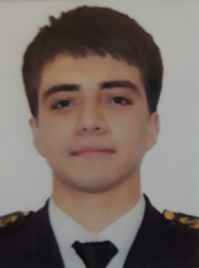

CV/APPLICATION FORM

Personal Details

Surname | Hasanov
First Name | Nurlan
Date of Birth | 10.08.1999
Place of Birth | Azerbaijan, Baku
Nationality | Azerbaijan
Marital status | Single
Education | Azerbaijan State Marine Academy
Mobile Number | +994558581013
Email Address | Hesenovnurlan099gmail.com@mail.ru
Home Address | Baku, Binaqadi

Passport & Seaman Book
Passport CO03632881No
Date Issued | 25.11.2021
Expires | 24.11.2031
Place Issued | Ministry of İnternal Affairs
Seaman Book No | DQK 019081
Seaman Book Issue Date | 12.01.22
Seaman Book Expiry | 12.01.27
Place Issued | State Maritime Administration
USA Visa expired

Language skills | Excellent | Good ( intermediate) | Not good ( beginner)
Azerbaijani | X
Turkish | X
English |  | X
Russian |  | X

CERTIFICATE of COMPETENCY
ELECTRO-TECHNICAL RATING İssued on : 11.01.2022 ID Number : RP10811
Certificate no 0024/22

Certificates

Name of Course / Certificate | Number | Issued | Expires |  | Place of  Issue
Basic training and instruction for all seafarers courses | SO-1487-19 | 17.05.2019 | 15.04.2024 |  | State Maritime Administration
Training for seafarers with designated security duties | SH-0897-21 | 24.09.2021 | 22.09.2026 |  | State Maritime Administration
Proficiency in survival craft and boats other than fast rescue boats | SL-1414-21 | 02.09.2021 | 02.09.2026 |  | State Maritime Administration
Ship security-related familiarization security-awareness training | SI-1460-19 | 17.05.2019 | 18.04.2024 |  | State Maritime Administration
Seafarer’s Medical Certificate |  | 23.08.2021 | 23.08.2023 |  | Unical-A LLC Uniclinica Clinic Center
International Safety Management Code | SP- 0800- 19 | 21.05.2019 | 22.04.2024 |  | State Maritime Administration
Basic training and qualifications on oil and chemical tanker cargo operations | SA-0286-21 | 08.09.2021 |  | 08.09.2026 | State Maritime Administration

Record of Sea Service

VESSEL | COMPANY | Type of Vessel | DWT /GRT | RANK | Sign on DATE | Sign off DATE
Barda | ASCO | Ferry ship | 8045 | Electrician | 31.01.2022 | 14.04.2022
Balakan | ASCO | Ferry ship | 8045 | Electrician | 20.06.2022 | 29.09.2022
A Plus 1 | Yarbunker | Dry cargo | 3743 | Electrician | 03.10.2022 | 23.01.2023
Naxchıvan | ASCO | Ferry ship | 5985 | Electrician | 15.02.2023

