CV Application Form  Name & Surname  Kərimli Rəkam  RANK: Able Seaman  DATE: 10.07.2023 | 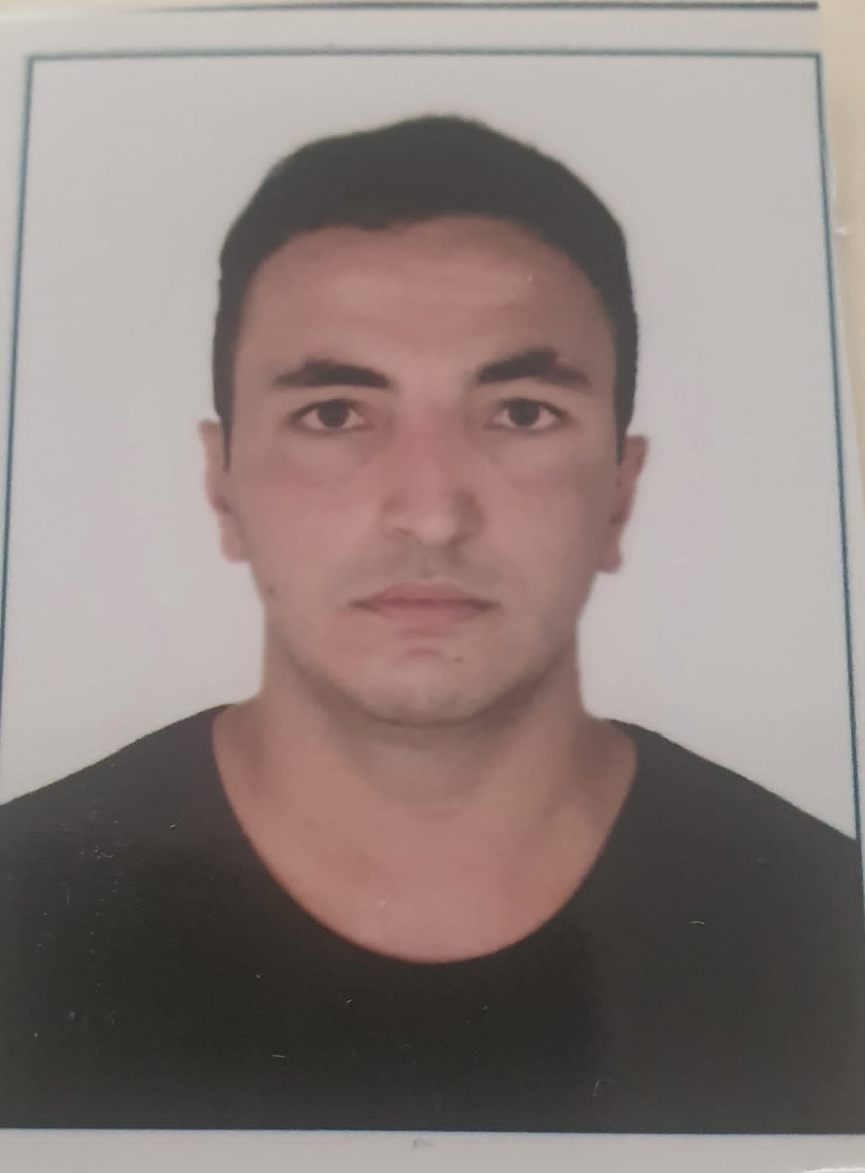  PHOTO

Main info
Name / Surname: | Kərimli Rəkam
Position applied for: | Able Seaman | Desired Vessel Type: | Offshore or crane and tanker
Minimum salary $: | 300 | Birthday / Placeofbirth: | 15.07.2002  Bakı şəhəri Suraxanı rayonu Hövsan qəsəbəsi
Phones: | 077-314-83-30  099-313-83-30 | Citizenship: | Azerbaijan
E-mail: | rekamseaman@gmail.com | Country ofresidence / City: | Azerbaijan/Baku
Skype: |  | Home address: | Bakı şəhəri Suraxanı rayonu Hövsan qəsəbəsi Məktəb küçəsi ev 34
English level: | Pre intermediate | Closest airport: | Heydar Aliyev international airport
Married: | - | Children: | -

Biometrics
Sex: Male | Height(cm): 1.82 | Overall size:
Eyes color: Mixed | Weight (kg): 78 | Shoe size:

Additional info
Maritime education: | Azerbaijan State Marine Academy | Additional skills:
Specialty: |  | Knowledge ofother  languages: | English / Russian / Ukraine  English

Next of Kin
Next of kin: | + | Kin phone: | 055-578-28-76
Kin name, Surname: | Rashad Karimli | Kin address:

Medical certificates
Title of document | Date of issue | Country of issue | Valid up
Yellow Fever
Last medical examination | 08.07.2023 | Azerbaijan | 08.07.2025

Passports / Certificates / Documents / Licenses
Title of document |  |  |  | No. | Date of issue | Country of issue | Valid up
Seaman's book |  |  |  | 016024 | 29.02.2020 | Azerbaijan | 28.02.2025
International passport |  |  |  | AZE020908 | 29.02.2020 | Azerbaijan | 28.02.2025
US VISA
Schengen VISA
 |  | Rank
Professional license
Endorsement
Certificate of competency
Basic Safety Training and Instructions
Advanced FireFighting
Proficiency in SurvivalCraft and RB
Security-related training instruction for all seafarers
Ship Security Officer
Designated security duties of shipboard personnel
ECDIS |  |  |  | SZ-0156-23 | 01.03.2023 | Azerbaijan | 16.01.2028
Radar Management(ARPA+Radar) |  |  |  | SR-0073-23 | 17.02.2023 | Azerbaijan | 12.01.2028
Medical First Aid
Medical Care |  |  |  | 050948 | 08.07.2023 | Azerbaijan | 08.07.2025
GMDSS Operator |  |  |  | DQ-0182-23 | 24.02.2023 | Azerbaijan
GMDSS Endorsement |  |  |  | DQ-0182-23 | 24.02.2023 | Azerbaijan | 14.06.2027
Ship Carrying Danger/hazard Cargo
Bridge ResourceManagement
Ship handling arrangements:
Security training for seafarers with designated security duties
Other Documents / Certificates |  |  |  | SP-0890-21 | 25.06.2021 | Azerbaijan | 02.06.2026
Other Documents / Certificates |  |  |  | SO-1221-21 | 17.06.2021 | Azerbaijan | 31.05.2026
Other Documents / Certificates
Other Documents / Certificates
Other Documents / Certificates
Other Documents / Certificates
Other Documents / Certificates
Other Documents / Certificates

Sea service (last 5 years)
Position | Vessel Name / Flag | Vessel type / GRT | ME Type / kW | From - Till | Shipowner
Cadet | Caspian Provider | Offshore | 2325×2 | 3 month 0 day | P&O maritime and logistic
Cadet | Caspian Provider | Offshore | 2325×2 | 2 month 17 day | P&O maritime and logistic
Cadet | Professor Gul | Ferry | 4350×2 | 2 month 19 day | A.X.D.G  Dəniz nəqliyyat donanması ASCO
Cadet | Genereal Asadov | Cruise Ship | 1200×2 | 3 month 12 day | A.X.D.G  Xəzər Dəniz Neft Donanması  ASCO

