CURRICULUM VITAE
PERSONAL DETAILS
Family name |  | Hajiyev |  |  | 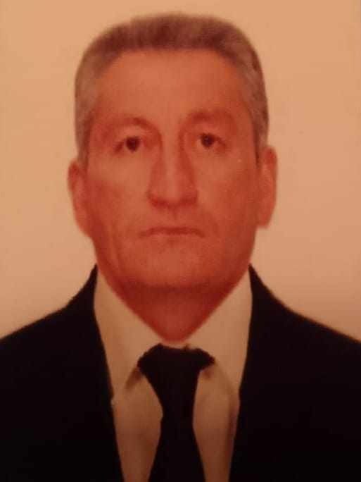
First name |  | Ilgar
Father’s name |  | Soltan
Date and place of birth |  | 25.01.1971
Nationality |  | Azerbaijan
Marital status |  | No
Permanent address |  | Azerbaijan, Ujar
Nearest airport |  | Heydar Aliyev International Airport Baku, Azerbaijan
Height (cm) | Weight (kg) | Eyes color | Hair color | Size of safety shoes | Size of coveralls
1.75cm | 85kg | Blue | White | 42 | XL
CONTACT DETAILS
Mobile | E-mail address
+994 50 666 59 72
WhatsApp
NEXT OF KIN (FOR EMERGENCY)
Next of kin | Hajiyev Hussein | Relationship | BROTHER
Phone | +994 50 666 12 28 | Address | Azerbaijan, Ujar Melikballi
TRAVEL PASSPORT DETAILS
Document | Number | Place of Issue | Issued | Valid
PASSPORT | C02145438 | Azerbaijan | 16.05.2018 | 16.05.2028
SEAMAN’S BOOK DETAILS
Document | Number | Place of Issue | Issued | Valid
Seaman book | DQK 020157 | Azerbaijan ,Baku | 12.05.2022 | 12.05.2027
SEAARERS IDENTITY | AZE025022 | Azerbaijan ,Baku | 12.05.2022 | 12.05.2027
EDUCATION
Full name of School | Place of Issue | Grade/Class | From | To
KASPIAN EDUCATION CENTRE “LLC” | Azerbaijan , Baku | Motorman | 07.01.2022 | 04.07.2022
KNOWLEDGE OF LANGUAGE
Languages | Speaking | Reading | Writing
Azerbaijan | Excellent | excellent | Excellent
Russian | Excellent | excellent | Excellent
Turkish | Excellent | excellent | Excellent
COMPUTER SKILLS
Windows | Microsoft Office | Internet
Excellent | Excellent | Excellent
MEDICAL INFORMATION
Document | Grade | Place of issue | Date of issue | Date of expiry
Med. Certificate | Motorman | Azerbaijan | 04.04.2022 | 04.04.2024
CERTIFICATE OF COMPETENCY
Class/Grade | Issuing country | Certificate  No.1540-22 | Date issued | Expires | Details of Limitations
Engine-room  Watch | Azerbaijan Marine Administration | RP11568 | 21.07.2022 | No limit | A-3/4
STCW AND OTHER CERTIFICATES
Name of course/Certificate | Institute | Place | Date of issue | Cert. No | Date of expiry
International Safety Management | Azerbaijan Marine Administration | Azerbaijan Baku | 21.04.2022 | SP-1089-22 | 21.04.2027
Proficiency in survival craft and boats other than fast rescue boats | Azerbaijan Marine Administration | Azerbaijan Baku | 18.04.2022 | SL-0875-22 | 18.04.2027
Training for seafarers with designated security duties | Azerbaijan Marine Administration | Azerbaijan Baku | 25.04.2022 | SH-0637-22 | 22.04.2027
Basic safety training | Azerbaijan Marine Administration | Azerbaijan Baku | 18.04.2022 | S0-1596-22 | 14.04.2027
Ship Security-related familization security-awareness | Azerbaijan Marine Administration | Azerbaijan Baku | 19.04.2022 | SI-0787-22 | 19.04.2027
SEA EXPERIENCE (LAST 5 YEARS – MOST RECENT EXPERIENCE ON TOP LINE)
Vessel | Company | Type of vessel | Flag | DWT | GRT | BHP | Rank | Sign on | Sign off
BABA DAG | Monolit-D LTD | Oil Tanker | Azerbaijan | 1131 g/t |  | 2 X 6CHNSP18/22 (600 HP) | Motorman | 09.04.2022 | 02.07.2022

