APPLICATION FORM

Position Applied for MOTORMAN
1. Personal Data
Family Name:  BAYRAMOV | First Name:  RASHAD | Middle Name:  GULOGHLAN
Date of Birth:  15.11.1987 | Place of birth :  ASTARA CITY, AZERBAIJAN | Citizenship:  AZERBAIJAN
Permanent Address;  AZERBAIJAN , ASTARA CITY. |  | Phone (Business/ Mobile) +994503659558  E-mail: Am89824057263@ gmail.com
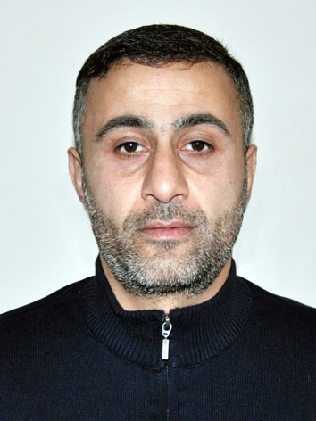

2. Maritime Education
Name of school | Town | Country | From | To | Type of degree or diploma
“KASPIAN EDUCATION CENTER” LLC | BAKU | AZERBAIJAN |  |  | PS № 000865

3. Professional Test
English Test Date | Name of Test | Score
Professional Test Date | Name of Test | Score
Professional Interview Date | Result

4. Family Details
Civil Status(Single, Married, Separated, Divorced, Widowed) : Married

Next of Kin (the first emergency contact) | Relationship
Address of Residence AZERBAIJAN , ASTARA CITY. | Phone : +994 50 303 09 99 What’s App

 | Son
Family Name | BAYRAMOV
First Name | XANOGHLAN
Date of Birth | 24.02.2022
City of living | Astara
Phone Numbers

5. Identity Documents
Document | Country | Number | Place of Issue | Issue Date | Expiry Date
Seaman's Book | Azerbaijan | DQK 017970 | State of maritime administration | 13.07.2021 | 13.07.2026
Travel Passport | Azerbaijan | C032728259 | Ministry of internal affairs | 27.07.2022 | 26.07.2032
Civil Passport | Azerbaijan | AZE028763 | Seafarers Identity Document | 26.05.2023 | 26.05.2028
6. Valid Visa
Country or Union | Type | Valid Until

7. Courses Attended and Certificates Obtained
Document | Number | Dates |  | Place
Document | Number | Issue | Expiry | Place

Certificate of Competency |  |  | PERMANENT | AZERBAIJAN
Maltese Endorsement of COC
Oil Tanker Endorsement
Chemical Tanker Endorsement
Gas Tanker Endorsement
Oil and Chemical Tanker Familiarization Training | SA-0154-23 | 28.02.2023 | 28.02.2028 | AZERBAIJAN
Gas Tanker Familiarization Training
Oil Tankers Specialized Training
Gas Tanker Specialized Training
Basic Trainings | SO-0907-23 | 15.11.2023 | 15.11.2023 | AZERBAIJAN
Proficiency in Survival Craft and Rescue Boats | SL-0747-23 | 27.02.2023 | 27.02.2028 | AZERBAIJAN
Advanced Fire Fighting
Medical First Aid Training and Medical Care
GMDSS
GMDSS Endorsement
Radar Observation & Plotting
Bridge Team Management
Shiphandling & Maneuvering
Ship Security Officer Training Course | SI-0525-23 | 21.02.2023 | 21.02.2028 | AZERBAIJAN
Maltese Endorsement of SSO
ISM Code | SP-0612-23 | 23.02.2023 | 23.02.2028 | AZERBAIJAN
Safety Officer
ECDISTraining Course
Risk Assessment Course
C.O.W./ I.G.S
Fire Practice on Tankers
Vapour Recovery System
Unmanned Machinery Space
FRAMO Familiarization Course
Hazardous Materials
Welder
Turner
Risk Management And Incident Investigation
Training of seafarers with designated security duties in compliance with ISPS Code | SH-0493-23 | 03.03.2023 | 03.03.2028 | AZERBAIJAN

8. Physical Data
Height | 175
Weight | 76
Colour of Hair | BROWN
Colour of Eyes | BROWN
Boilersuit Size | M
Shoes Size | 43

9. Medical History | Yes | No
Have you ever signed off a ship due to medical reasons? |  | +
Did you undergo any medical operation in the past? |  | +
Have you consulted a doctor during the last 12 months for an illness/accident? |  | +
Do you have any health or disability problems now? |  | +

 | Passed: | Valid till:
International Medical Examination | 04.04.2023 | 04.04.2025
Vaccination Against Yellow Fiver
Vaccination Against Diphtheria

10. References (please give name and address of your current or past employer) | Office remarks

Name of Company
Name of person to contact
Address
Phone

Name of Company
Name of person to contact
Address
Phone

11. Bank address for allotments
Beneficiary
Account No.
Name of Bank
Bank Address

12. Knowledge and experience | Yes | No
OCIMF vetting experience:
ISGOT knowledge:

13. I hereby declare that the above, including Medical History, is true
Place | Date | Signature

14. For Office use only

15. Seagoing Experience

Name of vessel | Flag | Vessel’s Type | DWT | Eng Type | HP | Manager or Owner | Rank | From d/m/y | To  d/m/y | Total  m/d

