APLICATION FORM
 | 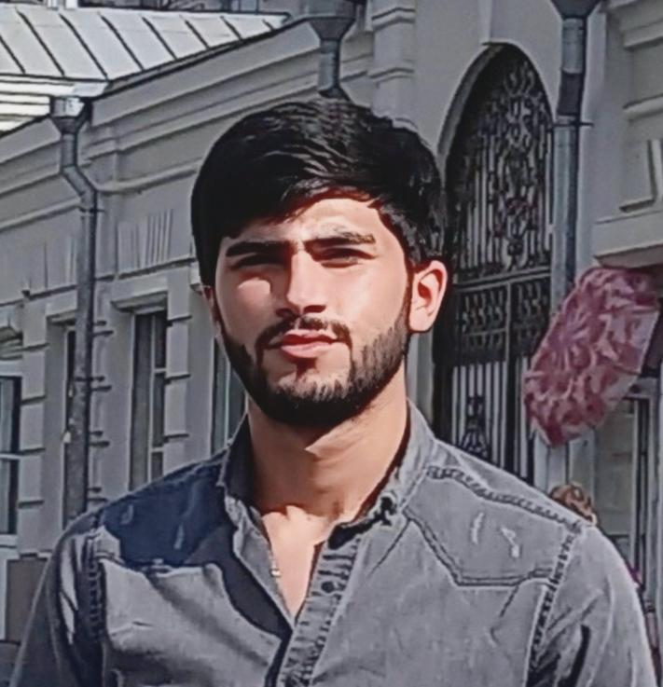
  Position: | OS & COOK | Citizenship: | AZERBAİJAN
  Last name: | MUSTAFAYEV | Marital status | SINGLE
  First name: | FAKHRADDIN | Children: | NO HAVE CHİLDREN
  Middle name: | RUSLAN | Nationality: | AZERBAİJAN
  Birth date: | 29.09.2002 | Birth place: | AZERBAİJAN, KHACMAZ
  Home address: | AZERBAİJAN, KHACMAZ | Phone mobile: | +994 505258050  What’s App
  Home address: | AZERBAİJAN, KHACMAZ | E-mail: | Fexreddinmustafayev2016@gmail.com

Passports & Seaman’s Book
Title | Number | Place of issue | Issued | Valid
PASSPORT | AZE C03931625 | Azerbaijan, Baku | 08.05.2022 | 07.05.2032
SEAMAN’S BOOK | DQK 015929 | Azerbaijan, Baku | 19.02.2020 | 19.02.2025
SEAFARERS İDENTITY DOCUMENT | AZE020819 | Azerbaijan, Baku | 19.02.2020 | 19.02.2025

Certificates
Title | Number | Place of issue | Issued | Valid
CERTIFICATE OF COMPETENCY.  RATING FORMING PART OF A NAVİGATİONAL WATCH | № RP11579 1552/22 | Azerbaijan, Baku | 27.07.2022
-Has successfully completed following safety familiarization ,basic training and instruction for all seafarers courses which has been developed in accordance with the mandatory minimum  requirements of Regulation VI/I of the International Convention STCW-78 ,as amended and of the SectionbA-VI/I of STCW Code and on programme approved by the State Maritime and Port Agency:  -Safety familiarization training  (STCW-78, A-VI/1 pa.1)  -Personal survival techniquies  (STCW-78, A-VI/1 pa.2.1.1)  -Fire prevention and fire fighting  (STCW-78, A-VI/1 pa.2.1.2)  -Elementary first aid  (STCW-78, A-VI/1 pa.2.1.3)  -Personal safety and social responsibilities  (STCW-78, A-VI/1 pa.2.1.4) | № SO-2683-22 | Azerbaijan, Baku | 24.06.2022 | 22.06.2027
- Proficiency in survival craft and boats other than fast rescue boats  (STCW Code, A-VI/1 Pa.1, Pa.2, Pa.3 and Pa.4) | № SL-1799-22 | Azerbaijan, Baku | 28.06.2022 | 28.06.2027
-International Safety Management Code | № SP-1991-22 | Azerbaijan, Baku | 30.06.2022 | 30.06.2027
- Ship Security – realted familiarization security awareness training.  (STCW Code , A-VI/6, Pa.1 to Pa.4 ) | № SI-1521-22 | Azerbaijan, Baku | 23.06.2022 | 23.06.2027
-Training for seafarers with designated security duties  (STCW Code A-VI/6, Pa.6 to Pa.8.) | № SH-1256-22 | Azerbaijan, Baku | 05.07.2022 | 05.07.2027

Medical Information
Title | Number | Place of issue | Issued | Valid
-Extraction From Seafarers Medical Certificate |  | Azerbaijan, Baku | 30.04.2022 | 30.04.2024

Knowledge of other Languages
1.AZERBAIJAN | 2.TURKISH | 3.ENGLISH | 4. RUSSIAN
GOOD | GOOD | N/A | NORMAL

Biometrics
SEX : MALE | HEIGHT : 183 sm | OVERALL SIZE : L
EYES COLOR : BROWN | WEIGHT : 72 kg | SHOE SIZE : 42 sm

Next of Kin
Next of kin : | FATHER | Kin phone : | +994 70 511 90 01 What’s app
Kin name, surname : | MUSTAFAYEV RUSLAN | Kin address : | Azerbaijan, Khacmaz

Name of vessel | Flag | Vessel’s Type | DWT | Rank | From d/m/y | To d/m/y | Total m/d
Temel Reis | Panama | Dry cargo | 2000 | OS & COOK | 27.08.2022 | 21.09.2023 | 12m,26d
Hazar-1 | Azerbaijan | Dry cargo | 2500 | OS | 01.04.2022 | 03.08.2022 | 4m,2d

