CURRICULUM VITAE
PERSONAL DETAILS
Family name |  | BAYRAMOV |  |  | 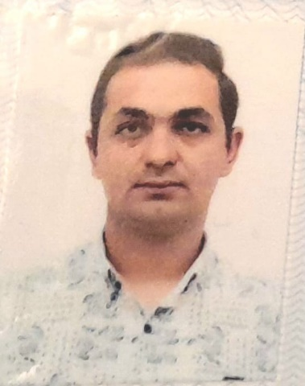
First name |  | ELCAN
Father’s name |  | QALIB
Date and place of birth |  | 23.06.1996 Azerbaijan
Nationality |  | Azerbaijani
Marital status |  | No
Permanent address |  | Azerbaijan, BAKU
Nearest airport |  | Heydar Aliyev International Airport Baku, Azerbaijan
Height (cm) | Weight (kg) | Eyes color | Hair color | Size of safety shoes | Size of coveralls
172cm | 79 kg | BROWN | BLACK | 43 | 52
CONTACT DETAILS
Mobile | E-mail address
+994513343754
NEXT OF KIN (FOR EMERGENCY)
Next of kin |  | Relationship | Brother
Date of birth |  | Address | Baku,Azerbaijan
Phone |  | Mobile phone
TRAVEL PASSPORT DETAILS
Document | Number | Place of Issue | Issued | Valid
PASSPORT | C02158177 | Azerbaijan | 20.10.2018 | 19.10.2028
SEAMAN’S BOOK DETAILS
Document | Number | Place of Issue | Issued | Valid
Seaman book | DGK017076 | Azerbaijan ,Baku | 11.02.2021 | 11.02.2026
SEAARERS IDENTITY | AZE022002 | Azerbaijan ,Baku | 11.02.2021 | 11.02.2026
EDUCATION
Full name of School | Place of Issue | Grade/Class | From | To
Azerbajan Marine KAINAT | Azerbaijan , Baku | 0379/21 | 04.06.2021
KNOWLEDGE OF LANGUAGES
Languages | Speaking | Reading | Writing
Azerbaijan | Excellent | Excellent | Excellent
Russian | Excellent | Excellent | Excellent
Turkish | Excellent | Excellent | Excellent

COMPUTER SKILLS
Windows | Microsoft Office | Internet
Excellent | Excellent | Excellent
MEDICAL INFORMATION
Document | Grade | Place of issue | Date of issue | Date of expiry
Med.Sertificate | A/B | Azerbaijan | 09.12.2022 | 17.10.2024
CERTIFICATE OF COMPETENCY
Class/Grade | Issuing country | Certificate No. | Date issued | Expires | Details of Limitations
SEAMAN | Azerbaijan Marine Administration | 0379/21 | 04.06.2021 |  | A-II4
STCW AND OTHER CERTIFICATES
Name of course/Certificate | Institute | Place | Date of issue | Cert.No | Date of expiry
International Safety Management | Azerbaijan Marine Adminstration | Azerbaijan Baku | 07.05.2021 | SP-0569-21 | 06.05.2026
Proficiency in survival craft and boats other than fast rescue boats | Azerbaijan Marine Adminstration | Azerbaijan Baku | 08.05.2021 | SL-0634-21 | 08.05.2026
Training for seafarers with designated security duties | Azerbaijan Marine Adminstration | Azerbaijan Baku | 05.05.2021 | SH-0314-21 | 21.04.2026
Basic safety trainig | Azerbaijan Marine Adminstration | Azerbaijan Baku | 18.05.2021 | S0-0811-21 | 18.05.2026
Ship Security-related familization security-awareness | Azerbaijan Marine Adminstration | Azerbaijan Baku | 30.04.2021 | SI-0292-21 | 19.04.2026
SEA EXPERIENCE (LAST 5 YEARS – MOST RECENT EXPERIENCE ON TOP LINE)
Vessel | Company | Type of vessel | Flag | DWT | GRT | BHP | Rank | Sign on | Sign off
FORTUNATE | SEBA DENIZCILIK | General Cargo | GIURGIULEST | 4762 | 2683 | 91.72 x 15.02 m | SEAMAN | 10.06.2021 | 16.12.2021
LADY DARYA | GN GROUP | General Cargo | Panama [PA] | 5647 | 2999 | 94.99 x 13.17 m | SEAMAN | 14.01.2022 | 19.08.2022
AMUR 2528 | DARYADALAN | General Cargo | Russia [RU] | 3332 | 3086 | 116.03 x 13.43 | SEAMAN | 21.09.2022 | 26.03.2023

