Curriculum Vitae
ALIYEV SHAHIN – able seafarer-engine

Personal Information
Rank | OILER | 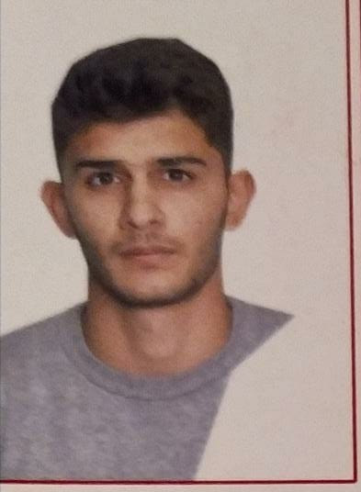
Surname | ALIYEV
Name | SHAHIN
Patronymic | AGAVERDI
Citizenship | Azerbaijan
Date of birth | 11.10.2000
Place of birth | Azerbaijan
Gender | Male
Contact Information
Home Address | BAKU city ELET township
Phone / e-mail | tell: me +994 70 837 63 43 / +994 70 883 69 84  e-mail: Liyevsahin88 @ gmail .com
Bio Data
Hair colour / Eyes | Black / Chestnut |  | Shoes | 42
Height / Weight | 178 cm / 65 kg |  | Boiler suit | S

Passports / Visas

Title | Document № | Authority | Issue | Expiry
Seaman’s book | DQK 019317 AZE024234 | azerbaijan, baku | 16/02/2022 | 16/02/2027
Travel Passport (biometrical) | AZE C03387957 | azerbaijan | 20/11/2021 | 19/11/2031
USA VISA (C1 / D)

certificate of competency (COC)

Title | Document № | Authority | Issue | Expiry
Able seafarer engine | 0171/22 | Azerbaıjan admistiration | 04/02/2022 | N/A

BASIC CERTIFICATES STCW 95

Title | Certificate № | Country | Issue | Expiry
International Safety Management | SP-1192-21 | Azerbaıjan admistiration | 13/07/2021 | 06/07/2026
Training for seafarers with designated security duties (STCW Code, A-VI/6, Pa.6 to Pa.8.) | SH-0545-21 | Azerbaıjan admistiration | 30/07/2021 | 23/07/2026

Ship Security-related familiarization security-awareness training (STWC Code, A-VI/6, Pa.1 to Pa.4.) | SI-0727-21 | Azerbaıjan admistiration | 15/07/2021 | 07/07/2026
Proficiency in survival craft and boats other than fast rescue boats (STWC Code, A-VI/2 Pa.1, Pa.2, Pa.3 and Pa.4) | SL-1229-21 | Azerbaıjan admistiration | 12/08/2021 | 12/08/2026
-personal survival techniques (STWC-78, A-VI/1-1)  -fire prevention and fire fighting (STWC-78, A-VI/1-2)  -elementary first aid (STWC-78, A-VI/1-3)  -personal safety and social responsibilities (STWC-78, A-VI/1-4) | SO-1872-21 | Azerbaıjan admistiration | 06/08/2021 | 02/08/2026

Medical Examination (accepted as equivalent to the UK’s ENG1 medical certificate) | Issue  22/09/2022 | Expiry  22/09/2024
Medical

Seagoing Experience

Vessel | Company | Type of vessel | Flag | DWT | GRT | Rank | Sign on | Sign off
SABIT ORUCOV | ASCO | PASSENGER  SHIP | AZERBAIJAN | 549 | 2621 | OİLER | 29.02.2021 | 22.11.2021
CƏFƏR CABBARLI 1977 | ASCO | GENERAL CARGO | AZERBAİJAN | 5000 | 3900 | OILER | 15.12.2021 | 9.05.2022
M/V AMANOS | CONCERDE SHİPPİNG | GENERAL CARGO | PALAU | 2218.8 | 1589 | OİLER | 22.06.2022 | 23.02.2023
a

