PERSONAL DETAİLS |  |  |  |  | 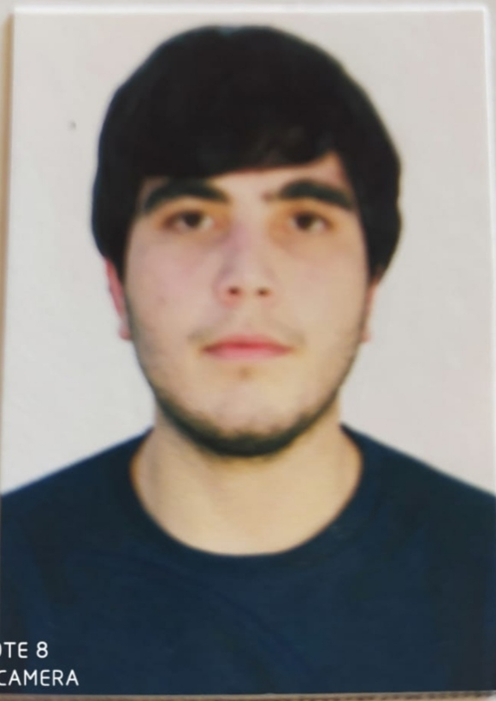
Name Surname | Sakhavat Mammadov
Date of birth , place | 03.04.2002 Salyan-Azerbaijan
Military stasus | No
Marital status | Single
Nationality | Azerbaijan citizen
Capacity | Seaman
CONTACT İNFORMATİON
RESİDANCE ADRESS | Azerbaijan/Absheron/Shabran
PHONE NUMBER | +90 535 563 14 78 |  | E-mail Adress | saxavatmammad@gmail.com
EDUCATİON
 | Astarkhan state tehnical university
SEAMAN İNFORMATİON
Passport no | C03303663 | Expiry Date : |  |  |  | 07.04.2033
Seaman’s Book No | DQK 018598 | Expiry Date |  |  |  | 15.10.2026
Medical examination |  | Expiry Date :
COVİD VACCİNATİON | SİNOVAC (FULLY VACCİNATED AGAİNST COVİD-19 TWO TİMES )
Yellov fever |  | Expiry Date :
Foreign Language Knowledge
Native Language | Turkish
Turkish Language
  Speaking | Writing | Reading
  A2 | A2 | A2
Russian Language
  Speaking | Writing | Reading
  B1 | B1 | B1
 |  | CERTİFİCATE NO | RANK | İSSUE DATE | EXPİRY DATE
1 | Basic safety training and instruction | AB No 1739311 | Ordinary seaman | 10.08.2021 | 10.08.2026
2 | Security training forseafarers with designated security duties | AB No1552067 | Ordinary seaman | 21.09.2021 | 21.09.2026
3 | Basic training for oil and chemical tanker | AB No1551683 | Ordinary seaman | 20.08.2021 | 20.08.2026
4 | At the Center for Profesional Training and advanced training | No 11-M2/20 | Ordinary seaman | 19.09.2021 | unlimit
5 | Preparation pf the sailor of the watch | No 03-VM/22 | Ordinary seaman | 02.03.2022 | Unlimit

Sea Service
Name of Vessel | Rank | Type of Vessel | DWT | Period of services  From to Duration |  |  | Name of Owner | Flag
Star-N | Ordinary seaman | Roro-Passanger |  | 12.07.2022 | 30.03.2023 | 262 days |  | PALAU

NOT:1983 yilindan 2006 yilina kadar Azerbaycan Devlet Deniz Sirketinin tanker gemilerinde calistim.

References
Name | Company / Rank | Rank | Phone

