 |  |  |  |  |  |  |  |  | 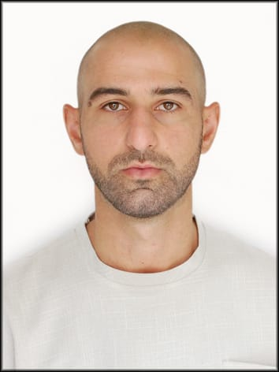

Application Form

Position
Position Applied for |  | Motorman
Lowest Position Acceptable |  | Motorman / Trainee
Date of Availability |  | Any time
Personal Details
Surname |  | Amrahov
Given Name |  | Subhan
Date & Place of Birth |  | Date: 07.12.1995 Place: Azerbaijan, Sumgayit
Nationality |  | Azerbaijan
Permanent Address |  | Azerbaijan, Masalli
Present Address |  | Azerbaijan, Masalli
PPE information |  | SAFETY SHOES SIZE |  |  | 42 |  | COVERALL SIZE |  |  |  | 48
Mobile Number |  | +994 51 362 48 47
WhatsApp Number |  | +994 51 362 48 47
Email Address |  | Subhanemrah044@gmail.com
Nearest Airport (and Distance) |  | Haydar Aliyev Baku International (GYD)
Passport and VISA details
Country of Issue |  | Azerbaijan / Baku
Date Issued |  | 19.04.2023
Place Issued |  | Azerbaijan
Passport Number |  | C03168160
Passport –Expires |  | 18.04.2033
Seaman book / Seaman Record Book
Issuing Country & Place |  | Azerbaijan |  |  |  | Date Issued |  |  |  | 01.06.2023
Number |  | DQK 023954 |  |  |  | Expiry Date |  |  |  | 01.06.2028
Next of Kin
Full Name / Relationship |  | Amrahov Valeh / Father
Address |  | Azerbaijan, Masalli
Contact Numbers |  | +994 50 386 63 93
STCW95 Highest Certificate of Competency
Class / Grade/Capacity | Issuing Country |  | Certificate No. | Date Issued |  | Expiry |  | Details of Limitations
Rating forming part of an engine room watch | Azerbaijan |  | 1206/23 | 17.05.2023 |  | 17.05.2033 |  | None
STCW95 related Courses Attended and Certificates Obtained
Name of Course / Certificate |  | STCW Code |  | Place |  | Issue Date |  | Cert No |  |  | Expiry Date
Mandatory minimum requirements for familiarization, basic safety training and instruction for all seafarers |  | A-VI/1-1,  A-VI/1-2, A-VI/1-3, A-VI/1-4 |  | Baku,  Azerbaijan |  | 16.01.2023 |  | SO-0174-23 |  |  | 11.01.2023
Proficiency in survival craft and boats oter than fast rescue boats |  | А-VI/2-1,2,3,4 |  | Baku,  Azerbaijan |  | 16.01.2023 |  | SL-0136-23 |  |  | 16.01.2023
International safety Management Code |  | SOLAS IX |  | Baku,  Azerbaijan |  | 19.01.2023 |  | SP-0126-23 |  |  | 18.01.2028
Ship Security-related training and instructing |  | А-IV/6, 1-4 |  | Baku,  Azerbaijan |  | 17.01.2023 |  | SI-0086-23 |  |  | 12.01.2028
Training for seafarers with designated security duties |  | А-IV/6-2 |  | Baku,  Azerbaijan |  | 24.01.2023 |  | SH-0152-23 |  |  | 24.01.2028
Medical History
 |  |  |  |  |  |  |  | YES |  |  | NO
Have you ever signed off a ship due medical reason? |  |  |  |  |  |  |  |  |  |  | x
Have you undergone any medical operations in past? |  |  |  |  |  |  |  |  |  |  | x
Have you consulted a doctor during the past 12 months for an illness / Accident |  |  |  |  |  |  |  |  |  |  | x
Do you have any health or disability problem now? |  |  |  |  |  |  |  |  |  |  | x

If answer to any of above is YES then give further details below or on a separate sheet
General
 |  |  |  |  |  |  |  | Yes |  |  | No
Have you ever been the subject of a court of enquiry or involved in a maritime accident |  |  |  |  |  |  |  |  |  |  | x
Have you ever had a professional licence suspended or revoked |  |  |  |  |  |  |  |  |  |  | x
Have you ever been convicted of any criminal offence? |  |  |  |  |  |  |  |  |  |  | x
Have you ever been dismissed |  |  |  |  |  |  |  |  |  |  | x
If yes to any of above then please full details below or on separate sheet of paper

SEA EXPERIENCE (LAST 5 YEARS – MOST RECENT EXPERIENCE ON TOP LINE)

Vessel | Company | Type of vessel | Flag | DWT | GRT | BHP | Rank | Sign on | Sign off

