APPLICATION FORM

NAME AND SURNAME | ISMAYIL MURADKHANLI |  | 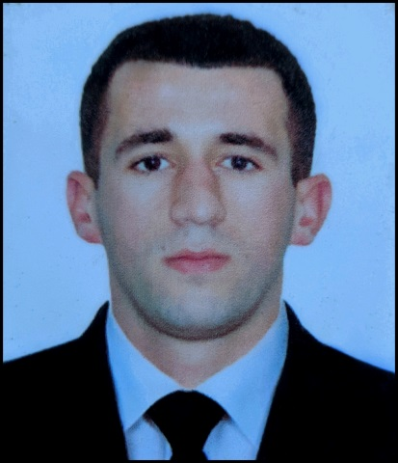
DATE OF BIRTH | 27.04.1996 AZERBAIJAN, ISMAYILLI
ADDRESS OF RECIDENCE | AZERBAIJAN, ISMAYILLI
NEAR OF AIRPORT | AZERBAIJAN BAKU, HAYDAR ALIYEV INTERNATIONAL AIRPORT
NEXT OF KIND | BROTHER: BABAYEV ELCHIN
RELATIONSHIP CONTACT | + 994 50 870 49 70 ( WHATSAPP BROTHER)
HOME ADDRESS | AZERBAIJAN, ISMAYILLI
HEIGHT | WEIGHT | COVERALL SIZE | SHOES SIZE
173 | 70KG | S (SMALL SIZE) | 41 (EUR)

CONTACT DETAILS
MY PHONE NUMBER | E_MAIL ADDRESS | WEB_ADDRESS
PHONE AND WHATSAPP: +994 51 410 21 28 | ismayilmuradxanli@gmail.com | PHONE (MOBILE): +90 535 829 61 01 (24 HRS WHATSAPP)

MARITIME EDUCATION
NAME OF SCHOOL | TOWN | COUNTRY | FROM | TO | DIPLOMA
AZERBAIJAN STATE MARITIME ACADEMY | BAKU | AZERBAIJAN | 15.09.2013 | 29.06.2017 | BACHELOR

COMPUTER SKILLS
WINDOWS | EXCELL | WORD | PHOTOSHOPS | OFFICE
GOOD | GOOD | GOOD | GOOD | GOOD

LANGUAGE KNOWLEDGE
ENGILSH | RUSSIAN |  | TURKISH |  | AZERBAIJAN
INTERMEDIATE | ELEMENTARY |  | FULIENT |  | MOTHER LANGUAGE
TRAVEL PASSPORT
NUMBER |  | ISSUES PLACE |  | PASSED |  | VALID
C02202928 |  | AZERBAIJAN, BAKU / MINISTRY OF INTERNAL AFFAIRS |  | 19.12.2018 |  | 18.12.2028

SEAMAN BOOK
NUMBER | ISSUES PLACE | PASSED | VALID
DQK023771 | AZERBAIJAN STATE MARITIME ADMINISTRATION | 19.05.2023 | 19.05.2028

ID CART
NUMBER | ISSUES PLACE | PASSED | VALID
AZE028639 | AZERBAIJAN STATE MARITIME ADMINISTRATION | 19.05.2023 | 19.05.2028

MEDICALL FITNESS
TOWN / COUNTRY PASSED | UNIKLINIKA MEDICAL CENTER | PASSED | VALID
AZERBAIJAN, BAKU | INTERNATİONAL MEDİCAL EXAMİNATİON | 13.04.2023 | 13.04.2025

OFFICER IN CHARGE
NUMBER | ISSUES PLACE | PASSED | VALID
0007822 | AZERBAIJAN STATE MARITIME ADMINISTRATION | 11.05.2023 | 11.05.2028

A/B DIPLOMA
NUMBER | ISSUES PLACE | PASSED | VALID
RP07891 | AZERBAIJAN STATE MARITIME ADMINISTRATION | 19.12.2018 | 19.12.2028

CERTIFICATES
DOCUMENT | NUMBER | ISSUES PLACE | PASSED | VALID
RADAR, ARPA, BRIDGE TEAMWORK AND SEARCH AN RESCUE(MANEGMENT LEVEL) | SQ-0054-23 | AZERBAIJAN STATE MARITIME ADMINISTRATION | 24.01.2023 | 09.01.2028
GMDSS GENERAL OPERATOR | DQ-026-23 | AZERBAIJAN STATE MARITIME ADMINISTRATION | 31.01.2023 | 31.01.2028
MEDICAL FIRST AID | SN-0096-23 | AZERBAIJAN STATE MARITIME ADMINISTRATION | 27.01.2023 | 27.01.2028
BRIDGE RESOURCE MANAGMENT | SW-0012-23 | AZERBAIJAN STATE MARITIME ADMINISTRATION | 23.01.2023 | 23.01.2028
LEADERSHIP AND TEAMWORK | DL-0041-23 | AZERBAIJAN STATE MARITIME ADMINISTRATION | 30.01.2023 | 30.01.2028
OPERATIONAL USE OF ELECTRONIC CHART DISPLAY AND INFORMATION SYSTEMS(ECDIS) | SZ-0023-23 | AZERBAIJAN STATE MARITIME ADMINISTRATION | 25.01.2023 | 25.01.2028
TRAINING IN ADVANCED FİRE FİGHTİNG | SJ-0418-22 | AZERBAIJAN STATE MARITIME ADMINISTRATION | 15.04.2022 | 15.04.2027
SHIP SECURITY – RELATED TRAINING AND INSTRUCTION | SI-0640-22 | AZERBAIJAN STATE MARITIME ADMINISTRATION | 06.04.2022 | 04.04.2027
PROFİCİENCY İN SURVİVAL CRAFT AND RESCUE BOATS | SL-0511-21 | AZERBAIJAN STATE MARITIME ADMINISTRATION | 23.04.2021 | 23.04.2026
INTERNATIONAL SAFETY MANAGEMENT CODE | SP-0433-21 | AZERBAIJAN STATE MARITIME ADMINISTRATION | 20.04.2021 | 20.04.2026
BASİC TRAİNİNG AND QUALİFİCATİONS ON OİL AND CHEMİCAL TANKER CARGO OPERATİONS | SA-0105-21 | AZERBAIJAN STATE MARITIME ADMINISTRATION | 16.04.2021 | 19.03.2026
DANGEROUS, HAZARDOUS AND HARMFUL CARGOES | SK-0142-21 | AZERBAIJAN STATE MARITIME ADMINISTRATION | 13.04.2021 | 13.04.2026
BASİC TRAİNİNGS | SO-0301-20 | AZERBAIJAN STATE MARITIME ADMINISTRATION | 11.02.2020 | 11.02.2025
TRAINING FOR SEAFARERS WITH DESIGNATED SECURITY DUTIES | SH-0019-19 | AZERBAIJAN STATE MARITIME ADMINISTRATION | 04.01.2019 | 25.12.2023

SIGNATURE: 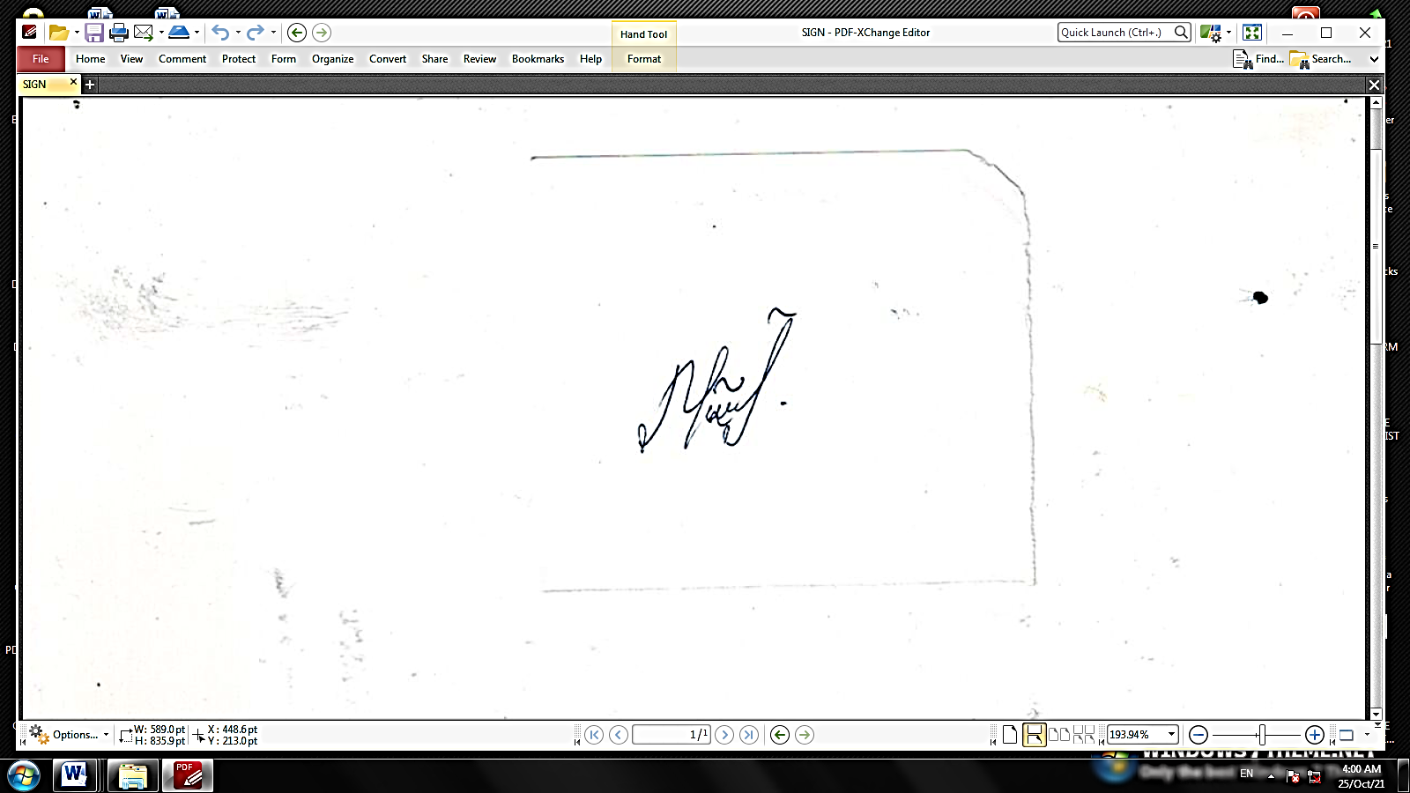

SEA SERVICE

NAME OF VESSEL | FLAG | COMPANY | VESSEL’STYPE | DWT | RANK | FROM D/M/Y | TO  D/M/Y | TOTAL  M/D
PROFESSOR GUL | AZERBAIJAN | ASCO | PASSENGER/RO-RO | 2300 | DECK CADET | 18.06.2014 | 30.09.2014 | 3MONTH
NEFTEGAZ-64 | AZERBAIJAN | ASCO | OFFSHORE(OSV) | 1393 | DECK CADET | 01.06.2015 | 15.09.2015 | 3MONTH
ALI AMIROV | AZERBAIJAN | ASCO | OFFSHORE(DSV) | 396 | DECK CADET | 22.06.2016 | 21.09.2016 | 3MONTH
SABIT ORUJOV | AZERBAIJAN | ASCO | PASSENGER | 549 | DECK CADET | 26.01.2017 | 20.04.2017 | 3MONTH
m/v ATLAS | MALTA | ATLAS | GENERAL CARGO | 5418 | ABLE SEAMAN | 18.02.2019 | 10.09.2019 | 7 MONTH
m/v SAVA | VANUATU | KAMER MARINE | GENERAL CARGO | 9679 | ABLE SEAMAN | 29.07.2020 | 07.04.2021 | 9 MONTH
m/t UNI TRADER | PANAMA | ADMR SHIPPING LTD | TANKER | 6623 | ABLE SEAMAN | 26.07.2021 | 04.02.2022 | 6 MONTH
m/t ALİ NAJAFOV | LİBERİA | PALMALI HOLDING | TANKER | 6620 | ABLE SEAMAN | 30.06.2022 | 23.01.2023 | 7 MONTH
m/t BEAUTY QUEEN | CAMEROON | DORIAN SHIPMANEGMENT | TANKER | 4282 | SECOND OFFICER | 25.05.2023 | 05.08.2023 | SİRKET PARA VERMEDİYİNDEN DOLAYI ENDİM

