CURRICULUM VITAE
PERSONAL DETAILS
Family name |  | ALIYEV |  |  | 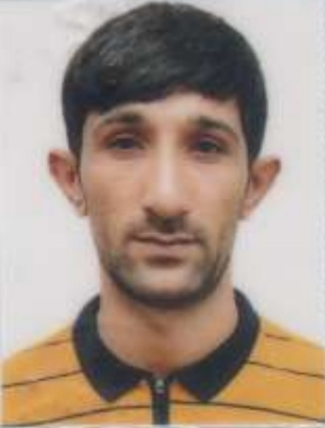
First name |  | SHAHMAR
Father’s name |  | ZABİL
Date and place of birth |  | 04.10.1992 Azerbaijan
Nationality |  | Azerbaijani
Marital status |  | No
Permanent address |  | Azerbaijan,BAKI
Nearest airport |  | Heydar Aliyev International Airport Baku, Azerbaijan
Height (cm) | Weight (kg) | Eyes color | Hair color | Size of safety shoes | Size of coveralls
173 cm | 70 kg | BROWN | BLACK | 42 | 52
CONTACT DETAILS
Mobile | E-mail address
+994775413300
NEXT OF KIN (FOR EMERGENCY)
Next of kin |  | Relationship | Brother
Date of birth |  | Address | Baku,Azerbaijan
Phone |  | Mobile phone | +994505767257
TRAVEL PASSPORT DETAILS
Document | Number | Place of Issue | Issued | Valid
PASSPORT | C04014912 | Azerbaijan | 27.04.2022 | 26.04.2032
SEAMAN’S BOOK DETAILS
Document | Number | Place of Issue | Issued | Valid
Seaman book | DGK019793 | Azerbaijan ,Baku | 14.04.2022 | 14.04.2027
SEAARERS IDENTITY | AZE024709 | Azerbaijan ,Baku | 14.04.2022 | 14.04.2027
EDUCATION
Full name of School | Place of Issue | Grade/Class | From | To
Azerbajan Marine Akademiy | Azerbaijan , Baku | ELECTRO-TECHNICAL RATING 15.03.2022 | 15.03.2022
KNOWLEDGE OF LANGUAGES
Languages | Speaking | Reading | Writing
Azerbaijan | excellent | Excellent | Excellent
Russian | excellent | Excellent | Excellent
Turkish | excellent | Excellent | Excellent
COMPUTER SKILLS
Windows | Microsoft Office | Internet
Excellent | Excellent | Excellent
MEDICAL INFORMATION
Document | Grade | Place of issue | Date of issue | Date of expiry
Med.Sertificate | A/B | Azerbaijan | 15.02.2022 | 15.02.2024
CERTIFICATE OF COMPETENCY
Class/Grade | Issuing country | Certificate No. | Date issued | Expires | Details of Limitations
ELECTRICIAN | Azerbaijan Marine Administration | ELECTRO-TECHNICAL RATING 0498/22 | 15.03.2022 |  | A-III/7
STCW AND OTHER CERTIFICATES
Name of course/Certificate | Institute | Place | Date of issue | Cert.No | Date of expiry
International Safety Management | Azerbaijan Marine Adminstration | Azerbaijan Baku | 02.03.2022 | SP-0490-22 | 02.03.2027
Proficiency in survival craft and boats other than fast rescue boats | Azerbaijan Marine Adminstration | Azerbaijan Baku | 28.02.2022 | SL-0387-22 | 28.02.2027
Training for seafarers with designated security duties | Azerbaijan Marine Adminstration | Azerbaijan Baku | 24.02.2022 | SH-0361-22 | 24.02.2027
Basic safety trainig | Azerbaijan Marine Adminstration | Azerbaijan Baku | 24.02.2027 | S0-0803-22 | 21.02.2027
Ship Security-related familization security-awareness | Azerbaijan Marine Adminstration | Azerbaijan Baku | 24.02.2022 | SI-0361-22 | 24.02.2027
SEA EXPERIENCE (LAST 5 YEARS – MOST RECENT EXPERIENCE ON TOP LINE)
Vessel | Company | Type of vessel | Flag | DWT | GRT | BHP | Rank | Sign on | Sign off
M/V SHAIR SABIR | CASPIAN SHIPPING | GEN CARGO | AZERBAIJAN | 4876 | 4532 | 1150x2 | ELECTRICIAN | 22.09.2021 | 15.04.2022
M/V ARSLANBEY | CUNDA SHİPPİNG | GEN CARGO | Panama | 3332 | 2980 | 2x515 | ELECTRİCİAN | 28.05.2022 | 20.05.2023

