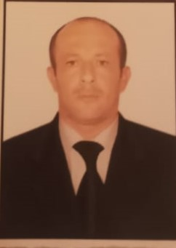
APPLICATION FORM
Name/ Surname : Khalilov Elshan Farhad
Place/Date of birth: Azerbaijan /Gazakh 04.03.1985
Address/Contacts: Azerbaijan /Aghstafa region/ Hasansu village
Azerbaijan. Wp +994556072719
Education: “Caspian Education Center”LLC
TRAVEL DOCUMENTS:
Description | No | Date of issued | Date of expire
Passport | AZE P5380079 | 14.08.2013 | 11.10.2023
Seaman’s book | DQK 018162 | 13.08.2021 | 13.08.2026
Seaman’s ID | AZE 023086 | 13.08.2021 | 13.08.2026

COURSES:
Description | Issued on | Valid until | Certif. No:
1.Training for seafarers with designated security duties  (STCW code, A-Vl/6, Pa.6 to Pa. 8) | 13.12.2021 | 09.02.2026 | SH-1248-21
2.-safety familiarization training (STCW code, A-Vl/1-1)  -personal survival techniques A-Vl/1-2.1.1)  -fire prevention and firefighting A-Vl/1-2.1.2)  -elementary first aid A-Vl/1-2.1.3)  -personal safety and social responsibilities A-Vl/1-2.1.4) | 08.12.2021 | 07.12.2026 | SO-3344-21
3.ISM-Chapter lX of SOLAS-74 | 09.12.2021 | 09.12.2026 | SP-2257-21
4.Proficiency in survival craft and boats other than fast rescue boats (STCW code, A-Vl/2, Pa 1 to Pa. 4) | 21.12.2021 | 17.12.2026 | SL-2316-21
5. Ship security related familiarization security-awareness training (STCW code, A-Vl/6, Pa 1 to Pa. 4) | 10.12.2021 | 10.12.2026 | SI-1562-21

SEA SERVICE RECORD:
Position | Vessel | Flag | DWT | Type | Period | Company

Language skills:
Language | Reading | Writing | Listening | Speaking
Azerbaijani | Excellent | Excellent | Excellent | Excellent
Russian | Beginner | Beginner | Beginner | Beginner
English | Beginner | Beginner | Beginner | Beginner
Turkish | Excellent | Excellent | Excellent | Excellent

KEY SKILLS AND COMPETENCE:
-Very organized, patient, accurate and attentive to detail.
-Team player, it is easy to adapt and work with people of different cultural backgrounds.
-Good welder and plumber.

