CURRICULUM VITATE

Matorman  Name in full: Babayev Elshad |  | Nationality:AZERBAIJAN |  |  | 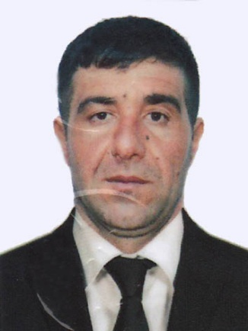
Languages;
AZERBAIJAN , RUSSIAN, TURKISH
 |  | Marital status; Married
Date& place of birth; 20.06.1988 AZERBAIJAN |  | Next of Kin;
Present adress; AZERBAIJAN , LENKARAN  Mobile phone : (+99450) 411-05-82  E-mail; belsad22@gmail.com  Nearest airport; BAKU/AZERBAIJAN |  | Name Relationship;  Address ; My brother  Mobile phone : (+99450) 593-34-44
 |  |  |  |  | Height; 176 cm
 |  |  |  |  | Weight; 70kg
Educational history:
English level; 4=B.SATISFACTORY
SEMANS IDENTIFICATON CARD | AZE027807 |  | 10.03.2023 | BAKU/AZERBAIJAN |  | 10.03.2028
PASSPORT TRAVEL AZERBAIJAN | C03167527 |  | 13.04.2023 | BAKU/AZERBAIJAN |  | 12.04.2033

LICENSE | Grade of License | Number | Date  issued | Place Issued | Exp. Date
National | Matorman electrician | RP12550 | 27.02.2023. | BAKU/AZERBAIJAN

CERTIFICATES | Number | Date Issued | Place Issued | Exp.Date
SHIPS SECURITY-RELATED FAMILIARIZATION SECURITY-AWARENESS TRAINING | SI-2318-22 | 22.09.2022 | BAKU/AZERBAIJAN | 22.09.2027.
TRAINING FOR SEFARERS WITH DESINGNATED SECURITY DUTIES | SH-2287-22 | 17.11.2022. | BAKU/AZERBAIJAN | 17.11.2027
INTERNATIONAL SAFETY MANAGEMENT CODE | SP-3408-22 | 15.11.2022. | BAKU/AZERBAIJAN | 15.11.2027.
PROFICIENEY INSURIVAL CRAFT AND BOATS OTHER THAN FAST RESCUE BOATS | SL-3683-22 | 21.11.2022. | BAKU/AZERBAIJAN | 21.11.2027.
- SAFETY FAMILIARIZATION TRAINING  - PERSONAL SURVIVAL TECHNIQUES  - FIRE PREVENTION AND FIRE FIGHTING  - ELEMENTARY FIRST AID  - PERSONAL SAFETY AND SOCIAL RESPONSIBILITIES | SO-4312-22 | 21.09.2022. | BAKU/AZERBAIJAN | 21.09.2027.
SEAFARERS MEDICAL CERTIFICATE | NUMBER  13649916 | 18.08.2022. | BAKU/AZERBAIJAN | 18.08.2024
Seaaman s Personal Record | DQK  022937 | 10.03.2023. | BAKU/AZERBAIJAN | 10.03.2028.

PREVIOUS SEA SERVICE:

Vessel`s  name | Type of vessel | DWT | flag | Company`s name | Rank | Period  From - To
M/V QARADAG | GENERAL CARGO | 3048 Ton | AZERBAIJA N | ASCO | OILER ELECTRICIAN | 01.03.2023  25.05.2023

