Application / CV for Employment

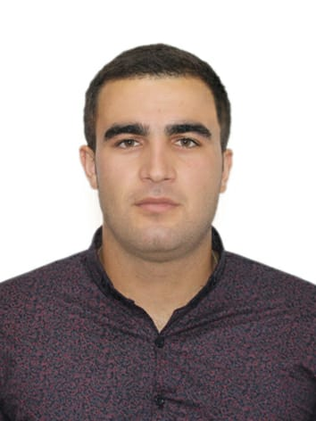
Name : EMIN
Surname: ALIBAYLI
Father’s Name: ETIRAM
Position: Officer Of The Watch

Date of Birth: 01.01.1996
Height: 185 Weight: 90 Eyes: Brown
Home address: Azerbaijan. Qobustan

Mobile Phone: 0099 470 6027184
Home Phones: 0099 451 4844460

E-mail: emincalov@gmail.com
Marital status: Single
Next of kin: Address Azerbaijan. Qobustan

JAFAROVA XALIDE(Mother) JAFAROV ETIRAM (Father)

Language skills: Azerbaijani : Native

English : Fluent (also Including Maritime terms)

Turkish : Fluent

Education: Diploma #:Grade: What was graduated Place

Academy | C No: 003448 | Good | Azerbaijan State Marine Academy | Baku

DOCUMENTS:Number:Issued on:Valid till:Place of Issue:
Passport | C02412810 | 30.08.2019 | 29.08.2029 | DIN Baku
Seaman’s BOOK | DQK 015739 | 22.01.20 | 22.01.25 | Baku SMA

CERTIFICATES:

Certificate of Competency: | 0007308 | 12.112021 | 12.11.2026 | SMA. Baku
Endorsement: Officer in Charge of Navigational Watch on ships of 500  Gross Tonnage or more | 0007308 | 12.11.2021 | 12.112026 | SMA. Baku
International Safety Management Code Certificate | SP-0178-20 | 11.02.2020 | 11.02.2025 | SMA. Baku
Training for Seafarers with designated security duties | SH-0108-20 | 09.02.2020 | 07.02.2025 | SMA. Baku
Radar Navigation, radar plotting and use of ARPA | SR-0023-18 | 09.03.2018 | 09.03.2023 | SMA. Baku
Operational Use of Electronic Chart Display and information Systems | SZ-0113-18 | 13.03.2018 | 13.03.2023 | SMA. Baku
GMDSS General Operator | DQ-0089-18 | 07.03.2018 | 07.03.2023 | SMA. Baku
Medical First Aid | SN-0697-21 | 30.09.2021 | 27.08.2026 | SMA. Baku
Training in Advance Fire Fighting | SJ-0829-21 | 27.09.2021 | 14.09.2026 | SMA. Baku
Proficiency in Survival Craft and boats other than fast rescue boats | SL-0093-20 | 27.01.2020 | 27.01.2025 | SMA. Baku
Personal Survival techniques | SO-0172-20 | 29.01.2020 | 29.01.2025 | SMA. Baku
Elementary First Aid | SO-0172-20 | 29.01.2020 | 29.01.2025 | SMA. Baku
Fire Prevention and Fire Fighting | SO-0172-20 | 29.01.2020 | 29.01.2025 | SMA. Baku
Personal Safety and Social Responsibilities | SO-0172-20 | 29.01.2020 | 29.01.2025 | SMA. Baku
Bridge Resource Management | SW-0403-21 | 01.10.2021 | 01.10.2026 | SMA. Baku
Leadership and Teamwork | DL-0960-21 | 27.09.2021 | 07.09.2026 | SMA. Baku

Medical Certificate: | 17661826 | 04.10.2021 | 04.10.2023 | Azerbaijan State Maritime Hospital

VESSEL | COMPANY | Type of Vessel | DWT or GRT | RANK | Sign on DATE | Sign off DATE
 |  |  |  |  | dd / mm / yy | dd / mm / yy
Azerbaijan | Azerbaijan Shipping Company(ASCO | Ro-RO | 5000 | Deck Cadet | 01.06.15 | 23.08.15
ZULFU HACIYEV | Azerbaijan Shipping Company(ASCO | CRANE VESSEL | 457 | Deck Cadet | 06.06.16 | 21.09.2016
M.V ANT | MAXSIMAR DENIZCILIK LTD | GENERAL CARGO | 5095 | Officer Nav.Watch | 23.03.2021 | 15.09.2021
T/G NEFTEQAZ-58 | Azerbaijan Shipping Company(ASCO) | Ferry | 11450 | Deck Cadet | 22.06.2017 | 22.09.2017
PROFESSOR GUL | Azerbaijan Shipping Company(ASCO) | RO-RO | 5000 | Deck Cadet | 24.01.2018 | 26.05.2018
M.V ANT | MAXSIMAR DENIZCILIK LTD | GENERAL CARGO | 5095 | A/B SEAMAN | 01.08.2020 | 22.03.2021
M.V VOLGO DON 207 | SALUTA SHIPPING LIMITED | GENERAL CARGO | 5338.88/  3991 | OFFICER  NAV.WATCH | 03.12.2021 | 08.07.2022

