CURRICULUM VITAE
PERSONAL DETAILS
Family name |  | GULIYEV |  |  | 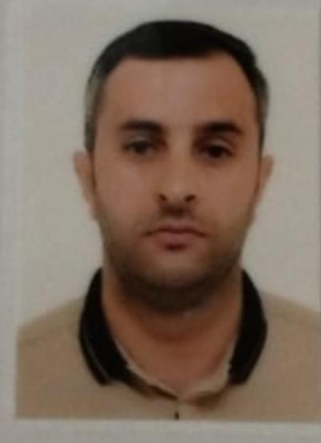
First name |  | RAFAT
Father’s name |  | MAZAHIR
Date and place of birth |  | 21.07.1986
Nationality |  | Azerbaijan
Marital status |  | Married
Permanent address |  | Azerbaijan, Jalilabad
Nearest airport |  | Heydar Aliyev International Airport Baku, Azerbaijan
Height (cm) | Weight (kg) | Eyes color | Hair color | Size of safety shoes | Size of coveralls
1.65 cm | 70 kg | BROWN | BLACK | 42 | XL
CONTACT DETAILS
Mobile | E-mail address
+99455 214 32 13  Watcaap | Rafedquluzade@gmail.com
NEXT OF KIN (FOR EMERGENCY)
Next of kin | GULIYEV NEHMED | Relationship | Brother
Phone | +99455 308 42 15 | Address | Azerbaijan Jalilabad city F.Ehmedov k
TRAVEL PASSPORT DETAILS
Document | Number | Place of Issue | Issued | Valid
PASSPORT | C00114443 | Azerbaijan | 12.11.2013 | 11.11.2023
SEAMAN’S BOOK DETAILS
Document | Number | Place of Issue | Issued | Valid
Seaman book | DGK021562 | Azerbaijan ,Baku | 05.10.2022 | 05.10.2027
SEAARERS IDENTITY | AZE026428 | Azerbaijan ,Baku | 05.10.2022 | 05.10.2027
EDUCATION
Full name of School | Place of Issue | Grade/Class | From | To
Azerbaycan Deniz Baliq Senaye kolleci | Azerbaijan , Baku | Motorman 54K-77 | 01.02.2007 | 30.09.2007
KNOWLEDGE OF LANGUAGE
Languages | Speaking | Reading | Writing
Azerbaijan | Excellent | excellent | Excellent
Russian | Excellent | excellent | Excellent
Turkish | Excellent | excellent | Excellent
COMPUTER SKILLS
Windows | Microsoft Office | Internet
Excellent | Excellent | Excellent
MEDICAL INFORMATION
Document | Grade | Place of issue | Date of issue | Date of expiry
Med.Sertificate | Engine-room watch | Azerbaijan | 08.08.2022 | 08.08.2027
CERTIFICATE OF COMPETENCY
Class/Grade | Issuing country | Certificate  No.2038/22 | Date issued | Expires | Details of Limitations
Engine-room  Watch | Azerbaijan Marine Administration | RP-11783 | 14.09.2022 | No limit | A-3/4
STCW AND OTHER CERTIFICATES
Name of course/Certificate | Institute | Place | Date of issue | Cert.No | Date of expiry
International Safety Managemen | Azerbaijan Marine Adminstration | Azerbaijan Baku | 23.08.2022 | SP-2491-22 | 23.08.2027
Proficiency in survival craft and boats other than fast rescue boats | Azerbaijan Marine Adminstration | Azerbaijan Baku | 24.08.2022 | SL-2479-22 | 22.08.2027
Training for seafarers with designated security duties | Azerbaijan Marine Adminstration | Azerbaijan Baku | 24.08.2022 | SH-1651-22 | 24.08.2027
Basic safety trainig | Azerbaijan Marine Adminstration | Azerbaijan Baku | 16.08.2022 | S0-3375-22 | 15.08.2027
Ship Security-related familization security-awareness | Azerbaijan Marine Adminstration | Azerbaijan Baku | 16.08.2022 | SI-1962-22 | 16.08.2027
SEA EXPERIENCE (LAST 5 YEARS – MOST RECENT EXPERIENCE ON TOP LINE)
Vessel | Company | Type of vessel | Flag | DWT | GRT | BHP | Rank | Sign on | Sign off
TURKAN | XDND | TYG | Azerbaijan | 854 t | 1763 t |  | Engine-room watch | 10.01.2020 | 14.08.2020
YARENQA | XDNE | TUG | Azeebaijan | 910 t | 1585 t |  | Engine-room watch | 15.10.2022 | 15.01.2023

