CURRICULUM VITAE
PERSONAL DETAILS
Family name |  | SAFAROV |  |  | 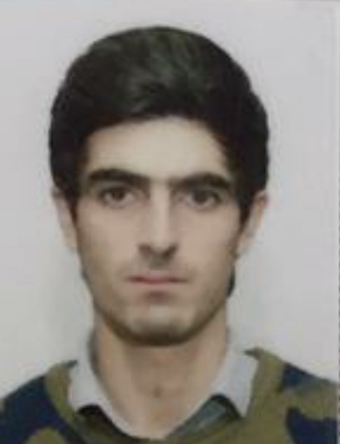
First name |  | JALAL
Father’s name |  | QILMAN
Date and place of birth |  | 13.03.1998 Azerbaijan
Nationality |  | Azerbaijani
Marital status |  | No
Permanent address |  | Azerbaijan, BAKU
Nearest airport |  | Heydar Aliyev International Airport Baku, Azerbaijan
Height (cm) | Weight (kg) | Eyes color | Hair color | Size of safety shoes | Size of coveralls
1.80 cm | 76 kg | BROWN | BLACK | 41 | 48
CONTACT DETAILS
Mobile | E-mail address
+994773794878 | calal.seferov@icloud.com
NEXT OF KIN (FOR EMERGENCY)
Next of kin | Father | Relationship | Brother
Date of birth | 01.02.1969 | Address | Baku,Azerbaijan
Phone | +994 50 723 29 35 | Mobile phone
TRAVEL PASSPORT DETAILS
Document | Number | Place of Issue | Issued | Valid
PASSPORT | C02437611 | Azerbaijan | 06.02.2019 | 05.02.2029
SEAMAN’S BOOK DETAILS
Document | Number | Place of Issue | Issued | Valid
Seaman book | DGK017764 | Azerbaijan ,Baku | 18.06.2021 | 18.06.2026
SEAARERS IDENTITY | AZE022687 | Azerbaijan ,Baku | 18.06.2021 | 18.06.2026
EDUCATION
Full name of School | Place of Issue | Grade/Class | From | To
Azerbajan Marine Akademiy | Azerbaijan , Baku | 0418/21 | 10.06.2021
KNOWLEDGE OF LANGUAGES
Languages | Speaking | Reading | Writing
Azerbaijan | Excellent | Excellent | Excellent
Russian | Elementary | Elementary | Elementary
Turkish | Excellent | Excellent | Excellent
COMPUTER SKILLS
MEDICAL INFORMATION
Document | Grade | Place of issue | Date of issue | Date of expiry
Med.Sertificate | A/B | Azerbaijan | 29.08.2022 | 29.08.2024
CERTIFICATE OF COMPETENCY
Class/Grade | Issuing country | Certificate No. | Date issued | Expires | Details of Limitations
AB SEAMAN | Azerbaijan Marine Administration | 0418/21 | 10.06.2021 | unlımıted | A-II/4
STCW AND OTHER CERTIFICATES
Name of course/Certificate | Institute | Place | Date of issue | Cert.No | Date of expiry
Basic training and qualifications on oil and chemical tanker cargo operations | Azerbaijan Marine Adminstration | Azerbaijan Baku | 17.06.2022 | SA-0364-22 | 17.06.2027
International Safety Management | Azerbaijan Marine Adminstration | Azerbaijan Baku | 29.12.2020 | SP-1269-20 | 29.12.2025
Proficiency in survival craft and boats other than fast rescue boats | Azerbaijan Marine Adminstration | Azerbaijan Baku | 14.12.2020 | SL-1297-20 | 08.12.2025
Training for seafarers with designated security duties | Azerbaijan Marine Adminstration | Azerbaijan Baku | 01.12.2020 | SH-0751-20 | 01.12.2025
Basic safety trainig | Azerbaijan Marine Adminstration | Azerbaijan Baku | 02.02.2021 | S0-0105-21 | 02.02.2025
Ship Security-related familization security-awareness | Azerbaijan Marine Adminstration | Azerbaijan Baku | 28.11.2020 | SI-0818-20 | 27.11.2025
Electric and Gas welder | IST Servıves | Azerbaijan Baku | 08.08.2022 | IST7920EGW235 | unlımıted
SEA EXPERIENCE (LAST 5 YEARS – MOST RECENT EXPERIENCE ON TOP LINE)
Vessel | Company | Type of vessel | Flag | DWT | GRT | BHP | Rank | Sign on | Sign off
ARSLANBEY | SALUTA SHIPPING | G/C | Panama | 3332 | 2980 | 116.03 x 13.43 | A/B | 05.08.2021 | 10.05.2022
VOLGODON 79 | SALUTA SHIPPING | G/C | CAMEROON | 5765 | 3994 | 138,8 x16.5 | A/B | 15.10.2022 | 10.05.2023

