PERSONAL DETAILS
Family name |  | Jafarov |  |  | 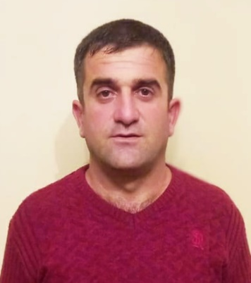
First name |  | Orkhan
Father’s name |  | Rustam
Date and place of birth |  | 14 October 1983 / Azerbaijan
Nationality |  | Azerbaijani
Marital status |  | Married
Permanent address |  | Azerbaijan, Baku city
Nearest airport |  | Haydar Aliyev Airport/Baku, Azerbaijan
Height (sm) | Weight (kg) | Eyes color | Hair color | Size of safety shoes | Size of coveralls
170 | 75 | Brown | Black | 41 | L (50)
CONTACT DETAILS
Mobile | E-mail address
+994 70 449 50 51 | orxanceferliiiii@gmail.com
NEXT OF KIN IN CASE OF EMERGENCY
Next of kin | Jafarova Aydan | Relationship | wife
Address | Azerbaijan, Khacmaz,Khudat
Mobile phone | +994 70 449 50 51
TRAVEL PASSPORT DETAILS
Document | Number | Place of Issue | Issued | Valid
National Travelling Passport | C 03834112 | Ministry of Internal Affairs of Azerbaijan Republic | 27.09.2022 | 26.09.2032
KNOWLEDGE OF LANGUAGES
Languages | Speaking | Reading | Writing
Azerbaijan | native | native | native
Turkish | excellent | excellent | excellent
Russian | excellent | excellent | excellent
MEDICAL INFORMATION
Document | Grade | Place of issue | Last exam | Next exam
Seaman’s Medical Certificate | Health Certificate | Azerbaijan State Maritime Administration | 19.09.2022 | 19.09.2023
STCW AND OTHER CERTIFICATES
Name of course/Certificate | Institute | Place | Date of issue | Cert. No | Date of expiry
Seaman's record book | STCW | Republic of Azerbaijan State Maritime Administration | 22.10.2022 | DQK 021735 | 22.10.2027
Seafarers identity document | STCW | Republic of Azerbaijan State Maritime Administration | 22.10.2022 | AZE026603 | 22.10.2027
Able Seafarer Deck | STCW | Azerbaijan | 14.10.2022 | № RP- 02808 | -----
(STCW-78, A-VI/ 1-1/ 1-2/ 1-3/ 1-4) | STCW | Azerbaijan | 21.09.2022 | № SO-4294-22 | 21.09.2027
Proficiency in survival craft and boats other than fast rescue boats | STCW | Azerbaijan | 19.09.2022 | №SL 2859-22 | 19.09.2027
Training for seafarers with designated security duties | STCW | Azerbaijan | 23.09.2022 | № SH- 1896-22 | 23.09.2027
International Safety Management | STCW | Azerbaijan | 16.09.2021 | № SP 2751-22 | 16.09.2027
Ship Security-related familiarization security-awareness training | STCW | Azerbaijan | 22.09.2022 | № SI- 2261-22 | 22.09.2027
SEA EXPERIENCE (MOST RECENT EXPERIENCE ON TOP LINE)
Vessel | Company | Type of vessel | Flag | Rank | Sign on | Sign off
H-560 | Naval forces of Azerbaijan | Hydrographic vessel | Azerbaijan | Bosman | 03.05.2004 | 05.07.2006
Rusalka | VI-ZA Star | General Cargo | Phonom Penh | Able Seaman | 11.03.2009 | 25.10.2009
Comet | Scarlet Maritime and Trading | General Cargo | Charlestown | Able Seman | 29.12.2009 | 03.03.2010
ST Filip | ROE Shipping Tradingsa | General Cargo | St Filip | Able Seman | 03.03.2010 | 16.06.2010
ST Catrien | ROE Shipping Trading | Geneal Cargo | St Catrien | Able Seman | 16.06.2010 | 12.09.2010
ST Catrien | Vamos Maritime | Genaral Cargo | St Catrien | Bosman | 12.09.2010 | 05.03.2011
H-569 | Naval forces of Azerbaijan | Hydrographic vessel | azerbaijan | Bosman | 17.07.2011

