CURRICULUM VITAE
PERSONAL DETAILS
Family name |  | Huseynov |  |  | 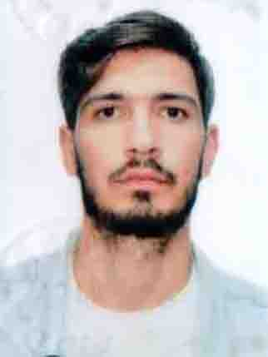
First name |  | Azizagha
Father’s name |  | Insaf
Date and place of birth |  | 26.03.2000, Azerbaijan, Salyan
Nationality |  | Azerbaijani an
Marital status |  | Single
Permanent address |  | Azerbaijan, Baku, Sharifzade Str.
Nearest airport |  | Heydar Aliyev International Airport
Height (cm) | Weight (kg) | Eyes color | Hair color | Size of safety shoes |  | Size of coveralls
193 cm | 76 kg | BROWN | Brown&white | 44 |  | XL
CONTACT DETAILS
Mobile | E-mail address
+99451 308 77 38 | azizhuseynove39@gmail.com
NEXT OF KIN (FOR EMERGENCY)
Next of kin | Rasim | Relationship | Brother
Date of birth | 03.09.1998 | Address | Azerbaijan, Baku, Khatai region, R.baghirov Str. 30
Phone |  | Mobile phone | +99451 857 55 05
TRAVEL PASSPORT DETAILS
Document | Number | Place of Issue | Issued | Valid
PASSPORT |  | Azerbaijan
SEAMAN’S BOOK DETAILS
Document | Number | Place of Issue | Issued | Valid
Seaman book | DQK 021884 | Azerbaijan, Baku | 11.11.2022 | 11.11.2027
SEAARERS IDENTITY | AZE026752 | Azerbaijan, Baku | 11.11.2022 | 11.11.2027
EDUCATION
Full name of School | Place of Issue | Grade/Class | From | To
Azerbaijan Maritime College of Azerbaijan State Maritime Academy | Azerbaijan, Baku | İnstallation of ship machinery and mechanisms, their maintenance (Subbachelor) | 2015 | 2019
KNOWLEDGE OF LANGUAGES
Languages | Speaking | Reading | Writing
Azerbaijan | excellent | excellent | excellent
Turkish | excellent | excellent | excellent
COMPUTER SKILLS
Windows | Microsoft Office | Internet
Good | Good | Excellent
MEDICAL INFORMATION
Document | Grade | Place of issue | Date of issue | Date of expiry
Med. Certificate | Rating forming part of an engine-room watch | Azerbaijan | 04.02.2022 | 04.02.2024
CERTIFICATE OF COMPETENCY
Class/Grade | Issuing country | Certificate No. | Date issued | Expires | Details of Limitations
Rating forming part of an engine-room watch | Azerbaijan Marine Administration | 2395/22 | 31.10.2022 | None | None
STCW AND OTHER CERTIFICATES
Name of course/Certificate | Institute | Place | Cert.No | Date of issue | Date of expiry
International Safety Management | ASMA | Azerbaijan, Baku | SP-0431-22 | 22.02.2022 | 22.02.2027
- Safety familiarization training  - Personal survival techniques  - Fire prevention and fire fighting  - Elementary first aid  - Personal safety and social responsibilities | ASMA | Azerbaijan, Baku | SO-0603-22 | 14.02.2022 | 14.02.2027
Proficiency in survival craft and boats other than fast rescue boats | ASMA | Azerbaijan, Baku | SL-0437-22 | 28.02.2022 | 28.02.2027
Training for seafarers with designated security duties | ASMA | Azerbaijan, Baku | SH-0275-22 | 04.03.2022 | 04.03.2027
Ship Security-related familiarization security-awareness training | ASMA | Azerbaijan, Baku | SI-0429-22 | 02.03.2022 | 02.03.2027
SEA EXPERIENCE (LAST 5 YEARS – MOST RECENT EXPERIENCE ON TOP LINE)
Vessel | Company | Type of vessel | Flag | DWT | GRT | BHP | Rank | Sign on | Sign off

