Cv Form
PERSONAL DETAILS
Family name |  | NIJAT |  |  | 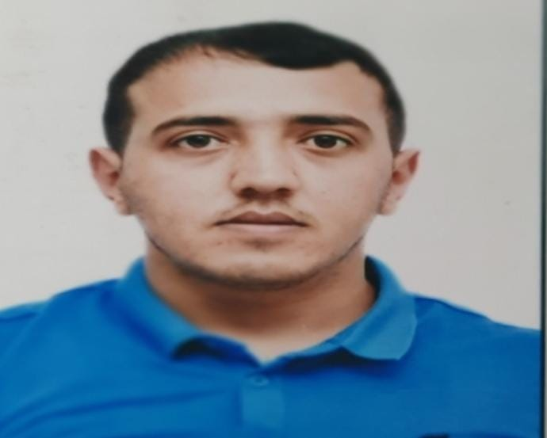
First name |  | BAGHIROV
Father’s name |  | ELMAN
Date and place of birth |  | 13.10.1998
Marital status |  | Single
Permanent address |  | Azerbaijan, Salyan city, Seyidsadigli village
Nearest airport |  | Heydar Aliyev International Airport Baku, Azerbaijan
Height (cm) | Weight (kg) | Eyes color | Hair color | Size of safety shoes | Size of coveralls
171cm | 70kg | BROWN | BLACK | 42 | M
CONTACT DETAILS
Mobile | E-mail address
+994 51 600 58 90  Whatsapp | nicatbagirov434@gmail.com
NEXT OF KIN (FOR EMERGENCY)
Next of kin | BAGHIROV ELMAN | Relationship | Father
Phone | +994 50 681 43 52 | Address | Azerbaijan, Salyan
TRAVEL PASSPORT DETAILS
Document | Number | Place of Issue | Issued | Valid
PASSPORT | C03721797 | Azerbaijan | 30.07.2021 | 29.07.2031
SEAMAN’S BOOK DETAILS
Document | Number | Place of Issue | Issued | Valid
Seaman book | DQK017151 | Azerbaijan ,Baku | 19.02.2021 | 19.02.2026
SEAARERS IDENTITY | AZE022077 | Azerbaijan ,Baku | 19.02.2021 | 19.02.2026

EDUCATION
Full name of School | Place of Issue | Grade/Class | From | To
Kainat Marine College | Azerbaijan , Baku | Oiler | 01.10.2020 | 22.04.2021
KNOWLEDGE OF LANGUAGE
Languages | Speaking | Reading | Writing
Azerbaijan | Excellent | Excellent | Excellent
Turkish | Excellent | excellent | Excellent
English | Average | Average | Average
COMPUTER SKILLS
Windows | Microsoft Office | Internet
MEDICAL INFORMATION
Document | Grade | Place of issue | Date of issue | Date of expiry
Med.Sertificate | Able Seafarer-Engine | Azerbaijan Baku | 20.10.2020 | 20.10.2022
CERTIFICATE OF COMPETENCY
Class/Grade | Issuing country | Certificate | Date issued | Expires | Details of Limitations
Able Seafarer-Engine | Azerbaijan Marine Administration | No:1527/23  Id  No:RP10366 | 03.07.2023 |  | III/5
STCW AND OTHER CERTIFICATES
Name of course/Certificate | Institute | Place | Date of issue | RANK | Cert.No | Date of expiry
International Safety Management | Azerbaijan Marine Administration | Azerbaijan Baku | 07.05.2021 | Able Seaman | SP-0567-21 | 06.05.2026
Proficiency in survival craft and boats other than fast rescue boats | Azerbaijan Marine Administration | Azerbaijan Baku | 08.05.2021 | Able Seaman | SL-0632-21 | 08.05.2026
Training for seafarers with designated security duties | Azerbaijan Marine Administration | Azerbaijan Baku | 05.05.2021 | Able Seaman | SH-0312-21 | 21.04.2026
Basic safety training | Azerbaijan Marine Administration | Azerbaijan Baku | 18.05.2026 | Able Seaman | SO-0809-21 | 18.05.2026
Ship Security-related familiarization security-awareness | Azerbaijan Marine Administration | Azerbaijan Baku | 30.04.2021 | Able Seaman | SI-0290-21 | 19.04.2026

SEA EXPERIENCE (LAST 5 YEARS – MOST RECENT EXPERIENCE ON TP LINE)
Name of vessel | Flag | Vessel’s Type | DWT | Manager or Owner | Rank | Sing on | Sing of
Caspian sea | Azerbaijan | Oil cargon | 4765 | Samaya MMC | Oiler | 27.02.2021 | 20.08.2021
Premier | Comoros | LPG GAS CARRIER 2G | 4512 | PREMIER ENERGY TARDING LTD | Oiler | 30.08.2021 | 27.02.2022
Statü denizcilik | Panama | General cargo | 4900 | Statü Denizcilik | Oiler | 16.05.2021 | 16.09.2022
Statü Denizcilik | Funafuti | General cargo | 5093 | Statü Denizcilik | Oiler | 07.12.2022 | 14.05.2023

