CURRICULUM VITAE

Rank: 1) SEAMAN  Name in full : SAFAROV ELCHİN |  | Nationality: AZERBAIJAN |  |  | 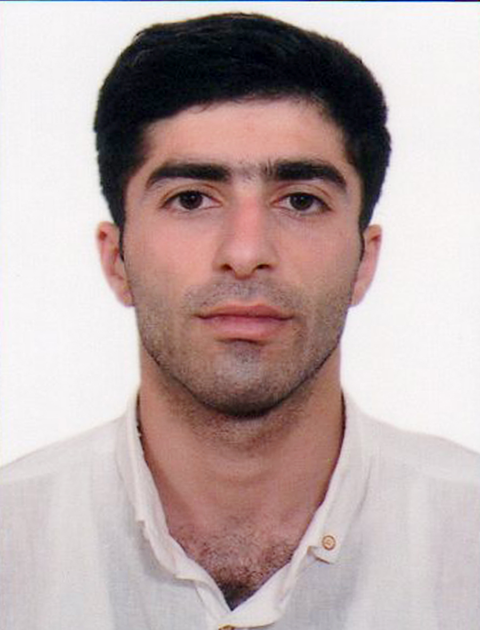
 |  | Languages; ENGLISH(beginner), RUSSIAN, TURKISH
 |  | Marital status; NO
Date & place of birth;  02.10.1997 AZERBAIJAN, BAKU |  | Next of Kin;
Present address; AZERBAIJAN / City of BAKU  Mobile phone : (+99450) 753 00 10  :  E-mail : elcinseferof1997@gmail.com  Nearest airport: BAKU / AZERBAIJAN |  | Name Relationship; ELCAN SAFAROV(Father)  Address ; AZERBAIJAN / City of BAKU
 |  |  |  |  | Height; 168 cm
 |  |  |  |  | Weight; 54 kg
SEAMAN`S BOOK | DQK 020014 |  | 27.04.2022 | BAKU/AZERBAIJAN |  | 27.04.2027
SEAMAN`S BOOK ID CART | AZE 024880 |  | 27.04.2022 | BAKU/AZERBAIJAN |  | 27.04.2027
PASSPORT TRAVEL AZERBAIJAN | C02786257 |  | 10.09.2019 | BAKU/AZERBAIJAN |  | 09.09.2029

CERTIFICATES | STCW Code | Number | Date Issued | Place Issued | Exp.Date
SHIP SECURITY – RELATED familiarization security-awarennes training | A-VI/ 6 | SI-0236-21 | 30.04.2021 | BAKU/AZERBAIJAN | 30.04.2026
TRAINING FOR SEAFARERS WITH DESIGNATED SECURITY DUTIES | A-VI/ 6 | SH-0518-21 | 16.07.2021 | BAKU/AZERBAIJAN | 30.06.2026
INTERNATIONAL SAFETY MANAGEMENT CODE | A-IX | SP-0466-21 | 28.04.2021 | BAKU/AZERBAIJAN | 28.04.2026
PROFICIENCY IN SURVIVAL CRAFT AND BOATS OTHER THAN FAST RESCUE BOATS | A-VI/ 2 | SL-0851-21 | 11.06.2021 | BAKU/AZERBAIJAN | 11.06.2026
SEFARER MEDICAL CERTIFICATE | A-1/9 |  | 17.06.2022 | BAKU/AZERBAIJAN | 17.06.2024
-PERSONAL SURVIVAL TECHNIQUES  -FIRE PREVENTION AND FIRE FIGHTING  -ELEMENTARY FIRST AID  -PERSONAL SAFETY AND SOCIAL RESPONSIBILITIES  -SAFETY FAMILIARIZATION TRAINING | A-VI/1-1  A-VI/1-2  A-VI/1-3  A-VI/1-4  A-VI/1-5 | SO-0706-21 | 04.05.2021 | BAKU/AZERBAIJAN | 26.04.2026

PREVIOUS SEA SERVICE:

Vessel`s  name | Type of vessel | Sailing  Range | Flag | Company`s name | Rank | Period  From = To
A PLUS 1 | GENERAL CARGO | AZOV SEA  BLACK SEA | Vanuatu | YRB SHIPPING | Seaman | 05/08/2022  25/02/2023

