AZERBAIJAN

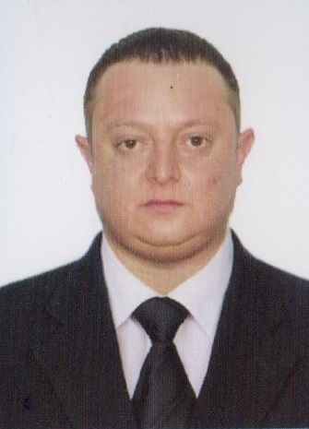

Tel:+994 70 640 38 70
Email: agayusif.salamov@mail.ru

APPLICATION FORM

A.SEAFARER-ENGİNE

PERSONAL DETAILS

POSITION TO APPLY FOR SEAFARER-ENGİNE CERTIFIED FOR
NAME / SURNAME SALAMOV AGHAYUSİF
FATHER'S NAME RAFAİL MOTHER'S NAME
D.O.B./P.O.B. 17.08.1990 NATIONALITY AZERBAIJAN
ADDRESS AZERBAIJAN. BAKU. BAKİKXANOV
MOB: (+994 70)6403870 PHONE NO.: +994 12429 69 69 E-mail agayusif.salamov@mail.ru MARITAL STATUS Single
NEXT OF KIN NO RELATION
NEXT OF KIN ADDRESS AND PHONE
GRADUATED FROM Azerbaijan State Marine Academy USA VISA:
DEGREE OF DIPLOMA ISSUED |  |  |  | SECOND ENGINEER
WEIGHT | 75 | HEIGHT | 150 |  |  | EYES COLOR |  | brown |  | HAIR COLOR |  | brown
B. DOCUMENTATION
CERTIFICATES |  |  |  |  | NUMBER |  | 1SSUING DATE |  | VAL1DATIO N DATE |  | ISSUING PLACE
SEAMANS BOOK |  |  |  |  | DQK№017349 |  | 31.03.2021 |  | 31.03.2026 |  | AZERBAIJAN
INTERNATIONAL PASSPORT |  |  |  |  | P5121170 |  | 25.09.2012 |  | 24.09.2022 |  | AZERBAIJAN
DIPLOM |  |  |  |  | ID RP03847 |  | 03.03.2021 |  |  |  | AZERBAIJAN
INTERNATIONAL SAFETY MANAGEMENT CODE |  |  |  |  | SP-0662-20 |  | 01.09.2020 |  | 01.09.2025 |  | AZERBAIJAN
SHIP SECURITY-RLATED FAMILIARIZATION SECURITY-AWARENESS TRAINING |  |  |  |  | SI-0486-20 |  | 02.09.2020 |  | 02.09.2025 |  | AZERBAIJAN
TRAINING FOR SEAFARERS WITH DESIGNATED |  |  |  |  | SH-0399-20 |  | 04.09.2020 |  | 04.09.2025 |  | AZERBAIJAN
( STCW-78,A-VI/1-1/1-2/1-3/1-4.) |  |  |  |  | SO-0991-20 |  | 06.09.2020 |  | 06.08.2025 |  | AZERBAIJAN
TRAINING IN ADVANCED FIRE-FIGHTING |  |  |  |  | SO-0991-20 |  | 06.09.2020 |  | 06.08.2025 |  | AZERBAIJAN
MEDICAL EXAMINATION |  |  |  |  |  |  | 04.06.2020 |  | 04.06.2021 |  | AZERBAIJAN
Proficiency in survival craft and boats other than fast rescue boats |  |  |  |  | SL-0701-20 |  | 03.09.2020 |  | 30.08.2025 |  | AZERBAIJAN

C. PREVIOUS SEA SERVICE
VESSEL | FLAG | TYPE / DWT | ENG / TYPE | RANK | S/ON | S/OFF | OWNERS
T.G. | AZERBAIJAN | 7914458 | 2*2625 kW | SEAFARER-ENGİNE | 01.09.2019 | 15.03.2020 | AZERBAIJAN
KAGAN BEY | Palau [PW] | 3332 |  | SEAFARER-ENGİNE | 24.04.2022 | 31.08.2022 | CUNDA SHİPPİNG

PLEASE COMPLETE CONTACT DETAILS OF YOUR PREVIOUS EMPLOYERS FOR REFERENCES

English abilities: Good: ⁯ Average: YES Poor: ⁯ ACCEPTABLE SALARY:

