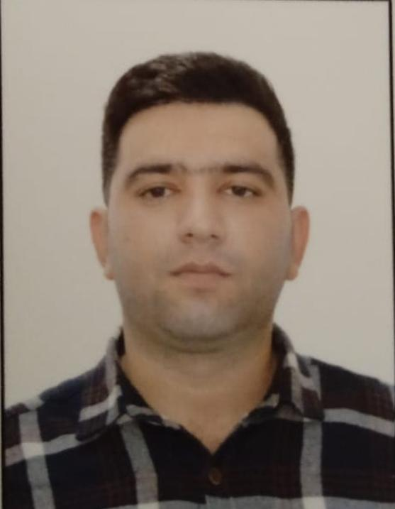

APPLICATION FORM

R | P | 1 | 0 | 8 | 6 | 8
Personal ID Number

Position Applied for: Oiler | Date Available from: Any time

1. Personal Data
Family Name:  Qafarli | First Name:  Parviz | Middle Name:  Hafis
Date of Birth: 28.02.1994 | Place of Birth (City and Country):  AZERBAIJAN/Masalli | Citizenship: AZERBAIJAN
Permanent Address: AZERBAIJAN.Baki |  | Phone Mobile/WP +994552204750  MOBİLE. +994552204750

2. Maritime Education
Name of school | Town | Country | From | To | Type of degree or diploma
” KAİNAT-M TM” LLC | BAKU | AZERBAIJAN | 09.04.21 | 28.10.21

3. Professional Test
English Test Date | Name of Test | Score
Professional Test Date | Name of Test | Score
Professional Interview Date | Result

4. Family Details
Civil Status(Single, Married, Separated, Divorced, Widowed) : Married

Next of Kin (the first emergency contact) Qafarov Hafis | Relationship: Father
Address of Residence  AZERBAYCAN MASALLI | Phone : +994553625885

 | Daughter | Son
Family Name
First Name
Date of Birth
City of living
Phone Numbers

5. Identity Documents
Document | Country | Number | Place of Issue | Issue Date | Expiry Date
Seaman's Book | AZERBAIJAN | DQK 018202 | AZERBAIJAN, BAKU | 19.08.21 | 19.08.26
Travel Passport | AZERBAIJAN | C02331038 | AZERBAİJAN, BAKU | 07.05.19 | 06.05.29

6. Valid Visa
Country or Union | Type | Valid Until
N/A | N/A | N/A
N/A | N/A | N/A

7. Courses Attended and Certificates Obtained
Document | Number | Dates |  | Place
Document | Number | Issue | Expiry | Place

Certificate of Competency | ID№RP10868 | 28.01.2022 |  | AZERBAIJAN
TRAINING FOR SEAFARERS WITH DESIGNATED SECURITY DUTIES | SH-1001-21 | 11.11.2021 | 11.11.2026 | AZERBAIJAN
Proficiency in Survival Craft and Rescue Boats | SL-1862-21 | 02.11.2021 | 02.11.2026 | AZERBAIJAN
Basic Trainings | SO-3062-21 | 19.11.2021 | 19.11.2026 | AZERBAIJAN
SHIP SECURITY – RELATED TRAINING AND INSTRUCTION | SI-1292-21 | 03.11.2021 | 03.11.2026 | AZERBAIJAN
ISM Code | SP-1976-21 | 05.11.2021 | 05.11.2026 | AZERBAIJAN

8. Physical Data
Height | 172sm
Weight | 75 kg
Colour of Hair | Black
Colour of Eyes | Brown
Boilersuit Size | M
Shoes Size | 43

9. Medical History | Yes | No
Have you ever signed off a ship due to medical reasons? |  | No
Did you undergo any medical operation in the past? |  | No
Have you consulted a doctor during the last 12 months for an illness/accident? |  | No
Do you have any health or disability problems now? |  | No

If yes, please give full details:

 | Passed: | Valid till:
International Medical Examination | 15.07.2021 | 15.07.2023
Vaccination Against Yellow Fiver | N/A | N/A
Vaccination Against Diphtheria | N/A | N/A

13. I hereby declare that the above, including Medical History, is true
Place: Baku | Date 22.01.2022 | Signature:

15. Seagoing Experience

Name of vessel | Flag | Vessel’s Type | DWT | Eng Type | HP | Manager or Owner | Rank | From d/m/y | To  d/m/y | Total  m/d
M/V VOLGO BALT 220 | PANAMA | GEN. CARGO | 3492 | SHKODA |  | AZOV 220 CO. | MOTORMAN/FITTER | 17.02.2022 | 16.08.2022 | 6 M
M/V VOLGO BALT 220 | PANAMA | GEN. CARGO | 3492 | SHKODA |  | AZOV 220 CO. | MOTORMAN/FITTER | 18.11.2022 | 28.05.2023 | 6 M 10 D

Total rank sea service: Total type of vessel sea service:

As Motorman/Fitter General cargo
1 year, 10 days

