CURRICULUM VITAE
PERSONAL DETAILS
Family name |  | NOVRUZOV |  |  | 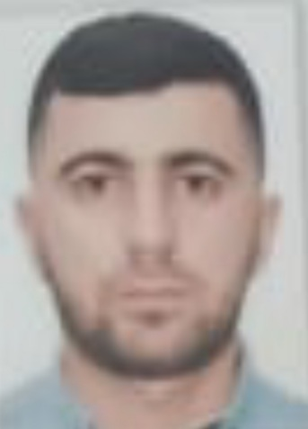
First name |  | ARAZ
Father’s name |  | TABRİZ
Date and place of birth |  | 16.10.1997 Azerbaijan
Nationality |  | Azerbaijani
Marital status |  | No
Permanent address |  | Azerbaijan, BAKU
Nearest airport |  | Heydar Aliyev International Airport Baku, Azerbaijan
Height (cm) | Weight (kg) | Eyes color | Hair color | Size of safety shoes | Size of coveralls
1.75 cm | 78 kg | BROWN | BLACK | 42 | 52
CONTACT DETAILS
Mobile | E-mail address
+994504352322 (whatsapp) | Araznovruzov047@gmail.com
NEXT OF KIN (FOR EMERGENCY)
Next of kin |  | Relationship | Brother
Date of birth |  | Address | Baku,Azerbaijan
Phone |  | Mobile phone | +994503773989
TRAVEL PASSPORT DETAILS
Document | Number | Place of Issue | Issued | Valid
PASSPORT | C03763343 | Azerbaijan | 23.06.2022 | 22.06.2032
SEAMAN’S BOOK DETAILS
Document | Number | Place of Issue | Issued | Valid
Seaman book | DGK019771 | Azerbaijan ,Baku | 13.04.2022 | 13.04.2027
SEAARERS IDENTITY | AZE024687 | Azerbaijan ,Baku | 13.04.2022 | 13.04.2027
EDUCATION
Full name of School | Place of Issue | Grade/Class | From | To
Azerbajan Marine Akademiy | Azerbaijan , Baku | 1168/22 | 10.06.2022
KNOWLEDGE OF LANGUAGES
Languages | Speaking | Reading | Writing
Azerbaijan | Excellent | excellent | Excellent
Russian | Excellent | excellent | Excellent
Turkish | Excellent | excellent | Excellent
COMPUTER SKILLS
Windows | Microsoft Office | Internet
Excellent | Excellent | Excellent
MEDICAL INFORMATION
Document | Grade | Place of issue | Date of issue | Date of expiry
Med.Sertificate | A/B | Azerbaijan | 20.12.2021 | 20.12.2023
CERTIFICATE OF COMPETENCY
Class/Grade | Issuing country | Certificate No. | Date issued | Expires | Details of Limitations
AB SEAMAN | Azerbaijan Marine Administration | A/B 1168/22 | 10.06.2022 |  | A-II/4
STCW AND OTHER CERTIFICATES
Name of course/Certificate | Institute | Place | Date of issue | Cert.No | Date of expiry
International Safety Management | Azerbaijan Marine Adminstration | Azerbaijan Baku | 19.05.2022 | SP-1466-22 | 18.05.2027
Proficiency in survival craft and boats other than fast rescue boats | Azerbaijan Marine Adminstration | Azerbaijan Baku | 16.05.2022 | SL-1230-22 | 16.05.2027
Training for seafarers with designated security duties | Azerbaijan Marine Adminstration | Azerbaijan Baku | 20.05.2022 | SH-0884-22 | 20.05.2027
Basic safety trainig | Azerbaijan Marine Adminstration | Azerbaijan Baku | 19.05.2022 | S0-2194-22 | 11.05.2027
Ship Security-related familization security-awareness | Azerbaijan Marine Adminstration | Azerbaijan Baku | 12.05.2022 | SI-1116-22 | 12.05.2027
SEA EXPERIENCE (LAST 5 YEARS – MOST RECENT EXPERIENCE ON TOP LINE)
Vessel | Company | Type of vessel | Flag | DWT | GRT | BHP | Rank | Sign on | Sign off
VOLGA 4007 | REGENBOGEN LTD | GEN CARGO | COOK ISLANDS | 6277 | 4911 | 139.81 x 16.65 | AB SEAMAN | 13.08.2022 | 05.03.2023

