APPLICATION FORM

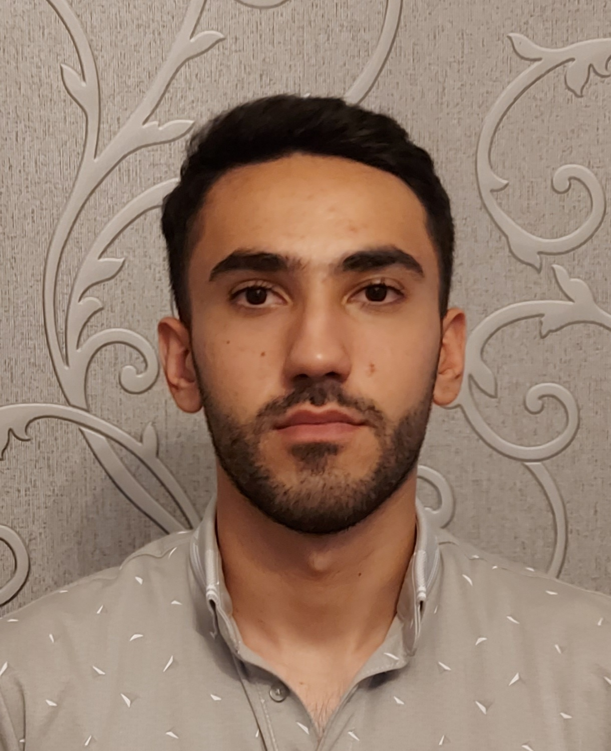

 |  |  |  |  | 7 | 5 | G | M | K | B | J
Personal ID Number

Position Applied for: Electrician (III/6) | Date Available from: ANY TIME

1. PersonalData
Family Name: Ibrahimov | First Name: Ibrahim | Middle Name: Zaur
Date of Birth: 04.11.2001 | Place of Birth:Azerbaijan/ Salyan | Citizenship: Azerbaijani
Permanent Address: Azerbaijan/ Salyan |  | Phone (Home): 051 470 18 20  Whatshapp +994514701820  E-mail: iiibrahimov064@gmail.com

2. MaritimeEducation
Nameofschool | Town | Country | From | To | Type of degree or diploma
Azerbaijan State Marine Academy | Baku | Azerbaijan | 2018 | 2022 | Bachelor

3. ProfessionalTest
EnglishTest Date | Nameof Test | Score
Professional TestDate | Nameof Test | Score
Professional Interview Date | Result

4. FamilyDetails
Civil Status (Single, Married, Separated, Divorced, Widowed) : Single

Next of Kin (the first emergency contact) : | Relationship /Father
Address of Residence:  Azerbaijan/Salyan | (050) 513 12 20

5. IdentityDocuments
Document | Country | Number | PlaceofIssue | IssueDate | ExpiryDate
Seaman'sBook | Azerbaijan | DQK 014709 | State Maritime Adminstration | 16.07.2019 | 16.07.2024
TravelPassport | Azerbaijan | C03817703 | Ministry of Internal Affairs | 28.01.2022 | 27.01.2032

6. ValidVisa
CountryorUnion | Type | ValidUntil

7. Courses Attended and Certificates Obtained
Document | Number | Dates |  | Place
Document | Number | Issue | Expiry | Place

CertificateofCompetency | RP-10672 | 16.11.2021 | 16.11.2031 | State Maritime Administration
MalteseEndorsementof COC
OilTankerEndorsement
ChemicalTankerEndorsement
GasTankerEndorsement
OilTankerFamiliarizationTraining
ChemicalTankerFamiliarizationTraining
GasTankerFamiliarizationTraining
OilTankersSpecializedTraining
ChemicalTankerSpecializedTraining
GasTankerSpecializedTraining
BasicTrainings | SO-1398-19 | 10.05.2019 | 15.04.2024 | State Maritime Administration
Proficiency in Survival Craft and Rescue Boats | SL-2775-23 | 04.08.2023 | 31.07.2028 | State Maritime Administration
AdvancedFireFighting
MedicalFirstAidTraining
Medical First Aid Training and Medical Care
GMDSS
GMDSS Endorsement
RadarObservation&Plotting
Automatic Radar Plotting Aids Simulator (ARPA)
BridgeTeamManagement
Shiphandling&Maneuvering
Ship Security-related familiarization security-awareness training | SI-1392-19 | 14.05.2019 | 18.04.2024 | State Maritime Administration
MalteseEndorsementof SSO
ISM Code | SP-0746-19 | 14.05.2019 | 22.04.2024 | State Maritime Administration
SafetyOfficer
ECDISTrainingCourse
RiskAssessmentCourse
C.O.W./ I.G.S
FirePracticeonTankers
VapourRecoverySystem
UnmannedMachinerySpace
FRAMO FamiliarizationCourse
Cargo Ballast Operations on Oil/Chemical Tankers
HazardousMaterials
Welder
Turner
Risk Management And Incident Investigation
Training of seafarers with designated security duties
Dangerous hazardous and harmfull cargoes | SH-1825-23 | 27.07.2023 | 27.07.2028 | State Maritime Administration
BasicTraining and qualifications on oil and chemical tanker cargo operations
Crowd management training

8. PhysicalData
Height | 176 sm
Weight | 68
ColourofHair | Black
ColourofEyes | Brown
BoilersuitSize | L
ShoesSize | 43

9. MedicalHistory | Yes | No
Have you ever signed off a ship due to medical reasons?
Did you undergo any medical operation in the past?
Have you consulted a doctor during the last 12 months for an illness/accident?
Do you have any health or disability problems now?

If yes, please give full details:

 | Passed: | Validtill:
International Medical Examination | 20.07.23 | 20.07.25
Vaccination Against YellowFiver
Vaccination Against Diphtheria

10. References (please give name and address of your current or past employer) | Officeremarks

NameofCompany
Name of person to contact
Address
Phone

NameofCompany
Name of person to contact
Address
Phone

11. Bank address forallotments
Beneficiary
AccountNo.
NameofBank
BankAddress

12. Knowledgeandexperience | Yes | No
OCIMF vetting experience:
ISGOT knowledge:

13. I hereby declare that the above, including Medical History, is true
Place

14. ForOfficeuseonly

15. SeagoingExperience

Nameofvessel | Flag | Vessel’sType | DWT | EngType | HP | Manageror Owner | Rank | From d/m/y | Tod/m/y | Total  m/d
Suleyman Vezirov | Azerbaijan | Drei cargo | 3950 | Diesel |  | Azerbaijan Caspian Shipping Closed Joint-Stock Company | practitioner | 18.06.2019 | 28.09.2019 | 3 m, 10 d.
Aura | Azerbaijan | Offshore | 1393 | Diesel |  | Azerbaijan Caspian Shipping Closed Joint Company | practitioner | 01.06.2020 | 28.09.2020 | 3 m, 28 d.
İslam Kerimov | Azerbaijan | Crane | 11159 | Diesel |  | Azerbaijan Caspian Shipping Closed Joint Company | electrician | 01.06.2021 | 01.01.2022 | 6 m,. 4 d
Dagıstan | Azerbaijan | Ro-Ro | 19813 | Diesel |  | Azerbaijan Caspian Shipping Closed Joint Company | electrician | 02.02.2022 | 22.08.2022 | 6 m, 20 d
Total |  |  |  |  |  |  |  |  |  | 1 y, 7 m.

Total rank sea service: Total type of vessel sea service:
Rank | Years |  | Typeofvessel | Years
Electrican |  |  | OIL TANKER
 |  |  | LPG
 |  |  | DRY CARGO
 |  |  | TANKER ICE
 |  |  | OIL /CHEMICAL TANKER
 |  |  | FERRY
Total |  |  | Total:

