CURRICULUM VITAE
PERSONAL DETAILS
Family name |  | ALİYEV |  |  | 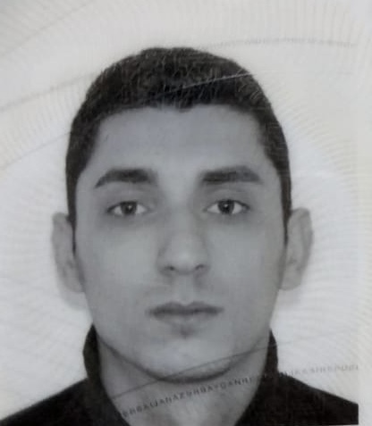
First name |  | MURAD
Father’s name |  | MİKAYIL
Date and place of birth |  | 26.05.2000 Azerbaijan
Nationality |  | Azerbaijani
Marital status |  | No
Permanent address |  | Azerbaijan, BAKU
Nearest airport |  | Heydar Aliyev International Airport Baku, Azerbaijan
Height (cm) | Weight (kg) | Eyes color | Hair color | Size of safety shoes | Size of coveralls
170 cm | 70 kg | BROWN | BLACK | 42 | 48
CONTACT DETAILS
Mobile | E-mail address
+994709552855
NEXT OF KIN (FOR EMERGENCY)
Next of kin |  | Relationship | Brother
Date of birth |  | Address | Baku,Azerbaijan
Phone |  | Mobile phone
TRAVEL PASSPORT DETAILS
Document | Number | Place of Issue | Issued | Valid
PASSPORT | C04054743 | Azerbaijan | 29.01.2000 | 28.01.2032
SEAMAN’S BOOK DETAILS
Document | Number | Place of Issue | Issued | Valid
Seaman book | DGK019222 | Azerbaijan ,Baku | 27.01.2022 | 27.01.2027
SEAARERS IDENTITY | AZE024139 | Azerbaijan ,Baku | 27.01.2022 | 27.01.2027
EDUCATION
Full name of School | Place of Issue | Grade/Class | From | To
Azerbajan Marine Akademiy | Azerbaijan , Baku | ABLE SEAFARER ENGİNE 0073/22 | 19.01.2022
KNOWLEDGE OF LANGUAGES
Languages | Speaking | Reading | Writing
Azerbaijan | Excellent | excellent | Excellent
Russian | Excellent | excellent | Excellent
Turkish | Excellent | excellent | Excellent
COMPUTER SKILLS
Windows | Microsoft Office | Internet
Excellent | Excellent | Excellent
MEDICAL INFORMATION
Document | Grade | Place of issue | Date of issue | Date of expiry
Med.Sertificate | A/B | Azerbaijan | 11.08.2023 | 11.08.2025
CERTIFICATE OF COMPETENCY
Class/Grade | Issuing country | Certificate No. | Date issued | Expires | Details of Limitations
MOTORMAN | Azerbaijan Marine Administration | 0073/22 | 19.01.2022 |  | A-III/5
STCW AND OTHER CERTIFICATES
Name of course/Certificate | Institute | Place | Date of issue | Cert.No | Date of expiry
International Safety Management | Azerbaijan Marine Adminstration | Azerbaijan Baku | 17.11.2021 | SP-2037-21 | 03.11.2026
Proficiency in survival craft and boats other than fast rescue boats | Azerbaijan Marine Adminstration | Azerbaijan Baku | 15.11.2021 | SL-1967-21 | 05.11.2026
Training for seafarers with designated security duties | Azerbaijan Marine Adminstration | Azerbaijan Baku | 16.11.2021 | SH-1086-21 | 15.10.2026
Basic safety trainig | Azerbaijan Marine Adminstration | Azerbaijan Baku | 19.11.2021 | S0-3069-21 | 17.11.2026
Ship Security-related familization security-awareness | Azerbaijan Marine Adminstration | Azerbaijan Baku | 19.11.2021 | SI-1362-21 | 13.10.2026
Basic training and qualifications on oil and chemical tanker cargo operations | Azerbaijan  Marine  Adminstration | Azerbaijan  Baku | 10.03.2023 | SA-0207-23 | 10.03.2028
SEA EXPERIENCE (LAST 5 YEARS – MOST RECENT EXPERIENCE ON TOP LINE)
Vessel | Company | Type of vessel | Flag | DWT | GRT | BHP | Rank | Sign on | Sign off
M/V SHAIR SABIR | CASPIAN SHIPPING | GEN CARGO | AZERBAIJAN | 4876 | 4532 | 1150x2 | MOTORMAN | 05.04.2020 | 15.11.2020
ŞAİR VAGİF | CASPIAN SHIPPING | GEN CARGO | AZERBAIJAN | 5495 | 5200 | 108,33 X 16.74 | MOTORMAN | 10.02.2021 | 11.12.2021
Suadiye | ESD SHIPPING  AND TRADING  LTD.Turkey | GEN  CARGO | PANAMA | 3197 | 3197 | GE/1030 | MOTORMAN | 01.04.2022 | 11.01.2023

