APPLICATION FORM  - Diploma of watch engineer + tanker endorsement  - All documents STCW 78/95 + liquefied gas tanker  - Schengen Visa Valid Up: 15.01.2023 |  |  |  | 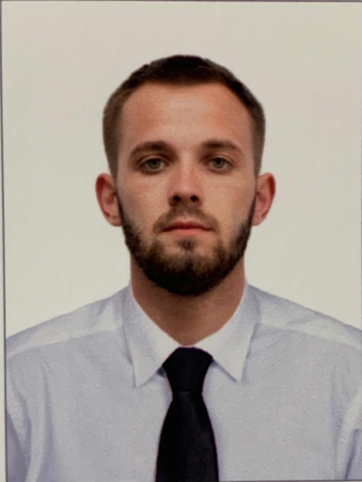
Main information
Position: | 4th Engineer / Training engineer_ | Desired Type of Ship: | Tanker only
Full Name: | Pavel Pavlov | Date of birth: | 18.03.1998
Citizenship: | Russian | Place of birth: | Chuvash Republic, the city Shumerlya
Phones: | +79677947674 | Country of residence: | Russia
E-mail: | Pavlov.engineer61@gmail.com. | City: | Nizhny Novgorod
Skype: | pacaca2222 | Full Address: | Herman Lopatin street 14/88
English level: | Pre - intermediate | USA visa valid up: | N/A

Passports / Smbk | № | Date of issue | Place of issue | Date of expire
Seaman's book | 0257450 | 25.06.2021 | Nizhny Novgorod
International passport | 75 4921251 | 17.05.2017 | Chuvash Republic | 17.05.2027
Diplomas | № | Date of issue | Place of issue | Valid up
Rank | Watch engineer
Professional license | ARH207105734 | 29.07.2022 | Arkhangelsk | 26.04.2027
Rank | Tanker endorsement
Professional license | ARH207105769 | 29.07.2022 | Arkhangelsk | 21.06.2026
Rank | Able seafarer engine
Professional license | ARH204930686 | 09.06.2021 | Arkhangelsk
Certificates | № | Date of issue | Place of issue | Valid up
Basic Safety Training and instruction | 82-209/22 | 26.04.2022 | Nizhny Novgorod. Marine Training Simulating Centre | 26.04.2027
Security training for seafarers with designated security duties | 91-153/22 | 13.05.2022 | Nizhny Novgorod. Marine Training Simulating Centre | 13.05.2027
Fast Rescue Boats course | 84-176/22 | 28.04.2022 | Nizhny Novgorod. Marine Training Simulating Centre | 28.04.2027
Medical firs aid | 88-111/22 | 06.05.2022 | Nizhny Novgorod. Marine Training Simulating Centre | 06.05.2027
Advanced fire fighting | 86-110/22 | 30.04.2022 | Nizhny Novgorod. Marine Training Simulating Centre | 30.04.2027
Basic training for liquefied gas tanker cargo operations | 111/0621-40 | 28.06.2021 | ST. Petersburg. Marine Systems | 28.06.2026
Basic training for oil and chemical tanker cargo operations | 108/0621-73 | 21.06.2021 | ST. Petersburg. Marine Systems | 21.06.2026
Yellow fever issued to: | 14.05.2021
Schengen Visa Valid Up | 15.01.2023

Sea service
Position | Name of Ship | Type of Ship | DWT | ME Type / kW | From - Till | Employer
Motorman, Wiper | Shturman  Ovtsyn | Product tanker | 44354 | 2 Azipods-2x 11000 kW | 02.04.2023 - 26.06.2023  2 Months 25 Days | Sovcomflot
Motorman, Wiper | Shturman  Ovtsyn | Product tanker | 44354 | 2 Azipods-2x 11000 kW | 17.10.2022 - 17.01.2023  2 Months 23 Days | Sovcomflot
Motorman, Wiper | Ligovsky Prosprct | Product tanker | 115000 | HSD-MAN B&W 5S70MC-C 15519 kW | 06.08.2021 - 27.02.2022  6 Months 23 Days | Sovcomflot
Main activities and responsibilities: I had different responsibilities on this vessel. Every morning I did safety round of the engine room, did all tanks measurements (bilge tank, sludge tank, waste oil tank, SBO tank, scav. air box drain tank, overflow tank and so on). Once a week I wrote down machinery working hours from counter levels and put them into AMOS program. We usually had a working day, watches were during cargo discharging only or during maneuvers . Much work I performed with a watch engineer, but more often I worked together with the 4th engineer due to this I got a big experience in having the 4th engineer’s responsibilities including keeping record books and reports in AMOS. During my contract I was learning schemes and diagrams of different systems and machineries. I took part in the axillary engine overhaul. We cleaned the machineries and changed liners and bearings. After that the 3rd engineer and me measured by raskep.

Motorman | “OT-2443” | Tug | 833 | 8170zc435-1  1766 kW | 01.04.2018 – 01.09.2018  5 Months | Volgskoe Parohodstvo
Motorman | Volgo – don 5048 | Dry cargo | 3964 | G – 60  1324 kW | 09.09.2018 – 11.11.2018  2 Months 2 Days | Volgskoe Parohodstvo
Main activities and responsibilities: My main activity was repairing maintenance of engines and auxiliary machinery, it helped me to get a lot of new experience. In contract I wrote a big report for my educational institution. I participated in many types of repair: ballast pumps, fire systems, air compressors, fuel pump high pressure, water boiler and turbine main engine.

Additional info
Education: higher secondary education |  | Education: Volga State University of Water Transport ( 4rd course)
Specialty: Engineer
Next of Kin
Next of kin: Father |  | Phone: +79030653603
Name, Surname: Pavlov Aleksey |  | Address: Chuvash Republic, the city Shumerlya, Lomonosova street, house number 60, flat number 4
Biometrical data
Sex: Male | Height: 178 |  | Overall size: 48
Eyes color: Light green | Weight: 74kg |  | Shoe size: 42

