

Application Form

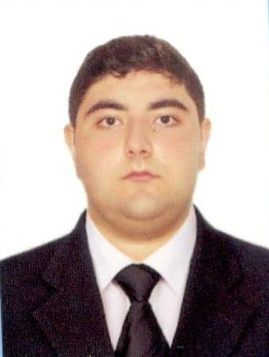
Position | Able Seaman
Alternative position | Matros
Expected salary | - USD/month
Availability date | -

Personal Details

Last Name | Sultanov | First Name | Ismayil
Date of Birth | 13.02.2000 | Place of Birth | Baku
Nationality | Azerbaijan | Citizenship | Azerbaijan
Sex | Male | Marital Status | Single
Shoe size | 45 | Weight | 110 kg
Height | 180 cm | Overall size | XXXL
Hair color | Brown | Eyes color | Brown
Address | Baku city, Nariman Narimanov district, Hasanoglu street 83A | Country | Azerbaijan
Airport | BAK (Baku, Azerbaijan - Baku) | City | Baku
Home phone | +994 12 5668387 | Mobile phone | +994 55 3055799
Phone number 2 |  | Skype
E-mail | ismayilsultanov2021@icloud.com | Availability date

Relatives

Contact name | Relationship | Date of Birth
Ramile | Sister | 10.05.1995
Camale | Sister | 15.07.1992

Next of Kin

Name | Relationship | Address | Phone number
Ramile | Sister | Baku city | +994 77 394 39 99
Camale | Sister | Baku city | +994 55 694 31 61

National Documents

Maritime Training Institute
Azerbaijan military navy college

 | Number | Issue date | Expiry date | Place of issue
Passport | CO1662787 | 03.06.2021 |  | Azerbaijan
Seaman's Book | DQK011606 | 26.01.2018 | 26.01.2023 | Azerbaijan
Seafarer Identity Card | AZE016069 | 26.01.2018 | 26.01.2023 | Azerbaijan

Certificates

 | Grade | Number | Issue date | Expiry date | Place of issue
Endorsement
 |  | Number | Issue date | Expiry date | Place of issue
Inrenational Safety Management Code |  | SP-05577-21 | 07.05.2021 | 06.05.2026 | AZERBAIJAN
Proficiency in survival craft and boats other than fast rescue boats A-V1/2 |  | SL-0642-21 | 08.05.2021 | 08.05.2026 | AZERBAIJAN
STCW Code A-VI/6 |  | SH-0321-21 | 05.05.2021 | 21.04.2026 | AZERBAIJAN
STCW Code, A-VI/6 |  | SI-0300-21 | 30.04.2021 | 19.04.2026 | AZERBAIJAN
IMO Model Courses 1.13,1.19,1.20,1.21 |  | So-0819-21 | 18.05.2021 | 18.05.2026 | Azerbaijan

Personal Skills

 | A: | B: | C: | D: | E: | Remarks
 | Upper | Intermed. / | Lower | Elementary / | Beginner /
 | Intermed. / | Upper | Intermed. / | Lower | Elementary
 | Advanced | Intermed. | Intermed. | Intermed.
Command of English language |  |  |  |  | x
Computer literacy |  |  |  |  | x

Previous Sea Services

Name of Vessel | Vessel type | Year built | Flag | GT | Engine type | KW | Engine model | Rank | Manager / Crew Agent | From | To

Nationalities worked with
Reason of leaving the previous company
References (contacts)
Ability to work in

In accordance GDPR (Regulation (EU) 2016/679) herewith I confirm my compliance with automatic processing of my personal data given in this application form, including transfer of my personal data and documents to the third parties and storage of this data and documents for employment purposes, I confirm that my personal data and documents inserted into this application are considered to be public information.

Above information is to the best of my knowledge correct. (To be signed by the person who completed the form)

Availability date |  | Name in print | Ismayil Sultanov

Copyright © 2021 BalticShipping.com. All rights reserved. E-mail: support@balticshipping.com

