Cv Form
PERSONAL DETAILS
Family name |  | MANSİMOV |  |  | 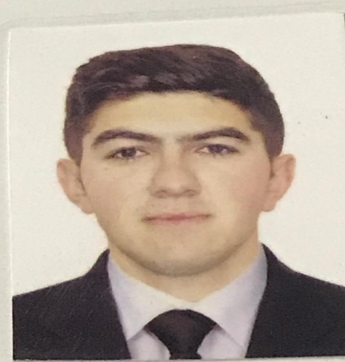
First name |  | SAYYAD
Father’s name |  | FİZULİ
Date and place of birth |  | 30.12.2000
Marital status |  | UNMARRIED
Permanent address |  | AZERBAIJAN, BAKU
Nearest airport |  | Heydar Aliyev International Airport Baku, Azerbaijan
Height (cm) | Weight (kg) | Eyes color | Hair color | Size of safety shoes | Size of coveralls
180cm | 83kg | BROWN | BLACK | 42 | M
CONTACT DETAILS
Mobile | E-mail address
+994 70 784 83 00  Whatsapp | themansimov@gmail.com
NEXT OF KIN (FOR EMERGENCY)
Next of kin | MANSIMOV NIZAMI | Relationship | BROTHER
Phone | +994 50 484 83 00 | Address | Azerbaijan, Salyan
TRAVEL PASSPORT DETAILS
Document | Number | Place of Issue | Issued | Valid
PASSPORT | C02902893 | Azerbaijan | 25.06.2021 | 24.06.2031
SEAMAN’S BOOK DETAILS
Document | Number | Place of Issue | Issued | Valid
Seaman book | DQK014595 | Azerbaijan ,Baku | 02.07.2019 | 02.07.2024
SEAARERS IDENTITY | AZE019399 | Azerbaijan ,Baku | 02.07.2019 | 02.07.2024
EDUCATION
Full name of School | Place of Issue | Grade/Class | From | To
AZERBAIJAN STATE MARINE ACADEMY | Azerbaijan , Baku | Marine Power Plants and Their Exploitation | 15.09.2018 | 21.06.2022
KNOWLEDGE OF LANGUAGE
Languages | Speaking | Reading | Writing
Azerbaijan | Excellent | Excellent | Excellent
Turkish | Excellent | Excellent | Excellent
English | Intermediate | Intermediate | Intermediate

COMPUTER SKILLS
Windows | Microsoft Office | Internet
Excellent | Excellent | Excellent
MEDICAL INFORMATION
Document | Grade | Place of issue | Date of issue | Date of expiry
Med.Sertificate | Rating forming part of an engine-room watch | Azerbaijan Baku | 26.07.2023 | 26.07.2025
CERTIFICATE OF COMPETENCY
Class/Grade | Issuing country | Certificate | Date issued | Expires | Details of Limitations
Rating forming part of an engine-room watch | Azerbaijan Marine Administration | No: 0996/21  ID  No:RP10692 | 26.11.2021 | Unlimited | A-III/4
STCW AND OTHER CERTIFICATES
Name of course/Certificate | Institute | Place | Date of issue | RANK | Cert.No | Date of expiry
International Safety Management | Azerbaijan Marine Administration | Azerbaijan Baku | 05.05.2019 | Motorman | SP-0624-19 | 22.04.2024
Basic safety training | Azerbaijan Marine Administration | Azerbaijan Baku | 08.05.2019 | Motorman | SO-1292-19 | 15.04.2024
Ship Security-related familiarization security-awareness | Azerbaijan Marine Administration | Azerbaijan Baku | 10.05.2019 | Motorman | SI-1273-19 | 18.04.2024
Training for seafarers with designated security duties. | Azerbaijan Marine Administration | Azerbaijan Baku | 04.08.2023 | Motorman | SH-2105-23 | 04.08.2028
Proficiency in survival craft and boats other than fast rescue boats | Azerbaijan Marine Administration | Azerbaijan Baku | 08.08.2023 | Motorman | SL-2904-23 | 08.08.2028
Manual electric arc welding, Gas metal arc welding, Tungsten wire gas arc welding. | Baku State Vocational Education Center for Industry and Innovation | Azerbaijan Baku | 18.12.2021 | Welder | 0000179 | ----

SEA EXPERIENCE (LAST 5 YEARS – MOST RECENT EXPERIENCE ON TP LINE)
Vessel | Company | Type of vessel | Flag | DWT | GRT | Rank | Sign on | Sign off
Gehreman Hagıyev | ASCO | Tanker | Azerbaijan | 4989 | 5866 | Motorman | 27.082019 | 27.10.2019
Gefer Jabbarly | ASCO | Dry Cargo | Azerbaijan | 4150 | 4320 | Motorman | 30.06.2021 | 14.09.2021
Muhendıs Mustafa Alı | ASCO | Tanker | Azerbaijan | 5387 | 5903 | Motorman | 01.02.2022 | 27.05.2023

