CURRICULUM VITATE

Rank:SECOND ENGİNEER OFFİCER CERTFİCATE OF COMPETENCY |  | Nationality: AZERBAIJANI |  |  | 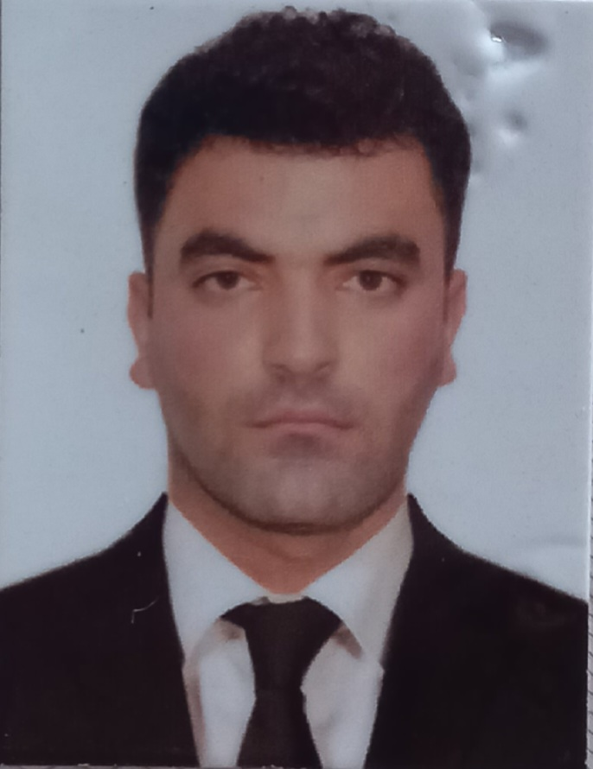
Languages: TURKISH Excellent
AZER. Excellent
RUSSIAN Normal

Full name Alakbarov Hajı
 |  | Marital status; Married
Date& place of birth; 13.08.1993 AZERBAIJAN |  | Next of Kin;  Mobile; Fathe. (+994) 50 763 70 68
Present address: Siyazan AZERBAIJAN  Nearest airport; Haydar Aliyev / BAKU |  | Mobile phone: (+994) 51 387 95 27
 |  |  |  |  | Height; 170cm
 |  |  |  |  | Weight; 85 kg
AZERBAIJAN STATE MARITIME ACADEMY
English level; Weak
SEMANS IDENTIFICATON CARD | AZE026134 |  | 09.09.2022 | AZ-STATE MARITIME AND PORT AGENCY(SMPA) |  | 09.09.27
SEAMENS BOOK | DQK 021269 |  | 09.09.2022 | AZ-STATE MARITIME AND PORT AGENCY (SMPA) |  | 09.09.2027
TRAVEL PASSPORT | PC AZE C01455220 |  | 07.11.2016 | AZERBAIJAN  MINISTRY OF INTERNAL AFFAIRS |  | 06.11.2026

LICENSE | Grade of License | Number | Date  issued | Place Issued | Exp. Date
National | OFFICER IN CHARGE OF AN ENGINEERING WATCH | A No 077112 | 15.09.2011 | AZERBAIJAN | 26.10.2015
AZERBAIJAN STATE MARITIME ACADEMY | Exstrace From Seafarers Medical Sertifcate | 21030 | 07.09.2022 | AZERBAIJAN CUSTOMS HOSPITAL | 07.09.2024

CERTIFICATES | Number | Date Issued | Place Issued | Exp.Date
Inrternational Safety Management Code | SP- 2431-22 | 18.08.2022 | State Maritime and Port Agency | 18.08.2027
Training for seaferers with designated securty duties(STCW Code,A-VI/6  IMO Model Course 3.26) | SH- 0754-21 | 02.09.2021 | State Maritime and Port Agency | 02.09.2026
Engine resource management | ER- 0460-22 | 15.07.2022 | State Maritime and Port Agency | 22.07.2022
Leadership and Teamwork | DL-1408-22 | 31.08.2022 | State Maritime and Port Agency | 31.08.2027
Training in advanced fire-fighting | SJ-1769-22 | 15.12.2022 | State Maritime and Port Agency | 15.12.2027
Proficiency in Fast Rescue Boats | SU-0123-23 | 17.03.2023 | State Maritime and Port Agency | 17.03.2028
Proficieny in survival craft and boats other than fast rescue boats | SL-2472-22 | 24.08.2022 | State Maritime and Port Agency | 24.08.2027
Safety familiarization training- personal survival tecniques  Elementary first aid  Personal safety and social responsibilities | SO-3876-22 | 24.08.2022 | State Maritime and Port Agency | 12.08.2027
Medical First Aid | SN-0998-22 | 12.08.2022 | State Maritime and Port Agency | 11.08.2027
Maintance of the DP System | DPM151/19 | from 25.11 2019  to 27.11.2019 | ASCO Training Center İnstructor
SECOND ENGİNEER OFFİCER CERTFİCATE OF COMPETENCY | 001760/22 | 27.10.2022 | State Maritime and Port Agency | 27.10.2027

PREVIOUS SEA SERVICE:

Vessel`s  name | Type of vessel | DWT | flag | Company`s name | RANK | Period  From - To
Nercha | OFSHORE | 1561 | Azerbaijan | ASCO | MOTORMAN | 05.01.2016  10.05.2016
Yarenga | OFSHORE | 1561 | AZERBAİJAN | ASCO | 3RD ENG | 25.06.2017  25.08.2017
Natavan | GEN.CARGO | 5200 | AZERBAIJAN | SAMAYA COLTD | 3RD ENG | 04.02.2018  06.08.2018
Shair Sabir | GEN.CARGO | 5200 | AZERBAİJAN | SAMAYA CO LTD | 3RD ENG | 03/04/2019  05/12/2019
OM | OFSHORE | 1561 | AZERBAİJAN | ASCO | 2RD ENG | 03.03.2020  03.05.2020
Shair Vagif | GEN.CARGO | 5200 | AZERBAİJAN | SSAMAYA COLTD | 2RD ENG | 09.10.2021  09.01.2022
Uzeyir Hajıbeyli | GEN.CARGO | 5200 | AZERBAİJAN | SAMAYA COLTD | 2RD ENG | 25.03.2022  25.06.2022

