CURRICULUM VITAE
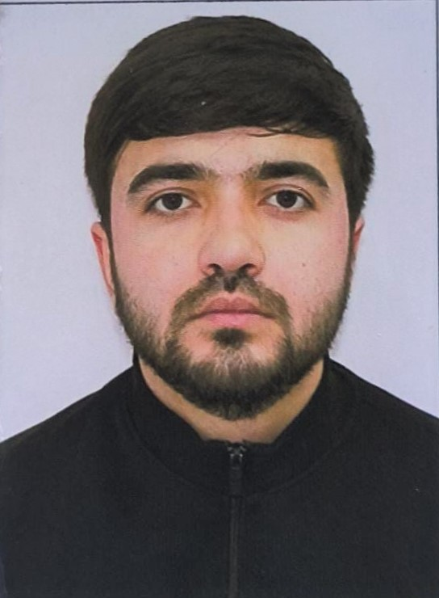PERSONAL DETAILS
Family name |  | MAMMADOV
First name |  | JEYHUN
Father’s name |  | JAVANSHIR
Date and place of birth |  | 20.03. 1998 Azerbaijan,Khachmaz
Nationality |  | Azerbaijani.
Marital status |  | Single
Permanent address |  | Azerbaijan, Khachmaz
Nearest airport |  | Heydar Aliyev International Airport Baku, Azerbaijan
Height (cm) | Weight (kg) | Eyes color | Hair color | Size of safety shoes |  | Size of coveralls
170 cm | 70 kg | BROWN | BLACK | 42 |  | 50
CONTACT DETAILS
Mobile | E-mail address
+99470-847-07-97 | haciyev.captain@gmail.com
NEXT OF KIN (FOR EMERGENCY)
Next of kin | SADİQ | Relationship | Brother
Date of birth | 05.01.1987 | Address | Baku,Azerbaijan
Phone | +99470-669-78-78 | Mobile phone | +99455-710-01-17
TRAVEL PASSPORT DETAILS
Document | Number | Place of Issue | Issued | Valid
PASSPORT | C03339815 | Azerbaijan | 14.07.2023 | 13.07.2033
SEAMAN’S BOOK DETAILS
Document | Number | Place of Issue | Issued | Valid
Seaman book | DQK022762 | Azerbaijan ,Baku | 21.02.2023 | 21.02.2028
SEAARERS IDENTITY | AZE023140 | Azerbaijan ,Baku | 21.02.2023 | 21.02.2028
EDUCATION
Full name of School | Place of Issue | Grade/Class | From | To
Marine College | Azerbaijan , Baku | A/B | 2017 | 2021
KNOWLEDGE OF LANGUAGES
Languages | Speaking | Reading | Writing
Azerbaijan | excellent | excellent | excellent
Ruskish | excellent | excellent | excellent
Turkish | excellent | excellent | excellent
COMPUTER SKILLS
Windows | Microsoft Office | Internet
Excellent | Excellent | Excellent
MEDICAL INFORMATION
Document | Grade | Place of issue | Date of issue | Date of expiry
Med.Sertificate | A/B | Azerbaijan | 24.10.2022 | 24.10.2024
CERTIFICATE OF COMPETENCY
Class/Grade | Issuing country | Certificate No. | Date issued | Expires | Details of Limitations
Rating Forming Part of an Engine-Room Watch | Azerbaijan Marine Administration | RP12429 | 10.02.2023 |  | No limit
STCW AND OTHER CERTIFICATES
Name of course/Certificate | Institute | Place | Date of issue | Cert.No | Date of expiry
Proficiency in survival craft and boats other than fast rescue boats | Azerbaijan Marine Adminstration | Azerbaijan Baku | 12.12.2022 | SL-4086-22 | 02.12.2027
Training for seafarers with designated security duties | Azerbaijan Marine Adminstration | Azerbaijan Baku | 16.12.2022 | SH-2486-22 | 08.12.2027
Basic safety trainig | Azerbaijan Marine Adminstration | Azerbaijan Baku | 21.12.2022 | SO-5925-22 | 25.11.2027
Ship Security-related familization security-awareness | Azerbaijan Marine Adminstration | Azerbaijan Baku | 07.12.2022 | SI-3065-22 | 07.12.2027
International Safety Management | Azerbaijan Marine Adminstration | Azerbaijan Baku | 16.12.2022 | SP-3709-22 | 29.11.2027
SEA EXPERIENCE (LAST 5 YEARS – MOST RECENT EXPERIENCE ON TOP LINE)
Vessel | Company | Type of vessel | Flag | DWT | GRT | BHP | Rank | Sign on | Sign off
M/V BAKU 357 | Azerbaijan Caspian Sg Co | Ore/Oil Carrier | AZERBAİJAN | 541 t | 2621 | 980x2 | Rating Forming Part of an Engine-Room Watch | 01.05.2020 | 01.08.2020

