CURRICULUM VITAE
MASTER SDPO

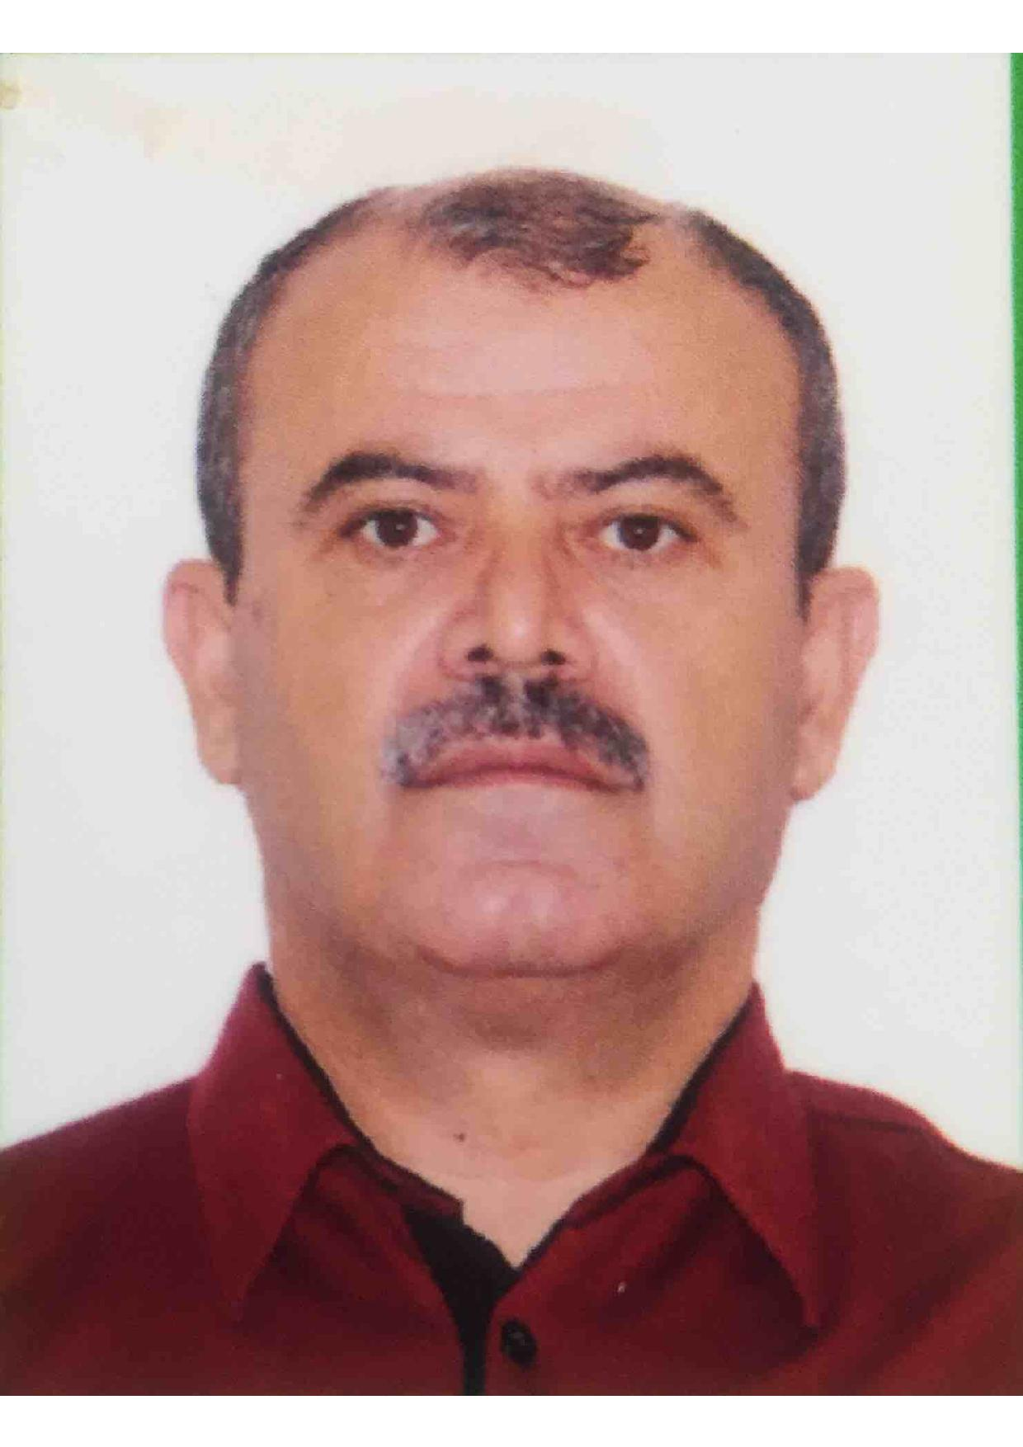
Personal Details:
Family name: Aliyev
First name: Seyfulla
Date of birth: 25/01/1967
Place of birth: Masallı, Azerbaijan
Nationality: Azeri
Status: Married
Permanent address: D.Bunyadzade st.22A,Lokbatan set.
Baku Azerbaijan
Mobile Phone: (+994)50 366 12 26
E-mail: seyfulla.aliyev.67@mail.ru

Passport Details:
Passport number: C00551083
Date of Issue: 26.04.2014
Date of Expiry: 25.04.2024
Place of Issue: Baku, Azerbaijan
Issued By: Ministry of Internal Affairs of Azerbaijan Republic

Seaman’s Book Details:
Seaman’s Book number: DQK 0001260
Date of Issue: 15.08.2022
Date of Expiry: 29.07.2027
Place of Issue: Baku, Azerbaijan
Issued By: Azerbaijan State Marine Administration
Certificates

CERTIFICATE TITLE | Certificate No: | Date Issue | Date Expire | Place Issue
Competency License | 001357/22 | 15.08.2022 | 29.07.2027 | ASMA
GMDSS | DQ-0334-22 | 24.05.2022 | 24.05.2027 | ASMA
Radar Navigation (management level) Radar, ARPA, Bridge teamwork, search and rescue | SQ-0448-21 | 24.12.2021 | 24.12.2026 | ASMA
International Safety Management Code | SP-1513-21 | 19.08.2021 | 19.08.2026 | ASMA
Safety familiarization, basic training and instruction for all seafarers | SO-1934-21 | 13.08.2021 | 19.08.2026 | ASMA
Advanced Fire Fighting | SJ-0684-21 | 18.08.2021 | 18.08.2026 | ASMA
Medical First Aid on board Ship | SN-0576-21 | 12.08.2021 | 12.08.2026 | ASMA
Medical Care on board Ship | SM-0199-21 | 20.08.2021 | 20.08.2026 | ASMA
Proficiency in Survival Craft and Boats | SL-2278-21 | 10.12.2021 | 10.12.2026 | ASMA
Ship Security Officer (SSO) | SG-0285-19 | 28.06.2019 | 28.06.2024 | ASMA
Ship Handling and Maneuvering | SV-0426-22 | 02.11.2022 | 02.11.2027 | ASMA
Bridge Team &Resources Management | SW-0606-22 | 11.11.2022 | 11.11.2027 | ASMA
Operational Use of Electronic Chart Display and Information Systems (ECDIS) | SZ-0472-21 | 10.12.2021 | 10.12.2026 | ASMA
Training of officers and ratings responsible for training handling on ships carrying dangerous and hazardous substances in sold form in bulk and in packaged form. | SK-0554-21 | 17.12.2021 | 17.12.2026 | ASMA
Leadership and managerials skills | DL-1338-21 | 16.12.2021 | 16.12.2026 | ASMA
Updating | XS-1074-22 | 29.07.2022 | 29.07.2027 | ASMA
DPO Certficate | 31593 | 06.09.2022 | 20.09.2027 | Nautical inst.
Medical Certificate / Health Certificate | N-050188 | 07.07.2022 | 07.06.2024 | Azerbaijan MEDI CLUB
Maritime Labor Convention (ILO-MLC,2006) Awareness Training course  Tel: +30 210 9441010  Fax: +30 210 4293809  Email: GreeceAcademy@eagle.org | ILO-MLS 2006 | 09.09.2015 |  | ABS Academy Greece 1,Sachtouri Street Poseldonos Ave.Kallithea 176 74 Greece

Sea service

Vessels Name | Company | Type of Vessel | Rank | Sign on Date | Sign of Date
“Topaz Triumph” | “ BUE Caspian Ltd ” | AHTS | MASTER SDPO | 01.11.2021 | Till present
“DMS 2000” | “ BUE Caspian Ltd ” | AHTS | MASTER | 15.10.2020 | 27.10.2021
“Topaz Triumph” | “ BUE Caspian Ltd ” | AHTS | MASTER SDPO | 27.11.2018 | 22.09.2020
“Topaz Triumph” | “ BUE Caspian Ltd ” | AHTS | MASTER SDPO trainee | 18.10.2018 | 07.11.2018
“DMS 2000” | “ BUE Caspian Ltd ” | AHTS | MASTER | 17.01.2017 | 13.07.2018
“CITADEL” | “ BUE Caspian Ltd ” | PSV | MASTER trainee | 13.07.2016 | 07.01.2017
“BUE TOBOL” | “BUE TOPAZ Kazakhstan” | Crew boat | MASTER | 08.04.2016 | 08.06.2016
“Lyutoga” | “Caspian Shipping” | AHTS | MASTER | 25.09.2015 | 10.01.2016
“Neftegaz-58” | “Caspian Shipping” | AHTS | MASTER | 16.06.2015 | 22.08.2015
“Yarenga” | “Caspian Shipping” | AHTS | MASTER | 16.03.2015 | 15.05.2015
“Sumgayit” | “Caspian Shipping” | PSV | MASTER | 15.12.2014 | 15.02.2015
“Lyutoga” | “Caspian Shipping” | AHTS | MASTER | 13.09.2014 | 16.11.2014
“Nefteqaz-58” | “Caspian Shipping” | AHTS | MASTER | 16.06.2014 | 12.08.2014
"Azerbaijan" | “SOCAR” “SAIPEM” | Crane | MASTER | 12.11.2010 | 10.04.2014
"Z.Haciyev" | “SOCAR“ (CSOF) | Crane | MASTER | 12.07.1999 | 31.05.2002
"Aura" | “Tidewater” | AHTS | MASTER | 02.03.1998 | 10.05.1999
"Irgiz" | “BUE Caspian” | AHTS | MASTER | 15.09.1997 | 01.03.1998
"Alatau" | “SOCAR” (CSOF) | AHTS | MASTER | 22.08.1994 | 01.07.1997

Date: 21.08.2023

