CURRICULUM VITAE
PERSONAL DETAILS
Family name |  | MURADOV |  |  | 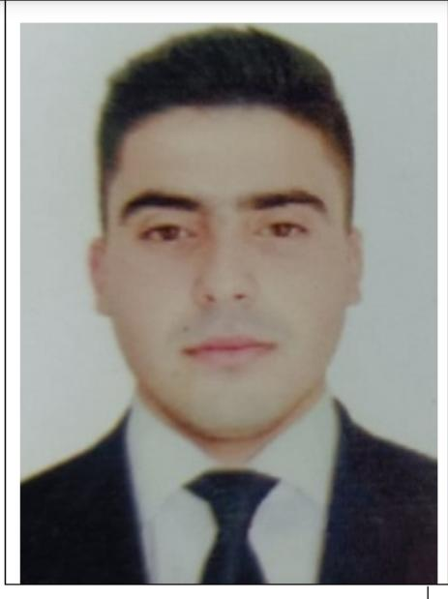
First name |  | AHMAD
Father’s name |  | TELMAN
Date and place of birth |  | 17.03.2000
Nationality |  | Azerbaijan
Marital status |  | Singl
Permanent address |  | Azerbaijan, Neftchala
Nearest airport |  | Heydar Aliyev International Airport Baku, Azerbaijan
Height (cm) | Weight (kg) | Eyes color | Hair color | Size of safety shoes | Size of coveralls
1.72 cm | 78 kg | CHESTUNT | BLACK | 42 | XL
CONTACT DETAILS
Mobile | E-mail address
+99450 435 85 12  Watcaap | ehmedmuradov44@gmail.com
NEXT OF KIN (FOR EMERGENCY)
Next of kin | MURADOV ELMAN | Relationship | BROTHER
Phone | +99451 523 11 72 | Address | Azerbaijan Neftchala
TRAVEL PASSPORT DETAILS
Document | Number | Place of Issue | Issued | Valid
PASSPORT | C03181180 | Azerbaijan | 16.12.2020 | 15.12.2030
SEAMAN’S BOOK DETAILS
Document | Number | Place of Issue | Issued | Valid
Seaman book | DGK018249 | Azerbaijan ,Baku | 02.09.2021 | 02.09.2026
SEAARERS IDENTITY | AZE023222 | Azerbaijan ,Baku | 02.09.2021 | 02.09.2026
EDUCATION
Full name of School | Place of Issue | Grade/Class | From | To
Azerbaycan Denizcilik kolleci | Azerbaijan , Baku | Motorman 104 k-1713 | 15.09.2016 | 20 07.2017
KNOWLEDGE OF LANGUAGE
Languages | Speaking | Reading | Writing
Azerbaijan | Excellent | excellent | Excellent
Russian | Excellent | excellent | Excellent
Turkish | Excellent | excellent | Excellent
COMPUTER SKILLS
Windows | Microsoft Office | Internet
Excellent | Excellent | Excellent
MEDICAL INFORMATION
Document | Grade | Place of issue | Date of issue | Date of expiry
Med.Sertificate | Engine-room watch | Azerbaijan | 20.07.2022 | 20.07.2024
CERTIFICATE OF COMPETENCY
Class/Grade | Issuing country | Certifikate | Date issued | Expires | Details of Limitations
Engine-room  Watch | Azerbaijan Marine Administration | RP-10567 | 31.08.2021 | 31.08.2026 | A-3/4
STCW AND OTHER CERTIFICATES
Name of course/Certificate | Institute | Place | Date of issue | Cert.No | Date of expiry
International Safety Managemen | Azerbaijan Marine Adminstration | Azerbaijan Baku | 24.10.2020 | SP-1005-20 | 24.10.2025
Proficiency in survival craft and boats other than fast rescue boats | Azerbaijan Marine Adminstration | Azerbaijan Baku | 22.10.2020 | SL-0944-20 | 22.10.2025
Training for seafarers with designated security duties | Azerbaijan Marine Adminstration | Azerbaijan Baku | 28 10.2020 | SH-0656-20 | 28.10.2025
Basic safety trainig | Azerbaijan Marine Adminstration | Azerbaijan Baku | 23.10.2020 | S0-1348-20 | 19 10.2025
Basic training and qualifications on oil and chemical tanker cargo operations | Azerbaijan Marine Adminstration | Azerbaijan Baku
Ship Security-related familization security-awareness | Azerbaijan Marine Adminstration | Azerbaijan Baku | 26 10.2020 | SI-0715-20 | 26.10.2025
SEA EXPERIENCE (LAST 5 YEARS – MOST RECENT EXPERIENCE ON TOP LINE)
Vessel | Company | Type of vessel | Flag | DWT | GRT | BHP | Rank | Sign on | Sign off
Neftqaz-10 | XDND | Offshore suppply | Azerbaijan | 2737 |  |  | Engine-room watch | 05.01 2017 | 30.06 2017
Volgo-bolt 217 | Azov-217 company | General cargo | ST.KITIS.NEVIS | 3488 | 2516 t |  | Engine-room watch | 20.09.2021 | 20 06.2022
ISKO MFU | Guha shipping company | General cargo | Equterial guinea | 4244 |  |  | Engine-room watch | 22 07.2022 | 22.10.2022
ADELHEID.BR | Faust Shıppıng company | General cargo | Barbados | 10860 |  |  | Engine-room watch | 27.12.2022 | 12.06.2023

