
PERSONAL DETAILS
Family name |  | ISMAYILOV |  |  | 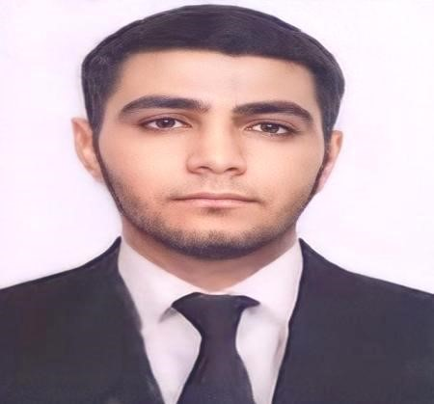
First name |  | VUSAL
Father’s name |  | MUSHVIG
Date and place of birth |  | 03.11.1999
Marital status |  | SINGLE
Permanent address |  | AZERBAIJAN, SUMGAYIT
Nearest airport |  | Heydar Aliyev International Airport Baku, Azerbaijan
Height (cm) | Weight (kg) | Eyes color | Hair color | Size of safety shoes | Size of overalls
175cm | 84kg | BROWN | BLACK | 41 | XL
CONTACT DETAILS
Mobile |  |  |  |  |  | E-mail address
+994 10 328 91 61 |  |  |  |  |  | vi5950484@gmail.com
NEXT OF KIN (FOR EMERGENCY)
Next of kin | Phone |  |  |  |  | Relationship |  |  |  | Address
ISMAYILOV MUSHVIG | +994 50 328 91 61 |  |  |  |  | Father |  |  |  | Azerbaijan, Sumgayit
TRAVEL PASSPORT DETAILS
Document | Number |  |  |  | Place of Issue |  |  |  | Issued |  | Valid
PASSPORT | C 04117863 |  |  |  | Azerbaijan |  |  |  | 01.06.2023 |  | 31.05.2033
COMPUTER SKILLS
Windows |  | Microsoft Office |  |  |  |  |  |  |  | Internet
Average |  | Average |  |  |  |  |  |  |  | Average
SEAMAN’S BOOK DETAILS
Document | Number | Place of Issue | Issued | Valid
Seaman book | DQK 024822 | Azerbaijan ,Baku | 30.08.2023 | 30.08.2028
SEAFARERS IDENTITY | AZE 029694 | Azerbaijan ,Baku | 30.08.2023 | 30.08.2028
Class/Grade | Issuing country | Certificate | Date issued | Expires | Details of Limitations
Rating forming part of a  navigational watch | Azerbaijan  Marine  Administration | No: 1825/23  ID No:RP13379 | 22.08.2023 |  | A-II/4
EDUCATION
Full name of School | Place of Issue | Grade/Class | From | To
State Border Service Academy | Azerbaijan , Baku | Marine Navigation Engineer | 2017 | 2021
“KAINAT MARITIME” LLC | Azerbaijan , Baku | Rating forming part of a navigational watch | 06.01.2023 | 31.07.2023
KNOWLEDGE OF LANGUAGE
Languages | Speaking | Reading | Writing
Azerbaijan | Excellent | Excellent | Excellent
Turkish | Excellent | Excellent | Excellent
English | Average | Average | Average
MEDICAL INFORMATION
Document | Grade | Place of issue | Date of issue | Date of expiry
Med.Certificate | Rating forming part of a navigational watch | Azerbaijan Baku | 26.04.2023 | 26.04.2025
CERTIFICATE OF COMPETENCY STCW AND OTHER CERTIFICATES
Name of  course/Certific ate | Institute | Place | Date of issue | RANK | Cert.No | Date of expiry
International Safety  Management | Azerbaijan Marine Administration | Azerbaijan Baku | 02.06.2023 | Rating  Forming Part of a  Navigational Watch | SP-175423 | 25.05.2028
Proficiency in survival craft and boats other than fast rescue boats | Azerbaijan Marine Administration | Azerbaijan Baku | 06.06.2023 | Rating  Forming Part of a  Navigational Watch | SL-188923 | 06.06.2028
Training for seafarers with  designated security  duties | Azerbaijan Marine Administration | Azerbaijan Baku | 06.06.2023 | Rating  Forming Part of a  Navigational Watch | SH-129923 | 31.05.2028
Basic safety training | Azerbaijan Marine Administration | Azerbaijan Baku | 20.06.2023 | Rating  Forming Part of a  Navigational Watch | SO-276623 | 30.05.2028
Ship Securityrelated  familiarization security-awareness | Azerbaijan Marine Administration | Azerbaijan Baku | 26.05.2023 | Rating  Forming Part of a  Navigational Watch | SI-154423 | 26.05.2028
SEA EXPERIENCE (LAST 5 YEARS – MOST RECENT EXPERIENCE ON TP LINE)
Vessel | Company | Type of vessel | Flag | DW  T | BHP | GR T | KW | Enginie | Rank | Sign on | Sign off
NEFTEG  AZ  (S-009) | The Coast Guard  Of State Border  Service Of  Azerbaijan Republic | AHTS | Azerbaijan | 1397 | 7200 | 2723 | 3800 | Wartsila | Trainee | 01.07.2017 | 02.09.2017
NEFTEG  AZ  (S-009) | The Coast Guard  Of State Border  Service Of  Azerbaijan Republic | AHTS | Azerbaijan | 1397 | 7200 | 2723 | 3800 | Wartsila | Trainee | 15.05.2018 | 10.07.2018
NEFTEG  AZ  (S-009) | The Coast Guard  Of State Border  Service Of  Azerbaijan Republic | AHTS | Azerbaijan | 1397 | 7200 | 2723 | 3800 | Wartsila | Trainee | 05.04.2019 | 03.06.2019
NEFTEG  AZ  (S-009) | The Coast Guard  Of State Border  Service Of  Azerbaijan Republic | AHTS | Azerbaijan | 1397 | 7200 | 2723 | 3800 | Wartsila | Trainee | 01.07.2020 | 03.09.2020
SHALDA  G MK-V  (S-009) | The Coast Guard  Of State Border  Service Of  Azerbaijan Republic | NAVY | Azerbaijan | 1397 | 712 | 2723 | 712 | Caterpillar | Trainee | 02.06.2021 | 05.10.2021

