Position | Electrıcal | Mobile: +994555324741, +994514084879 E-mail: vhusal.mammadzada2001@gmail.com |  |  |  |  |  |  |  | 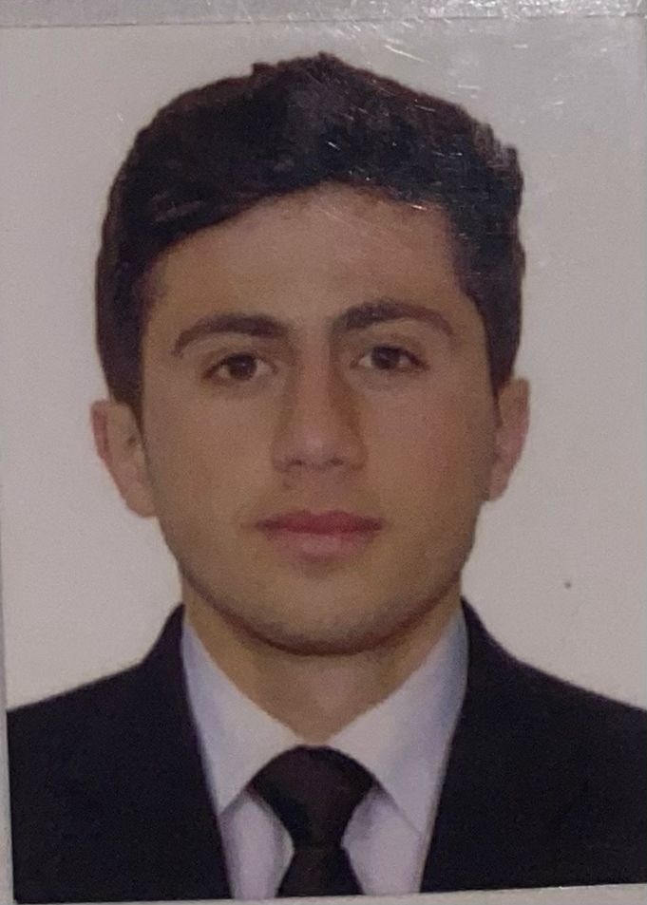
 |  | Home address: Azerbaijan. Astara.
Surname |  | Mammadzada |  | Name | Vusal |  | Nationality | Azerbaijan
Date of birth |  | 13.01.2001 | Height (cm) | 172 | Color of Eyes | Broun | Shoes | 42
Place of birth |  | Aze/Astara | Weight (kg) | 65 | Color of Hairs | Black | Clothes | 52
Father’s Name |  | Ilkın | Mother’s Name |  | Mother’s Family Name
Next of kin |  |  | Relation |  | Address | The same
LICENSE / PASSPORTS |  | № | Date of issue | Date of expire | Place |  | Marital status | Sıngle
Seaman’s Passport |  | DQK 014827 | 27.07.2019 | 27.07.2024 | Azerbaijan |  | Children till 18 years | nil
Travel Passport |  | C03640564 | 19.07.2023 | 18.07.2033 | Azerbaijan |  | English | normal
Electro-technıcal ratıng |  | 0980/21 | 18.11.2021 | --------- | Azerbaijan | Education | Azerbaijan High Marine School (Academy)
Securıty-related traınıng |  | SI-1383-19 | 14.05.2019 | 18.04.2024 | Azerbaıjan | Limitations: | NIL
Servıval craft and boats |  | SL-2272-23 | 12.07.2023 | 10.07.2028 | Azerbaijan | Identity №
Seafarers wıth desıgnated |  | SH-1700-23 | 14.07.2023 | 14.07.2028 | Azerbaijan | Other skills
IMO model Courses 1-1,1-2,1-3,1-4 |  | SO-1389-19 | 10.05.2019 | 15.04.2024 | Azerbaijan

Internatıonal Safety Management Code | SP-0737-19 | 14.05.2019 | 22.04.2024 | Azerbaijan

SEA SERVICE
Vessel’s Name  Flag | Year of  built | Type\ G.T | Engine – HP- DWT | Rank | Sign On | Sign Off | Shipping Co. | Salary  USD
ALI MUSTAFAEV | 1991 | Pollutıon Control Vessel | 2200KW | STAJER | 01.08.2019 | 01.10.2019 | ASCO
GYULTAKIN ASKEROVA | 1984 | Tug/Supplu Shıp | 5298KW | STAJER | 01.07.2020 | 01.09.2020 | ASCO
GYULTAKIN ASKEROVA | 1984 | Tug/Supply Shıp | 5298KW | STAJER | 02.07.2021 | 03.09.2021 | ASCO
ALI MUSTAFAEV | 1991 | Pollutıon Control Vessel | 2200KW | STAJER | 25.01.2022 | 27.03.2022 | ASCO

Date: 14.08.2023

