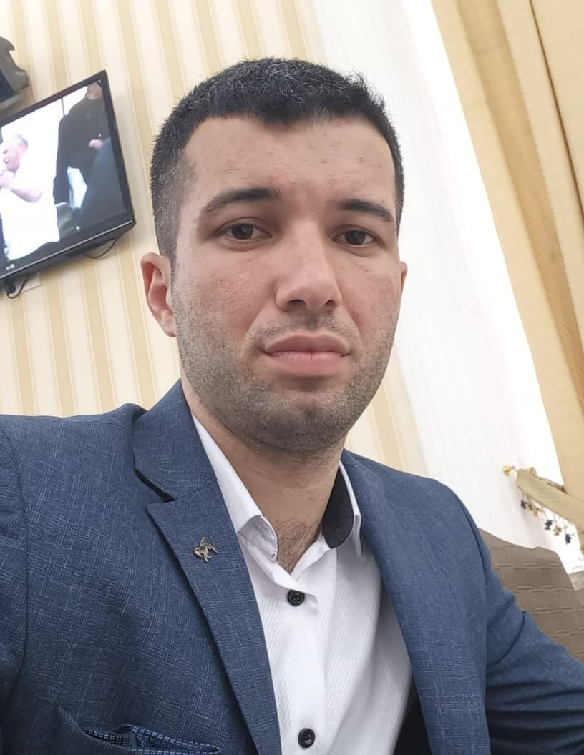

APPLICATION FORM

Personal ID Number

Position Applied for Able Seafarer Deck | Date Available from: 11.05.2022

1. Personal Data
Family Name: QULİYEV | First Name: RƏSUL | Middle Name: ƏFQAN
Date of Birth: 05.03.1996 | Place of Birth (City and Country): AZERBAIJAN, TOVUZ | Citizenship: AZERBAIJAN
Permanent Address: AZERBAIJAN, TOVUZ, MAMED ZEYNALOV, HOME 48 |  | Phone (Home): 02231 2 24 07  Phone (Business/ Mobile): +994 70 957 97 67  E-mail:

2. Maritime Education
Name of school | Town | Country | From | To | Type of degree or diploma
KASPİAN EDUCATİON CENTER | BAKU | AZERBAIJAN | 09.01.2023 | 19.06.2023 | OS SAILOR

3. Language knowledge
English | Average
Russian | Average
Azerbaijan | Very well

4. Family Details
Civil Status(Single, Married, Separated, Divorced, Widowed) : SİNGLE

Next of Kin (the first emergency contact): FRİEND, +994 55 668 50 52 | Relationship: SHAHLAR AHMADOV
Address of Residence: AZERBAIJAN, TOVUZ, MAMED ZEYNALOV, HOME 48

5. Identity Documents
Document | Country | Number | Place of Issue | Issue Date | Expiry Date
Seaman's Book | Azerbaijan | DQK024561 | Baku, State Marine Administration | 02.08.2023 | 02.08.2028
Travel Passport | Azerbaijan | C03446725 | Ministry of Internal Affairs | 19.07.2023 | 18.07.2033
Civil Passport

6. Valid Visa
Country or Union | Type | Valid Until

7. Courses Attended and Certificates Obtained
Document | Number | Dates |  |  | Place
Document | Number | Issue |  | Expiry | Place
Certificate of Competency (Chief mate on ships of 3000gross tonnages or more) | RP 02542 |  | 11.03.2022 | N/A | AZERBAIJAN
Proficiency in Survival Craft and Rescue Boats | SL-2175-23 |  | 06.07.2023 | 25.06.2028 | AZERBAIJAN
Ship Security Officer Training Course | SI-1790-23 |  | 21.06.2023 | 21.06.2028 | AZERBAIJAN
ISM Code | SP-2048-23 |  | 04.07.2023 | 04.07.2028 | AZERBAIJAN
Training of seafarers with designated security duties in compliance with ISPS Code | SH-1572-23 |  | 06.07.2023 | 05.07.2028 | AZERBAIJAN
Seafarers Medical Certificate |  |  | 23.05.2023 | 23.05.2025 | AZERBAIJAN
Basic Trainings | SO-3026-23 |  | 23.06.2023 | 20.06.2028 | AZERBAIJAN

8. Physical Data
Height | 184sm
Weight | 78 kg
Colour of Hair | Black
Colour of Eyes | Brown
Boilersuit Size | M
Shoes Size | 43

9. Medical History | Yes | No
Have you ever signed off a ship due to medical reasons? |  | x
Did you undergo any medical operation in the past? |  | x
Have you consulted a doctor during the last 12 months for an illness/accident? |  | x
Do you have any health or disability problems now? |  | x

15. Seagoing Experience

Name of vessel | Flag | Vessel’s Type | DWT | Eng Type | HP | Manager or Owner | Rank | From d/m/y | To  d/m/y | Total  m/d

