CURRICULUM VITAE
PERSONAL DETAILS
Family name |  | AKBAROV |  |  | 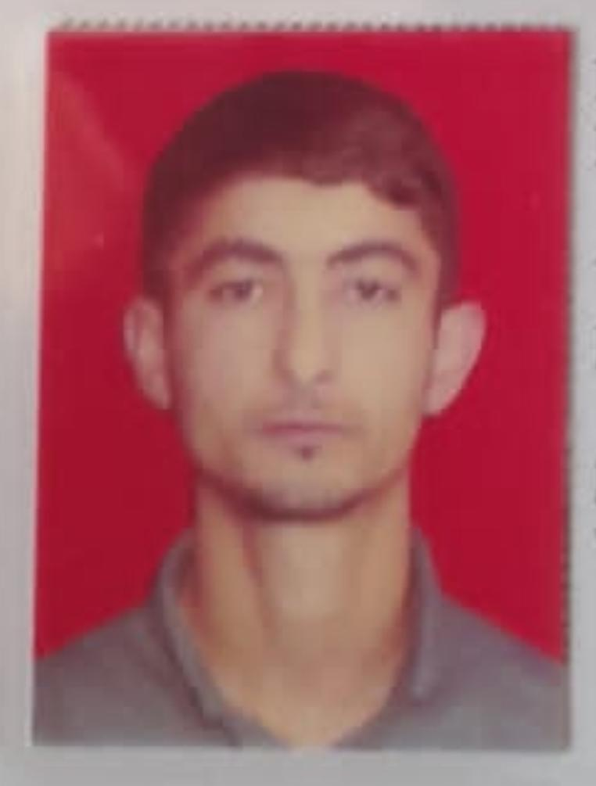
First name |  | PARVIN
Father’s name |  | MARDALI
Date and place of birth |  | 15.11.1994
Nationality |  | Azerbaijan
Marital status |  | Singl
Permanent address |  | Azerbaijan Masalli
Nearest airport |  | Heydar Aliyev International Airport Baku, Azerbaijan
Height (cm) | Weight (kg) | Eyes color | Hair color | Size of safety shoes | Size of coveralls
1.72 cm | 60 kg | BROWN | BLACK | 41 | XL
CONTACT DETAILS
Mobile | E-mail address
+99450 894 36 57
Watcaap
NEXT OF KIN (FOR EMERGENCY)
Next of kin | AKBAROV MARDALI | Relationship | FATHER
Phone | +99451 644 46 10 | Address | AZERBAIJAN Masalli Khirmandali village
TRAVEL PASSPORT DETAILS
Document | Number | Place of Issue | Issued | Valid
PASSPORT | C03158513 | Azerbaijan | 13.05.2023 | 12.05.2033
SEAMAN’S BOOK DETAILS
Document | Number | Place of Issue | Issued | Valid
Seaman book | DGK024011 | Azerbaijan ,Baku | 06.06.2023 | 06.06.2028
SEAARERS IDENTITY | AZE028879 | Azerbaijan ,Baku | 06.06.2023 | 06.06.2028
EDUCATION
Full name of School | Place of Issue | Grade/Class | From | To
KASPIAN EDUCATION CENTER “MMC” | Azerbaijan , Baku | PS N-000891 | 27.09.2022 | 30..03.2023
KNOWLEDGE OF LANGUAGE
Languages | Speaking | Reading | Writing
Azerbaijan | Excellent | excellent | Excellent
Turkish | Excellent | excellent | Excellent
English | Excellent | Excellemt | Excellent
COMPUTER SKILLS
Windows | Microsoft Office | Internet
Excellent | Excellent | Excellent
MEDICAL INFORMATION
Document | Grade | Place of issue | Date of issue | Date of expiry
Med.Sertificate | Rating forming part of a Navigational watch | Azerbaijan Baku | 17.11.2022 | 17.112.2024
CERTIFICATE OF COMPETENCY
Class/Grade | Issuing country | Certifikate | Date issued | Expires | Details of Limitations
Rating forming part of a navigational watch | Azerbaijan Marine Administration | No 1267-23  RP-12966 | 23.05.2023 | No limit | A-2/4
STCW AND OTHER CERTIFICATES
Name of course/Certificate | Institute | Place | RANK | Date of issue | Cert.No | Date of expiry
International Safety Managemen | Azerbaijan Marine Adminstration | Azerbaijan Baku | Rating forming part of a navigational watch | 19.01.2023 | SP-0125-23 | 18.01.2028
Proficiency in survival craft and boats other than fast rescue boats | Azerbaijan Marine Adminstration | Azerbaijan Baku | Rating forming part of a navigational watch | 16.01.2023 | SL-0135-23 | 16.01.2028
Training for seafarers with designated security duties | Azerbaijan Marine Adminstration | Azerbaijan Baku | Rating forming part of a navigationak watch | 24.01.2023 | SH-0153-23 | 24.01.2028
Basic safety trainig | Azerbaijan Marine Adminstration | Azerbaijan Baku | Rating forming part of a navigationak watch | 16..01.2023 | S0-0175-23 | 11.01.2028
Ship Security-related familization security-awareness | Azerbaijan Marine Adminstration | Azerbaijan Baku | Rating forming part of a navigational watch | 17.01.2023 | SI-0185-23 | 12.01.2028
SEA EXPERIENCE (LAST 5 YEARS – MOST RECENT EXPERIENCE ON TOP LINE)
Vessel | Company | Type of vessel | Flag | DWT | GRT | Rank | Sign on | Sign off

