plication Form

Position: ABLE SEAMAN(AB)
Surname: Gaflanov | First name: Kamil
Date of birth: 05/11/1998 | Place of birth: Azerbaijan Region of Gusar
Father name Gaflanov Fazir | Citizenship: Azerbaijan
Phones:+994556211815 | Nearest international airport: Baku(Heydar Aliyev int)
Marital Status: Married | Level of English: Above Avarage
Email: gaflanov.kamil@mail.ru

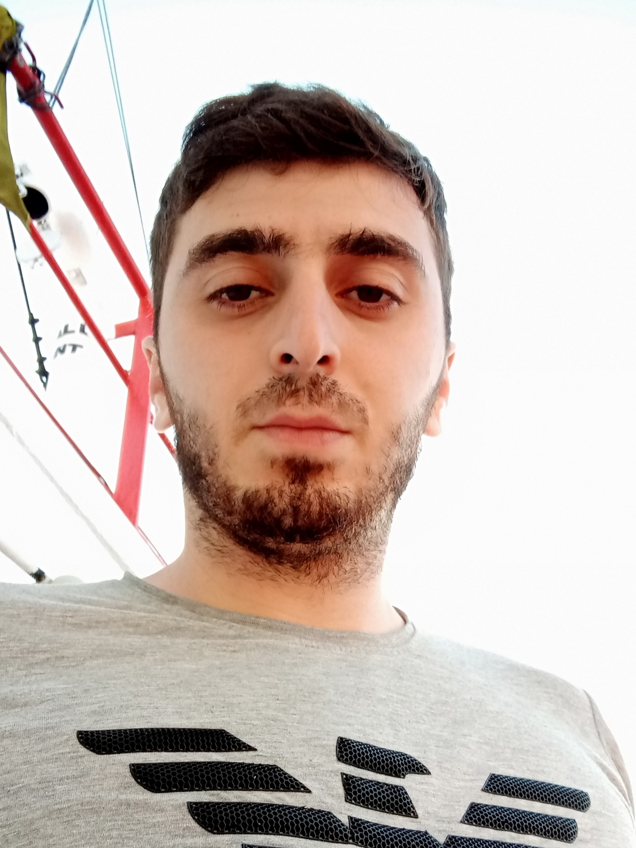
Documents

Passport No. | C02368964 | Issued on: | 02.05.2019 | Expiry date: | 01.05.2029
S/book No. | DQK013912 | Issued on: | 03.04.2019 | Expiry date: | 03.04.2024

Next of kin:Uncle
Name: Vagif Safarov
Home address: Azerbaijan.Gusar
Phones:+994503502994
Email:

CERTIFICATES | Cert No | Date of Issue | Expiry date
PROFICIENCY IN SURVIVAL GRAFT | SL-0943-19 | 29/07/2019 | 25/07/2024
ISM CODE | SP-1098-19 | 22/07/2019 | 22/07/2024
SHIP SECURTY-RELATED FAMILIARIZATION SECURTY-AWARENESS TRAINING | SI-1900-19 | 25/07/2019 | 17/07/2024
TRAINING FOR SEAFARERS WITH DESIGNATED SECURITY | SH-1072-19 | 25/07/2019 | 19/07/2024
PERSONAL SURVIVAL TECHNIQUES | SO-1902-19 | 26/07/2019 | 25/07/2024
FIRE PREVENTION AND FIRE FIGHTING | SO-1902-19 | 26/07/2019 | 25/07/2024
ELEMEMTARY FIRST AID | SO-1902-19 | 26/07/2019 | 25/07/2024
PERSONAL SAFETY AND SOCIAL RESPONSIBILITIES | SO-1902-19 | 26/07/2019 | 25/07/2024
ORDINARY SEAMAN | RP00770 | 23/09/2019 | 23/09/2024
PAMAMA POSPORT | PA0286775 | 19/09/2022 | 13/09/2027

SEA SERVICE
NAME OF VESSEL | COMPANY | TYPE OF VESSEL | TYPE OF ENGINES | DWT | RANK | PERIOD OF SERVICE
NAZ 1 | SUDE DENIZCILIK | GENERAL CARGO |  | 3500 | AB | 26.07.2020 | 1.03.2021
NAZ 1 | SUDE DENIZCILIK | GENERAL CARGO |  | 3500 | AB | 14.07.2021 | 26.08.2021
RIVER PRIDE | SENEMAR SHIPPING | GENERAL CARGO |  | 3500 | AB WELDER | 12.10.2021 | 26.01.2022
VIVA GALAXY | UNITY. N. SHIPPING | BULKER |  | 53000 | OS | 15.09.2022 | 12.03.2023

